Checklist Tracker

# Risk Tracker

**Please DO NOT DELETE - for team discussion purposes only**

**Owner- Sabby**

<https://docs.google.com/spreadsheets/d/1oLgt_IQMhI6YD0e9yHnK7MHx3HsAh42VE72Uge8C3YI/edit?gid=0#gid=0>

# WEEK 3

**Feb 9rd to Feb 13th**

# 

# 

# WEEK 3

**Feb 3rd to Feb 7th**

| **Wk.** | **Task** | **Owner** | **Notes** | **Done** |
| --- | --- | --- | --- | --- |
| 3 | Start AI Hypothesis Evaluation | Sabby/Anshu | #1 API's  #2 Once data is received, what will you do with it?  #3 What persistence (database) are you thinking about?  #4 What should the Ai do with the data that it receives from multiple sources?  #5 Walk through a persona when describing RewardWise but including the technology layers. (Input,Processing,Output)..  #6 Are you using RAG, Agents? If so, how?  #7 Do you need ML to do any computing on people's point aggregation or spending trends?  #8 How do you handle these anomalies if there are any?  #9 Evals toolkit  **ETA 2/6** | In Progress |
| 2 | Competitor Analysis | Smital  (backup Autumn) | [Gandola.ai](http://gandola.ai); Awardtravel; [Point.me](http://point.me); Hopper; Banks?  Combine competitor analyses (work with Autumn) into unified document for team discussion on **ETA 2/6** | Done |
| 2 | PRD v2 | Autumn  (backup Sabby) |  | Not Started |
| 2 | UX v2 | Sebas | Update designs based on User flows tab  **ETA 2/6** | In Progress |
| 3 | Presentation for Dev/DS | Smital  (backup Sabby) |  | In Progress |
| 3 | User Research | Eshma | Outputs 1-2 pages summarizing: top 3 validated pain points, top 3 surprises, recommended user segments, open questions. Format: Google Doc in shared workspace. ETA 3/6 | In Progress |
| 3 | Competitor UX Audit | Eshma | Document user flows for Seats.aero, PointsYeah, and Point.me. For each: screenshots of key screens, notes on decision-point UX, copy/language patterns, and one "we should steal this" insight. Format: Google Slides or Notion. | In Progress |
| 3 | Mentor discussion | Sabby | Setup weeklies with the Mentor Linda Wang | Done |
| 3 | Pricing analysis for B2B | TBD | TBD | Not Done |

**Week 4 status 2/16**

**Week 3 status 2/9**

*We are on track to launch for beta testing by 3/30. Since our last update, 1) we have stood up the full team with five PMs and two designers, 2) completed Voice of Customer research and 3) competitive analysis, and 4) shipped a sample prototype website. As next steps, we will finalize user and competitor UX research (2/13), our AI architecture stack proposal (ETA TBD), and deliver the technical presentation to Engineering and Data Science (2/10). We are not blocked on anything. We have identified four risks. On the technical side, our architecture currently depends on a single API for availability, which creates a single point of failure. We plan to evaluate fallback providers and a caching layer by (ETA TBD). Hallucination and ML accuracy is an inherent risk with our AI approach; our early mitigation strategy is to define accuracy thresholds and implement output guardrails as part of the architecture proposal. On the business side, our B2B versus B2C positioning is not yet locked, and will work with the mentor to align on our MVP customer positioning by 2/16. Finally, MVP scope creep is a risk we're monitoring on an ongoing basis and cutting scope wherever possible actively.*

prototype <https://rewardwise-app.vercel.app/>

**Feb 6th Agenda**

1. Competitor Analysis
2. Developer Presentation
3. UX
4. GTM

**Feb 3rd agenda**

1. I am adding Eshma as Designer 2 to the team (key tasks to be actioned below). Seba continues to lead the UX designs with strong inputs/helping hand from Eshma who is the User Research lead. Seba and I spoke on it today and we are aligned.
2. VoC key takeaways (Anshu)
3. AI tech stack (Sabby)
4. Competitor analysis key takeaways (Autumn/Smital)
5. Finalized what to present to developers (scheduled feb10)
6. **We need to do a ROI/Pricing analysis for B2B**

**Designer 2 -**

1. Survey Synthesis Doc — 1-2 pages summarizing: top 3 validated pain points, top 3 surprises, recommended user segments, open questions. Format: Google Doc in shared workspace. ETA 3/6
2. Competitor UX Audit (Initial) — Document user flows for Seats.aero, PointsYeah, and Point.me. For each: screenshots of key screens, notes on decision-point UX, copy/language patterns, and one "we should steal this" insight. Format: Google Slides or Notion. ETA 3/6
3. Interview Strategy Proposal — Recommend 5-8 respondents to interview, proposed outreach message, core questions to ask, and scheduling approach. Format: 1-page doc.
4. Interview format ETA 3/9
   1. **Scope the interviews to validate, not discover.** The interviews are confirmation, not exploration. The question isn't "what do users want?" — it's "does our current direction resonate?"

* Show the prototype, get reactions
* Ask: "Would you trust this recommendation enough to act on it?"
* Ask: "What's missing that would make you not use this?"
  1. If interviews reveal something fundamental, it doesn't block Tuesday pitch; we can iterate on it.

**Next Steps**

1. Eshma: Kick off user research, UX competitor analysis and user interviews (Sabby/Anshu to help_
2. Sabby: Send AI stack framework to Anshu tonight for tomorrow’s mentor meeting
3. Anshu/Sabby: share AI stack thoughts with the team prior to 2/6 meeting
4. Smital: Combine competitor analyses (work with Autumn) into unified document for team discussion on 2/6
5. Smital: Work with Sabby on the next weeks’ developer presentation
6. Autumn: Start working on PRD (with support from Sabby)
7. Friday 2/6 agenda: Competitor analysis deep dive, Prototype/wireframe review

# WEEK 2

| **Wk.** | **Task** | **Owner** | **Notes** | **Done** |
| --- | --- | --- | --- | --- |
| 2 | Get at least 3 committed PMs | Sabby | Autumn, Anshu, Smital, Sabby | Done |
| 2 | Get at least 2 committed Designer | Sabby | Sebastian, Eshma | Done |
| 2 | Responsibilities | All | VoC - Anshu/Sabby (ETA 1/31 12 PM PST)  Competitor Analysis - Autumn/Smital (ETA Feb 3rd 5 PM PST)  Tech Stack (AI stack) - Sabby/Anshu (ETA Feb 3rd 5 PM PST)  PRD v2 - Autumn/Sabby (ETA Feb 6th X PM PST)  UX - Sebas <https://labs.google/> (ETA Feb 7th no meeting required)  Presentation for Devs/DS - Smital (ETA Feb 3rd 5 PM PST)  **Pitch to Developers - Feb 10th** | Done |
| 2 | Determine Project Management Tool | Sabby | Google workspace | Done |
| 2 | VoC | Anshu (backup Sabby) |  | Done |

**Week 2 Status Update**

Competitor Analysis

# Synopsis (Owner- Smital)

ETA 2/6

anshu's notes

1. **Gondola AI:**

Onboarding flow:

1. Ask to login via Google/Micrsoft/other accts
2. Redirect to account and authenticate
3. User Interactive screen → By using “How it works “ CTA → creates curiousity
4. Tells them user can search across all the hotel chains through them
5. Shows them if user books through them then he can see all the hotel points, cassock and credit card cash back all in one account.

Explains How the connectivity works → also explains the Security side of sharing and securing their credit card details

1. Giving options to users to either connect email to their system or forward reservations so that they can extract all the details and make calculations
2. Enter manually

I chose manually → Landing page is a trip search page with hotel recommendations along with points/cash required for each booking for each hotel.

Cash vs points comparison and suggestion which will sound best based on ur profile.

Total Earnings

Points:

Add loyalty programs manually

Add Credit Card and Loyalty points manually or add through MX transfer

TRIPS:

Track trips and accumulate point through email.

Keeps track on what was searched recently and suggest packages based on the search. Including dates and travellers info.

Search:

Shows Cash vs Points comparison and tells the user which option is best for them visually. Displays Loyalty program points.

They suggest hotels based on the points/cash as well with For You option ( I guess based on the piints/cash accumulation or trip preference only decision is made).

Alerts suggestion for Price tracking through out the month ( window selected for the trip) for hotels.

**POINTS YEAH - the fastest award search tool on the planet!**

Free Signup programme for Ideal hotel and flights -

Great Introduction, easy navigation tips when the user visits the site for the first time.

Indicating any new changes in the system.

**Flights:** Search flights →shows ideal flights with Cash/price points needed for booking

**Hotels:** Hotel search results in hotels along with the cash/points required for booking. Shows the loyalty programs provided by the hotel.

Multiple filters ranging from Points/cash needed, hotel/bank programmes to search for hotels.

**Travel Radar**

[Travel Radar](https://www.pointsyeah.com/travel-radar) gives you the year-long view that was missing. Instead of tracking a handful of days, it monitors your chosen routes for a full 365 days. Results refresh periodically and highlight the opportunities that matter most.

Think of it as your personal award travel command center.

* Track up to 4 routes for a full year
* Periodically refreshes keep availability and pricing current
* Clean calendar view highlights the lowest points days
* Smart filters narrow results by cabin, stops, airlines, and more
* At-a-glance insights show new availability and recent price drops

How it works:

Choose Route → Set filters ( Focus on specific airline or bank transfer programs, Require a minimum percentage of premium cabin space ,Limit connections or exclude airlines you do not want to fly) → Travel radar builds a full year calendar that refreshes periodically.

Radar calnder gives you

* Lowest points days across the year
* Newly added award space since the last refresh
* Price drops worth your attention

Then deep dive into a single flight to view transfer partners and pricing breakdowns.

This is how the calendar looks like:

Travel Radar vs. Points Price Alerts

Both tools are powerful. Together, they are unbeatable.

* **Points Price Alerts:** Best for precision. Each alert monitors a specific window of up to 8 days and notifies you when availability or pricing changes. Free users can set 4 alerts. Premium members can set 32.
* [**Travel Rada](https://www.pointsyeah.com/travel-radar)r:** Best for the big picture. Tracks entire routes for a year, refreshing periodically and showing you availability in a single calendar view. Premium exclusive.

**BANK & CARD OFFERS**

CREDIT CARD, AIRLINE PROGRAM & BANK PROMOTIONS

## **Travel Radar vs. Points Price Alerts**

Both tools are powerful. Together, they are unbeatable.

* **Points Price Alerts:** Best for precision. Each alert monitors a specific window of up to 8 days and notifies you when availability or pricing changes. Free users can set 4 alerts. Premium members can set 32.
* [**Travel Rada](https://www.pointsyeah.com/travel-radar)r:** Best for the big picture. Tracks entire routes for a year, refreshing periodically and showing you availability in a single calendar view. Premium exclusive.

| **Feature** | **Free** | **Premium** |
| --- | --- | --- |
| [**Travel Radar**](https://www.pointsyeah.com/travel-radar) | ❌ | Track 4 routes for 365 days (Premium exclusive) |
| **Points Price Alerts** | Up to 4 | **Up to 32** |
| **Hotel Alerts** | Up to 4 | **Up to 15** |
| **Number of search days (one-way)** | Up to 4 | **Up to 8** |
| **Multi-Airport Search** | ❌ | ✅ |
| **United Airlines upgrade alerts** | ❌ | ✅ |
| **Custom value per point** | ❌ | ✅ |

Smital's Notes

## **Summary:**

**The Critical Gap (Main Opportunity)**

* ALL competitors show OPTIONS, NONE give THE VERDICT
* Point.me: Shows 47 ways (109 sec) - user must decide
* PointsYeah: Shows all flights/ways (24 sec) - user must interpret
* Gondola: Shows CPP comparison - user must choose
* RewardWise opportunity: "Transfer 70K Chase→Air France, Book AF123 June 15, Save $4,200"
* **We are positioning our app as B2C; think of it as a B2B**

**Top Competitors Benchmarked**

1. Point.me (29/45) - Most comprehensive but slowest, expensive, no decision-making

2. Gondola.ai (33/45) - Hotels only, FREE, great UX, limited scope

3. AwardTravel (33/45) - Balanced tool, good coverage

4. Hopper - Cash booking (DIFFERENT market), AI prediction, $5B valuation, NO points/miles

## **Direct User Segments**

1. Overwhelmed Optimizer - 500K points, 8 hrs research, still confused
2. Aspiring Points Hacker - Don't know what questions to ask
3. Business Traveler - 2M points, zero time
4. Small Business Owner - $500K/yr spend, no strategy
5. Family Gifter - Want to gift travel, don't understand
6. Special Trip Planner - Honeymoon, can't mess up
7. Travel Advisors - Clients expect expertise they lack

## **Market Gaps Identified**

* No decision-making layer (all show options)
* No multi-wallet optimization
* No personalization/learning
* No proactive intelligence ("book now" vs "wait")
* SMBs, corporate travel, family gifting completely underserved

## **Universal Pain Point**

**Direct Users: "Just tell me what to do" (decision paralysis from information overload)**

**-> this is RewardWise USP**

Credit Cards/Airlines: Tension between showing value vs. keeping redemptions low

Regulators: Consumer protection concerns (transparency, devaluations)

* **-> this is RewardWise Risk**

Missed Opportunities: SMBs, corporate travel, family gifting, wealth advisors all underserved

## **Table 1: Direct Competitors (Reward Search & Optimization Tools)**

| **Competitor** | **Offerings** | **Key Features** | **Pricing** | **Strengths** | **Weaknesses** | **Positioning** |
| --- | --- | --- | --- | --- | --- | --- |
| [Point.me](https://www.point.me/) | Full-service award flight search + concierge | • 30+ programs, 150+ airlines  • Concierge booking service  • Portfolio tracking  • Strategy consultation | Standard: $129/yr  Premium: $260/yr  Concierge: $200/pax | • Most comprehensive coverage  • Professional concierge  • Finds routes others miss | • Very slow (109 sec)  • No multi-date search  • Shows options, doesn't decide | Premium comprehensive search |
| [PointsYeah](https://www.pointsyeah.com/landing) | Award flight + hotel search | • 20+ programs  • Fastest searches (24.6 sec)  • Multi-date search  • Hotel search included | Free: Robust features  Pro: ~$100/year | • Best speed  • Strong free version  • Excellent UI | • Missing some programs  • Occasional glitches  • Search only, no recommendations | Best value for DIY searchers |
| [Roame](https://roame.travel/) | Free award flight search with community | • 15-16 programs  • Real-time results  • 160K-member community  • Newsletter with deals | Free: Full features  Friends: $9.16/mo  Enterprise: $291.66/mo | • Completely free  • Best community support  • Great for beginners | • Fewer programs  • Missing Qatar, Lufthansa  • No decision-making | Free, community-first |
| [AwardTool](https://www.awardtool.com/) | Power user flight search | • 20+ programs  •Up to 32 simultaneous searches  • Flexible configurations  • Very fast | Free: Available  Pro: ~$100/year | • Unmatched flexibility  • Multiple configurations• Fast results | • Buggy interface  • Less accurate results  •Search-focused only | Technical power user tool |
| [Gondola](https://www.gondola.ai/onboarding) | Hotel-only AI cash vs. points optimizer | • Hotels ONLY  • Cash vs. points comparison  • 3-7% cash back  • Auto price monitoring | FREE (entire platform) | • Best cash vs. points analysis  • Auto price monitoring  •Triple-dipping rewards | • Hotels ONLY - no flights  • Requires email access  • Limited scope | Hotel-specific optimizer |
| [Seats.aero](https://seats.aero/) | Premium cabin award search specialist | • 15+ programs  • Premium cabin focus  • Specialized finders  • Unlimited alerts (Pro) | Free: 60-day window  Pro: $100/year | • Best for premium cabins  • Excellent alert system  • Specialized tools | • Free version very limited  • Not beginner-friendly  • Search-only | Premium cabin specialist |
| [ExpertFlyer](https://www.expertflyer.com/) | Legacy aviation professional tool | • Award & upgrade availability  • Seat maps (40+ airlines)  • Fare class availability  • GDS-level data | Free: LimitedPro  Basic: $60/yrPro  Premium: $120/yr | • Deep GDS data  •Professional-grade  • Seat map viewer | • Removing airline support  • Dated 1990s UI  • Not recommend | Declining legacy tool |
| [Awayz](https://www.awayz.com/) | Hybrid flight + hotel search | • Flight AND hotel search  • Cash vs. points comparison  • AwardWallet integration | Free: Available  Premium: ~$100/year | • Combines flights + hotels  • Good cash/points analysis | • Less comprehensive  • Search, not decision | Hybrid solution attempt |
| [MaxMyPoint](https://maxmypoint.com/) | Hotel award availability tracker | • Hotels only (4 chains)  • Calendar view  • Award alerts | Free: Basic  Gold: $48/yr  Platinum: $96/yr | • Focused on major chains  • Calendar visualization | • Hotels only  • Limited to 4 chains  •Search-focused | Basic hotel tracker |
| [Hopper](https://hopper.com/) | AI-powered travel booking appFlights, hotels, car rentals, vacation homes  Price prediction & fintech services | • AI price prediction (95% accuracy claim)  • Price Freeze feature  • Carrot Cash rewards (1-5%)  • Push notifications for price drops  • Color-coded price calendar  • Cancel for Any Reason insurance  • B2B white-label (Hopper Cloud | **FREE app**  Revenue from:  • Booking commissions  • Fintech add-ons (Price Freeze, insurance)  • B2B licensing | •Best-in-class UX (4.8 stars)  • Unique Price Freeze  • Massive scale (120M+ downloads)  • Strong AI prediction  • $5B valuation, well-funded  • Mobile-first excellence | • Cash only - NO points/miles  • Limited personalization  • Prediction not 100% reliable  • Customer support issues  • OTA intermediary model | Smarter booking with AI prediction |

## 

## 

## **Table 2: Indirect Competitors - Tracking & Trip Management Tools**

| **Competitor** | **Offerings** | **Key Features** | **Pricing** | **Strengths** | **Weaknesses** | **Positioning** |
| --- | --- | --- | --- | --- | --- | --- |
| [AwardWallet](https://awardwallet.com/) | Points & miles tracking platform | • Tracks any loyalty program  • Expiration alerts  • Excel export  • Integrations | Free: Sufficient  Plus: $30/year | • Most comprehensive  • Industry standard  • Free version excellent | • Tracking only  • No optimization  • No recommendations | Essential companion tool |
| [TripIt](https://www.tripit.com/web/free/download) | Trip organization tool | • Trip itinerary tracking  • Flight/hotel consolidation  • Delay alerts | Free:  Basic  Pro: $49/year | • Best trip organization  • Email parsing  • Real-time alerts | • Not points-focused  • No award optimization  • Only app (no website) | Trip management |
| [Google Flights](https://www.google.com/travel/flights?gl=US&hl=en-US) | Cash flight search | • Price history graphs  • Price alerts  • Calendar view  • Flexible dates | FREE (ad-supported) | •Comprehensive cash search  • Price tracking  • Google ecosystem | • Cash flights only  • No award search  • No points optimization | Baseline cash comparison |
| [Thrifty Traveler Premium](https://thriftytraveler.com/premium/) | Award deal alerts service | • Curated award deals  • Expert curation  • Email delivery | Premium: $59-99/yr | • Passive deal discovery  • Expert curation  • Time-saving | • No custom search  • Generic deals only  • Not personalized | Alternative to DIY |
| [Arrivia](https://www.arrivia.com/) | White-label travel rewards platform | • For banks, FIs, orgs  • 1.5M+ hotels  • API/SSO  • 30-90 day launch | Enterprise B2B Custom pricing | • Leading B2B platform  • Fast deployment  • Enterprise clients | • B2B only  • High enterprise cost  • Not personalized | Enterprise white-label |
| [Switchfly](https://www.switchfly.com/) | Travel loyalty technology | • Airlines, banks focus  • Dynamic packaging  • Points + cash  • 22+ years experience | Enterprise B2B Custom pricing | • 22+ years experience  •Airline-focused  •Enterprise-grade | • B2B only  • Complex integration  • Enterprise sales cycle | Enterprise travel tech |
| [iSeatz](https://www.iseatz.com/en/) | Loyalty tech for card issuers | • For credit card companies  • Personalization tech  • Lifestyle rewards | Enterprise B2BCustom pricing | • Card issuer focus  •Personalization tech | • B2B only  • High cost | B2B tech for issuers |

## **Key Insights**

### **The Critical Gap - What NO Competitor Does:**

Every competitor shows OPTIONS. None give THE VERDICT.

• Point.me: "Here are 47 ways to book this flight" (109 seconds to show you)

• PointsYeah: "Here are all flights in the next 8 days" (fastest at 24 seconds)

• Gondola: "Cash is $200 or 25K points at 1.2¢ CPP"

### **RewardWise's Opportunity:**

*"Transfer 70,000 Chase points to Air France. Book Flight AF123 June 15. Save $4,200 vs. cash." (hypothesis)*

### **Pricing Competitive Analysis:**

• Point.me Concierge: $200/passenger

• RewardWise Concierge: $39-199 (65-80% cheaper ✓)

• Point.me Premium: $260/year

• RewardWise Pro: $119/year (54% cheaper ✓) [hypothetical]

### **Company Stage Summary:**

• Point.me: Series B ($38.5M raised, led by Nyca Partners & Citi Ventures)

• Most competitors: Bootstrap or Early Stage (not heavily funded)

• While AI captured 50% of VC in 2025 ($211B), travel rewards tools are NOT getting mega-funding

## **Travel Rewards Ecosystem Map**

<https://drive.google.com/file/d/1b4IKKRdGYdKvFNhmZ1AITeLmjVGLsE6M/view?usp=sharing>

Download this file on your system and click on the interactive system to view how it is connected.

## 

## **Competitive Benchmarking Analysis**

| **Value Proposition Dimensions** | **Gondola.ai** | | **AwardTravel** | | **PointMe** | |
| --- | --- | --- | --- | --- | --- | --- |
| **Core Features** | **Rating** | **Core Features** | **Rating** | **Core Features** | **Rating** |
| **Feature 1: Decision Making** | Shows cash vs points CPP comparison.  User decides. | ★★★☆☆ | Calendar view of availability. User decides dates/program. | ★★☆☆☆ | Shows 47 options across 30+ programs. User decides. | ★★☆☆☆ |
| **Feature 2: Search Coverage** | Hotels only. 4 major chains (Marriott, Hyatt, Hilton, IHG) | ★★☆☆☆ | 15+ programs. Good flight coverage. | ★★★★☆ | 30+ programs, 150+ airlines. Most comprehensive. | ★★★★★ |
| **Feature 3: Speed** | Real-time hotel search. Fast results. | ★★★★☆ | Fast calendar loads. Quick availability checks. | ★★★★☆ | Slowest: 109 sec avg. Comprehensive but slow. | ★★☆☆☆ |
| **Aesthetics** | Clean, modern AI-first interface. Simple design. | ★★★★★ | Calendar-focused UI. Clean and functional. | ★★★★☆ | Professional but dense. Information overload. | ★★★☆☆ |
| **Usability** | Simplest: cash vs points clearly shown. Low expertise. | ★★★★★ | Intuitive calendar. Easy to understand availability. | ★★★★☆ | Requires points expertise to interpret 47 options. | ★★☆☆☆ |
| **Performance** | Automatic price monitoring. Auto rebooking on drops. | ★★★★★ | Real-time award availability. Reliable data. | ★★★★☆ | Step-by-step booking instructions. Finds hidden routes. | ★★★★☆ |
| **Durability/Reliability** | 2yr old launch of 2024. Early stage, unproven. | ★★☆☆☆ | Established tool. Consistent performance. | ★★★★☆ | Series B funded ($38.5M). Most stable. | ★★★★★ |
| **Serviceability** | Email support. AI-first, minimal human touch. | ★★☆☆☆ | Email support. Community forums. | ★★★☆☆ | Premium concierge $200/pax. Email support. | ★★★★☆ |
| **Cost** | Completely FREE. Makes money on 3-7% cashback. | ★★★★★ | Free basic. Premium features available. | ★★★★☆ | Free limited, Premium $260/yr, Concierge $200/pax. | ★★☆☆☆ |
| **Total** |  | 33 |  | 33 |  | 29 |

## **Direct User** (7 segments who use tools/programs directly):

1. Overwhelmed Optimizer - "500K points, 8 hours research, still don't know if I chose right"
2. Aspiring Points Hacker - "Don't even know what questions to ask"
3. Business Traveler - "2M points, zero time to research"
4. Small Business Owner - "Spending $500K/year, no optimization strategy"
5. Family Gifter - "Want to gift travel to grandkids, don't understand how"
6. Special Trip Planner - "Honeymoon - CANNOT mess this up"
7. Travel Advisors - "Clients expect points expertise, I don't have it"

## **InDirect Stakeholders** (10 entities affected but don't use directly)

1. Credit Card Companies - Complex: Want users earning (good) but redeeming at low value (profit)
2. Airlines - Want award space flexibility, fight scrapers, but foreign carriers want US awareness
3. Hotels - Similar to airlines, dynamic pricing tension
4. Regulators (CFPB/DoT) - 1,200+ complaints, investigating devaluations
5. B2B Platforms - Build infrastructure, no optimization layer
6. Affiliates/Publishers - $100M+ revenue from card referrals
7. Existing Competitors - Users still confused after using tools
8. OTAs - Lose commission on award bookings
9. Corporate Travel Departments - No tool for employee points strategy
10. Financial Advisors - Can't advise on $10K-50K points portfolios

autumn's notes

# The Competitive Landscape

| Category | Competitors | Target Persona | Value Prop | Users still have to do themselves |
| --- | --- | --- | --- | --- |
| The Discovery Engines | Seats.aero, AwardTool, PointsYeah, Roame | Flexible traveler who are looking for good redemption value | "I want to fly Business Class to Europe this summer with points" | • still must decide if it’s worth it  • still have to double check phantom  • still have to call in some cases |
| The Concierge Services | Point.me, Gondola | The Beginner / Busy Executive | "find and book for you" | • still have to trust  • still have to accept back and worth which could be bad in time sensitive situations |
| The Cash-Based Services | Hopper, Google Flights | The Average Traveler | "Clean UX to show cash values of flights on a given day" | • not using their points |
| The DIY community | Reddit (r/awardtravel), Flyertalk, blogs, spreadsheets | Advanced / obsessive travelers | “I trust my own judgment more than tools” | • still must invest time + expertise |
| Human Concierge (offline / WhatsApp / WeChat agents) |  | premium Asian travelers | “white glove the entire process” | • still have to trust  • still have to accept back and worth which could be bad in time sensitive situations |

# 

# Feature Parity Matrix

|  | Search Range | pricing | step by step / assistance | inventory accuracy | explorer | multiple airports | alerts |
| --- | --- | --- | --- | --- | --- | --- | --- |
| [Seats.aero](http://seats.aero/) | free tier: up to 14 days; paid tier up to a year | $10 monthly | ❌ | ✅ highly accurate | minimal UI | ✅ | very accurate |
| [AwardTool](https://www.awardtool.com/) | free tier: up to 4 days; paid tier up to 32 days | $10 monthly | ✅ transfer path;  ✅ transfer guide | ✅ (based on results of searching some test routes) | themed route inspirations, but results are still row based | ✅ | ✅ but haven’t tried |
| [PointsYeah](https://www.pointsyeah.com/) | free tier: up to 4 days; paid tier up to 8 days | $20 monthly | ✅ transfer path;  ✅ transfer guide;  ✅ reminder about transfer or point purchase bonus;  ✅ airline specific policy / issue reminders | ✅ (based on results of searching some test routes) | themed route inspirations; destinations rendered on map | ❌ for search; ✅ for explorer | ✅ but haven’t tried |
| [Roame](https://roame.travel/) | free tier: up to 2 days; paid tier up to 6 days | $9.16 monthly | ✅transfer path | ✅ (based on results of searching some test routes) | only by origin, results very repetitive | ❌ | ✅but haven’t tried, only for paid members |
| [point.me](https://www.point.me/home) | free tier 1 day; paid tier up to 60 days | $10.75 monthly | ✅ transfer path | ❌ results showed from other tools did not show up; also not very usable (e.g 355k points from sfo to pvg is marked as ‘good deal’) | ❌ | ❌ | ❌ |
| [gondola](https://www.gondola.ai/hotel/search) (hotel only tool) |  |  |  |  |  |  |  |

# Select Competitor Teardown

## [**Seats.aero**](http://seats.aero)

* The competitive advantage lies in data availability and accuracy. No other tools offer comparable data coverage, and its accuracy is frequently cited by advanced Reddit users as the primary reason they choose it over competitors.
* The UI is clearly lacking, with no explanation for transfer procedures and a presentation limited to rows rather than visuals. The tool is clearly designed for knowledgeable users who prioritize essential information and are proficient in execution.
* The cost is relatively low considering the value provided, which includes significantly higher data availability than competitors and unlimited alerts

## [**PointsYeah**](https://www.pointsyeah.com/)

* The most ambitious product in terms of user education and surface area
* Strong at contextual nudges: transfer bonuses, airline policy warnings reduce execution errors

## [**Point.me**](http://point.me)

* A particular strength is not evident, as multiple areas outlined in section 2 make the tool clearly less effective than alternatives.
* The mislabeling of extreme redemptions as “good deals” actively erodes user trust.

# Unmet User Needs Across the Market

Across both planned and unplanned travel scenarios, existing tools help users *find options* but fail to help them decide with confidence. The core unmet need is not search or booking, but judgment under uncertainty.

## Scenario 1: User has an intended trip in mind

**When availability exists:**

* Users struggle to determine which option is actually best given their current pool of points (tradeoffs across programs, fees, routing, flexibility, how valuable each program is to them)
* Execution remains fragile: users don’t know where to double-check availability when results conflict or appear phantom
* If points are insufficient, users lack clear guidance on what to do next (transfer bonuses, alternative programs)

**Why existing tools fail:**

* **Tools surface availability but do not explain why one option is preferable -> this is RewardWise USP**
* Execution guidance is fragmented and assumes prior expertise
* Users are left second-guessing and validating elsewhere (Reddit, blogs)

**When no availability exists:**

* Users want to know whether to wait, pivot, or abandon the plan
* Unclear which airlines or programs are *worth monitoring*
* Alerts exist, but users don’t know **what’s worth setting alerts for**

**Why existing tools fail:**

* Tools can notify *when* something changes, but not *what to focus on*
* **No guidance on strategy during downtime, leading to frustration or over-monitoring -> this is RewardWise USP**

## Scenario 2: User has points to burn but no fixed plan

**-> Not part of RewardWise MVP but something to consider for later**

* Users want inspiration that is **actually bookable**, not just aspirational
* Difficulty connecting flexible ideas (“somewhere warm this spring”) to concrete, realistic options
* Hard to reason about **relative value** across destinations, dates, and programs

**Why existing tools fail:**

* Discovery tools inspire, but don’t translate inspiration into confidence
* Results feel overwhelming or arbitrary, increasing cognitive load rather than reducing it
* Users still feel compelled to manually research and validate before committing

Sabby's notes

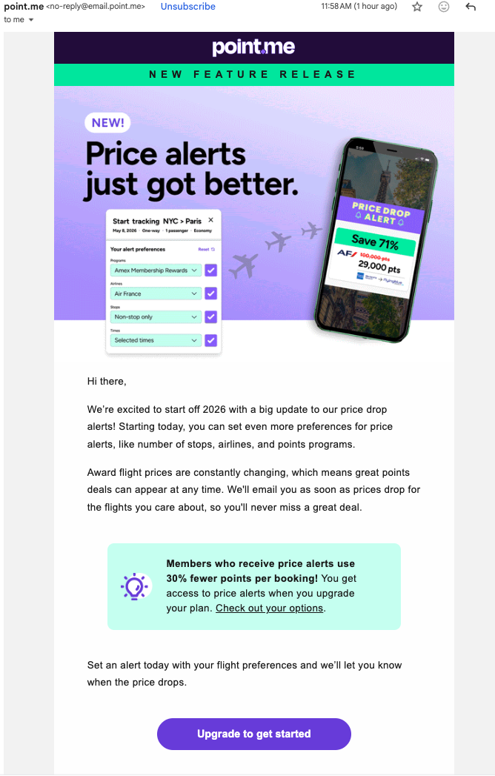

Summary of the Competitive Analysis

REWARDWISE COMPETITIVE ANALYSIS REPORT

**SECTION 1- SUMMARY**

The travel rewards optimization market presents an significant opportunity of $5.4 billion for RewardWise. All competitors excel at showing options but fail to provide decisive recommendations. While tools Hopper, Gondola, [Point.me](http://point.me), Point.yeah, awardtravel and others display comprehensive search results, they leave users overwhelmed with decision paralysis. RewardWise's unique value proposition—delivering clear verdicts instead of just options—addresses the core unmet need in this market: judgment under uncertainty.

Our competitors, such as Point.me show 47 options in P50 109 seconds and still leave users guessing. We win user trust by delivering one recommendation, cash or points or both in under 10 seconds e.g. "Transfer 70K Chase to Air France, book AF123, save $4,200" because users don't want more choices, they want the right answer. Our survey proves the gap is confidence, not information - 64% of respondents said their core pain is "not knowing if it's worth it," 49% waste time double-checking multiple sources, and 69% want "absolute best value," yet every competitor makes this worse by surfacing more data instead of making the decision for them. Our AI verdict scales at zero marginal cost while Point.me's $200/passenger concierge scales with headcount. This product design advantage means we can undercut their $129-260/year pricing by 50-80% while serving 10x the users without 10x the cost, which is the fundamental requirement for winner-take-all dynamics. Further, the B2B corporate travel market is a $750M opportunity with zero competition. Assuming 30,000+ mid-size companies that $500K-$2M annually on travel with zero points optimization strategy, we assume that these companies leave $200K-$500K in unrealized value on the table each year, and not a single competitor (Point.me, PointsYeah, Gondola) offers enterprise portfolio management or corporate policy integration. Based on our competitor analysis and product positioning, we recommend pursuing B2C (MVP) and B2B (post MVP) because they reinforce each other. Individual users validate the product at near-zero CAC(customer acquisition cost), then champion RewardWise at their companies, converting a $99/year subscriber into a $25K/year enterprise contract with 12-month commitments and switching costs that Point.me's $38.5M in funding can't easily disrupt.

**MARKET SIZE**

| **Metric** | **Values** | **Significance** |
| --- | --- | --- |
| TAM | $5.4 billion | Value lost annually by international points users |
| SAM | $685 million | Revenue RewardWise can capture at scale |

**TAM CALCULATION**

U.S. international travelers (~2025): 107.7 million people

What % use points/miles for redemptions?

Travelers × Use points: 107.7M × 50% = 53.85 million people (Points users)

What's the value of their point redemptions?

Average points redeemed per user annually: 50,000 points

Industry average for active international travelers

* Light users: 25K-30K points/year
* Heavy users: 100K+ points/year
* Average: ~50K points/year
* References: The Points Guy, Frequent Miler annual surveys

Average redemption value at current rates: 50,000 × $0.015 = $750

Total current redemption value: 53.85M × $750 = $40.4 billion annually

How much value are they LOSING?

Current average redemption: 1.5¢ per point

Optimal redemption (with tool): 2.5¢ per point

Value gap: 1.0¢ per point

Active points users seeking optimization: 53.85M × 20% = 10.77 million (Addressable users)

Value lost per user: $500/year × 10.77M = $5.4 billion(REALISTIC TAM)

**SAM CALCULATION**

Of TAM users, how many use platforms for booking?

= 10.77 million × 85%

= 9.15 million (Digital platform users)

What's their total redemption value?

Platform users: 9.15 million

Average points redeemed per year: 50,000 points

Current redemption value: $750 per user

Total current redemption value: 9.15M × $750 = $6.86 billion annually

What value can RewardWise serve/improve?

Platform users: 9.15 million

Value gap per user: $500/year

(from TAM calculation - difference between current 1.5¢ and optimal 2.5¢)

Total addressable value gap: 9.15M × $500 = $4.58 billion

But RewardWise can't serve everyone at once. Realistic serviceable market:

Platform users who would benefit × Realistic reach (Year 5-7 scale): 9.15M × 15%

= 1.37 million users (Users RewardWise can serve)

SAM = Value per user we can improve × Serviceable users

= $500/year × 1.37M

= $685 million

**SECTION 2- THE CRITICAL MARKET GAP**

All competitors show OPTIONS. None give THE VERDICT:

• Point.me: Shows 47 ways to book (109 seconds) - user must decide

• PointsYeah: Shows all flights (24 seconds) - user must interpret

• Gondola: Shows cash vs. points comparison - user must choose

• RewardWise opportunity: "Transfer 70K Chase→Air France, Book AF123 June 15, Save $4,200"

**SECTION 3- MARKET LANDSCAPE**

COMPETITIVE CATEGORIES

1. Discovery Engines

Competitors: Seats.aero, AwardTool, PointsYeah, Roame

Target Persona: Flexible travelers seeking good redemption value

Value Proposition: "I want to fly Business Class to Europe this summer with points"

User Pain Points:

• Must decide if redemption is worth it

• Must verify phantom availability

• Manual booking still required in some cases

2. Concierge Services

Competitors: Point.me, Gondola

Target Persona: Beginners / Busy Executives

Value Proposition: "Find and book for you"

User Pain Points:

• Must trust unfamiliar service

• Back-and-forth delays in time-sensitive situations

3. Cash-Based Services

Competitors: Hopper, Google Flights

Target Persona: Average travelers

Value Proposition: Clean UX to show cash values

User Pain Points:

• Not using accumulated points (missing optimization opportunity)

**DETAILED COMPETITOR ANALYSIS**

TABLE 1: FEATURE COMPARISON MATRIX

| **Feature** | [**Seats.aero**](http://seats.aero) | **AwardTool** | **PointsYeah** | [**Point.me**](http://point.me) | **Gondola** |
| --- | --- | --- | --- | --- | --- |
| **Search Range** | 14 days (free) / 1 year (paid) | 4 days (free) / 32 days (paid) | 4 days (free) / 8 days (paid) | 1 day (free) / 60 days (paid) | Real-time |
| **Pricing** | $10/month | $10/month | $20/month | $10.75/month | FREE |
| **Transfer Path Guidance** | No | Yes | Yes + Bonuses | Yes | N/A |
| **Inventory Accuracy** | Highly Accurate | Good | Good | Poor | Good |
| **Multi-Airport Search** | Yes | Yes | No (search) / Yes (explorer) | No | N/A |
| **Price Alerts** | Unlimited (Pro) | Yes | Yes (paid only) | 4 (free) / 32 (premium) | Automatic |

TABLE 2: COMPETITIVE CATEGORIES

| **Category** | **Competitors** | **Target Persona** | **User Still Must Do** |
| --- | --- | --- | --- |
| **Discovery Engines** | Seats.aero, AwardTool, PointsYeah, Roame | Flexible travelers seeking value | Decide if worth it; Verify phantom availability; Call to book sometimes |
| **Concierge Services** | Point.me, Gondola | Beginners / Busy Executives | Trust the service; Accept back-and-forth delays |
| **Cash-Based Services** | Hopper, Google Flights | Average travelers | Not using their points |
| **DIY Community** | Reddit, FlyerTalk, blogs | Advanced travelers | Invest time + expertise |
| **Human Concierge** | WhatsApp/WeChat agents | Premium Asian travelers | Trust + Accept delays |

TABLE 3: B2B VS B2C COMPARISON *(B2B is out of scope for bootcamp)*

| **Factor** | B2B | B2C |
| --- | --- | --- |
| **Contract Value** | $25K-$50K annually | $119 annually |
| **Customer Lifetime Value** | High (multi-year contracts) | Lower (annual subscriptions) |
| **Sales Cycle** | Longer (3-6 months) | Immediate (self-service) |
| **Churn Rate** | Low (high switching costs) | Higher (easy to cancel) |
| **Revenue Predictability** | High (annual contracts) | Moderate |
| **Market Size** | $750M (potentially larger) | Significant but smaller |
| **Competition** | Zero (blue ocean) | Several competitors |
| **Time to First Revenue** | Slower (pilot programs) | Faster (launch and scale) |

TABLE 4: Competitive Benchmarking Analysis

| **Value Proposition Dimensions** | **Gondola.ai** | | **AwardTravel** | | **PointMe** | |
| --- | --- | --- | --- | --- | --- | --- |
| **Core Features** | **Rating** | **Core Features** | **Rating** | **Core Features** | **Rating** |
| **Feature 1: Decision Making** | Shows cash vs points CPP comparison.  User decides. | ★★★☆☆ | Calendar view of availability. User decides dates/program. | ★★☆☆☆ | Shows 47 options across 30+ programs. User decides. | ★★☆☆☆ |
| **Feature 2: Search Coverage** | Hotels only. 4 major chains (Marriott, Hyatt, Hilton, IHG) | ★★☆☆☆ | 15+ programs. Good flight coverage. | ★★★★☆ | 30+ programs, 150+ airlines. Most comprehensive. | ★★★★★ |
| **Feature 3: Speed** | Real-time hotel search. Fast results. | ★★★★☆ | Fast calendar loads. Quick availability checks. | ★★★★☆ | Slowest: 109 sec avg. Comprehensive but slow. | ★★☆☆☆ |
| **Aesthetics** | Clean, modern AI-first interface. Simple design. | ★★★★★ | Calendar-focused UI. Clean and functional. | ★★★★☆ | Professional but dense. Information overload. | ★★★☆☆ |
| **Usability** | Simplest: cash vs points clearly shown. Low expertise. | ★★★★★ | Intuitive calendar. Easy to understand availability. | ★★★★☆ | Requires points expertise to interpret 47 options. | ★★☆☆☆ |
| **Performance** | Automatic price monitoring. Auto rebooking on drops. | ★★★★★ | Real-time award availability. Reliable data. | ★★★★☆ | Step-by-step booking instructions. Finds hidden routes. | ★★★★☆ |
| **Durability/Reliability** | 2yr old launch of 2024. Early stage, unproven. | ★★☆☆☆ | Established tool. Consistent performance. | ★★★★☆ | Series B funded ($38.5M). Most stable. | ★★★★★ |
| **Serviceability** | Email support. AI-first, minimal human touch. | ★★☆☆☆ | Email support. Community forums. | ★★★☆☆ | Premium concierge $200/pax. Email support. | ★★★★☆ |
| **Cost** | Completely FREE. Makes money on 3-7% cashback. | ★★★★★ | Free basic. Premium features available. | ★★★★☆ | Free limited, Premium $260/yr, Concierge $200/pax. | ★★☆☆☆ |
| **Total** |  | 33 |  | 33 |  | 29 |

**TARGET USER SEGMENTS**

RewardWise can serve seven distinct direct user segments, all of whom share a common pain point: decision paralysis from information overload.

| **#** | **Segment** | **Pain Point Quote** |
| --- | --- | --- |
| 1 | Overwhelmed Optimizer | 500K points, 8 hours research, still don't know if I chose right |
| 2 | Aspiring Points Hacker | Don't even know what questions to ask |
| 3 | Business Traveler | 2M points, zero time to research |
| 4 | Small Business Owner | Spending $500K/year, no optimization strategy |
| 5 | Family Gifter | Want to gift travel to grandkids, don't understand how |
| 6 | Special Trip Planner | Honeymoon - CANNOT mess this up |
| 7 | Travel Advisors | Clients expect points expertise, I don't have it |

PRIMARY SEGMENTS

1. Overwhelmed Optimizer: "500K points, 8 hours of research, still don't know if I chose right"

2. Aspiring Points Hacker: "Don't even know what questions to ask"

3. Business Traveler: "2M points, zero time to research"

4. Small Business Owner: "Spending $500K/year, no optimization strategy"

5. Family Gifter: "Want to gift travel to grandkids, don't understand how"

6. Special Trip Planner: "Honeymoon - CANNOT mess this up"

7. Travel Advisors: "Clients expect points expertise, I don't have it"

**UNMET MARKET NEEDS**

Existing tools help users find options but fail to help them decide with confidence. The core unmet need is not search or booking, but judgment under uncertainty.

SCENARIO 1: PLANNED TRIP WITH AVAILABILITY

User Struggles:

• Cannot determine which option is actually best given their current pool of points

• Unclear on tradeoffs across programs, fees, routing, flexibility

• Don't know where to double-check when results conflict or appear phantom

• When points are insufficient, lack clear guidance on next steps

Why Existing Tools Fail:

• Surface availability but don't explain WHY one option is preferable

• Execution guidance is fragmented and assumes prior expertise

• Users are left second-guessing and validating elsewhere (Reddit, blogs)

SCENARIO 2: PLANNED TRIP WITHOUT AVAILABILITY

User Struggles:

• Want to know whether to wait, pivot, or abandon the plan

• Unclear which airlines or programs are worth monitoring

• Don't know what's worth setting alerts for

Why Existing Tools Fail:

• Can notify when something changes, but not what to focus on

• No guidance on strategy during downtime

• Leads to frustration or over-monitoring

**REWARDWISE COMPETITIVE POSITIONING**

MARKET RISKS & STAKEHOLDER TENSIONS

| **Stakeholder** | **Interest/Tension** | **Risk Level** |
| --- | --- | --- |
| **Credit Card Companies** | Want users earning points BUT redeeming at LOW value (more profitable for them) | Medium - May not partner if optimization reduces their profit |
| **Airlines** | Want award flexibility but resist scrapers; Dynamic pricing creates tension | Medium - May block access or change policies |
| **Hotels** | Similar to airlines - want control over award availability | Medium - May restrict data access |
| **Regulators (CFPB/DOT)** | 1,200+ complaints filed; Investigating devaluations; Consumer protection concerns | Low-Medium - Could increase transparency requirements |
| **OTAs (Online Travel Agencies)** | Lose commission on award bookings | Low - Different business model |
| **Corporate Card Issuers** | Potential partners for B2B distribution | Low - Aligned interests in B2B |

UNIQUE VALUE PROPOSITION

RewardWise is positioning as the first B2C decision engine in the travel rewards space. Along with competitors function as search tools (B2B infrastructure thinking), RewardWise provides actionable verdicts.

**THE COMPETITIVE ADVANTAGE**

Example Output:

"Transfer 70,000 Chase points to Air France. Book Flight AF123 on June 15. This saves you $4,200 versus paying cash."

Competitor Output:

• Point.me: "Here are 47 ways to book this flight" (109 seconds)

• PointsYeah: "Here are all flights in the next 8 days" (24 seconds)

• Gondola: "Cash is $200 or 25K points at 1.2¢ per point"

**B2B MARKET OPPORTUNITY: CORPORATE TRAVEL OPTIMIZATION**

THE UNTAPPED B2B SEGMENT

While the B2C market shows clear opportunity, the B2B corporate travel segment represents an even larger, completely underserved market. Companies with employees who travel frequently for work are hemorrhaging value by failing to optimize their travel rewards strategy.

THE CORPORATE PAIN POINT

Current State:

• Companies spend millions on corporate travel (average mid-size company: $500K-$2M annually)

• Employees book through corporate cards, accumulating massive points

• Zero strategy for optimizing these points across the organization

• Travel managers have no tools to track, optimize, or leverage collective points portfolios

• Individual employees optimize (or fail to optimize) in isolation

• Companies leave hundreds of thousands of dollars in value on the table annually

What Companies Are Missing:

• Consolidated view of all employee points across programs

• Strategic guidance on which cards to use for which bookings

• Optimization across the entire organization's points portfolio

• Clear ROI on travel spend through points maximization

• Ability to pool or strategically allocate points for high-value company trips

REWARDWISE B2B VALUE PROPOSITION (future scope)

For Corporate Travel Managers:

"Turn your $2M travel spend into $2.5M in travel value through intelligent points optimization across your organization."

What RewardWise B2B Delivers:

1. Enterprise Dashboard

• Real-time visibility into all employee points portfolios

• Aggregate view of company-wide points value ($XXX,XXX in redeemable value)

• Track points accumulation and redemption patterns

• Identify optimization opportunities across departments

2. Corporate Card Strategy

• Recommend which corporate cards to use for specific booking types

• Maximize points earning across different travel categories

• Suggest strategic transfers between programs

• Calculate true ROI on different card programs

3. Booking Optimization

• When employee needs to book travel, RewardWise analyzes:

- Company's aggregate points portfolio

- Best redemption option across all available programs

- Whether to use points or cash based on current availability and value

- Which employee's points should be used (if pooling strategy exists)

4. Policy Integration

• Integrates with corporate travel policies

• Ensures compliance while maximizing value

• Provides pre-approved booking recommendations

• Tracks savings vs. cash bookings

5. Executive Travel Premium Service

• White-glove service for C-suite and board travel

• Complex international itineraries

• Premium cabin optimization

• 24/7 support for travel disruptions

THE B2B BUSINESS MODEL

Target Customer Profile:

• Companies with (50-100) employees/single owner/ sole prop who travel regularly(for more than 100 employees the company has process that does end-to-end execution like [SAP Concur](https://www.concur.com/lp/travel-policy?pid=ppc&cid=us_goo_web_ph_travel_policy&ef_id=Cj0KCQiAhaHMBhD2ARIsAPAU_D46evlzN7NLLwgqM0CyHzK5PpZbJDx4taePoS1NGMKKGdABkGhcXYkaAskJEALw_wcB:G:s&s_kwcid=AL!5224!3!590730702177!p!!g!!company%20travel%20policy!631337949!39835794719&gad_source=1&gad_campaignid=631337949&gbraid=0AAAAAD3bfZ7qrPelx6g54CPxL63IMXnVb&gclid=Cj0KCQiAhaHMBhD2ARIsAPAU_D46evlzN7NLLwgqM0CyHzK5PpZbJDx4taePoS1NGMKKGdABkGhcXYkaAskJEALw_wcB)

• Annual corporate travel spend of $500K+

• Industries: Consulting, sales organizations, professional services, tech companies

• Currently using corporate cards (Amex, Chase, Citi) with no optimization strategy

Sales Strategy:

• Partner with corporate card issuers (Amex Business, Chase Ink)

• Integrate with corporate travel management companies (Concur, TripActions)

• Target CFOs and Travel Managers with ROI-focused messaging

• Case studies showing $200K-$500K annual savings for mid-size companies

Risk/Challenges

Current competitors are focused on individual consumer tools:

• Point.me: Individual search, no enterprise features

• PointsYeah: DIY tool for personal use

• Gondola: Hotels only, individual travelers

• Hopper: Cash bookings, no B2B offering

None have:

• Multi-user portfolio management

• Corporate policy integration

• Enterprise-grade security and permissions

• Consolidated reporting and analytics

• Strategic optimization across an organization

This creates a blue ocean opportunity for RewardWise.

THE B2B COMPETITIVE MOAT

Once RewardWise is embedded in a company's travel workflow:

• High switching costs (integration with existing systems)

• Network effects (more employees = more optimization opportunities)

• Data moat (learning company-specific travel patterns and preferences)

• Contract length (annual enterprise agreements)

• Strategic value increases over time as points accumulate

**MARKET SIZE ESTIMATE**

Total Addressable Market (TAM):

• 6M+ businesses in US with employees who travel

• Average potential customer: $1M travel spend, 50 traveling employees

• Conservative capture: 0.5% market penetration = 30,000 companies

• Average contract value: $25,000/year

• Market opportunity: $750M annually

This B2B segment alone could be larger than the entire B2C travel rewards optimization market.

**B2B GO-TO-MARKET STRATEGY**

Phase 1: Pilot Program (Months 1-6)

• Identify 10-20 ideal pilot companies

• Offer discounted rate in exchange for case study rights

• Focus on companies with $1M+ travel spend

• Measure and document ROI rigorously

• Refine product based on enterprise feedback

Phase 2: Channel Partnerships (Months 6-12)

• Partner with American Express, Chase, Citi for corporate card programs

• Integrate with Concur, TripActions, Navan (corporate travel platforms)

• Join corporate card issuer referral networks

• Co-marketing with travel management companies

Phase 3: Direct Sales (Months 12-24)

• Build enterprise sales team

• Target Fortune 5000 companies

• Attend corporate travel conferences

• Leverage case studies and ROI calculators

• Expand to international markets

**WHY B2B SHOULD BE A STRATEGIC PRIORITY**

1. Higher LTV: Enterprise contracts worth $25K-$50K vs. individual subscriptions at $119

2. Lower Churn: Annual contracts with high switching costs

3. Predictable Revenue: B2B contracts provide stability for growth

4. Market Leadership: First-mover advantage in completely untapped segment

5. Competitive Moat: Enterprise features create barriers to entry

6. Expansion Revenue: Start with travel optimization, expand to other corporate perks

7. Validation: Corporate customers validate the technology for B2C market

**HYBRID B2B/B2C STRATEGY**

RewardWise should pursue both markets simultaneously:

B2C Provides:

• Faster initial traction and validation

• User feedback for product development

• Consumer brand recognition

• Individual travelers who can champion tool to their employers

B2B Provides:

• Larger contract values and higher margins

• Revenue stability and predictability

• Competitive differentiation

• Proof of enterprise-grade capability

The flywheel effect: Individual users discover RewardWise personally, then request it for their company. Companies adopt RewardWise, employees become power users, they continue subscription even after changing jobs.

**MARKET OPPORTUNITIES**

UNDERSERVED SEGMENTS

Several lucrative market segments remain completely underserved by existing competitors:

• Small and Medium Businesses (SMBs) - $500K+ annual spend with no optimization strategy

• Corporate travel departments - no tool for employee points strategy

• Family gifting - grandparents wanting to gift travel but lacking expertise

• Wealth advisors - cannot advise on $10K-$50K points portfolios

TECHNOLOGY GAPS

• No multi-wallet optimization across different points programs

• No personalization or learning from user preferences

• No proactive intelligence ("book now" vs "wait for better availability")

• No decision-making layer - all competitors only show options

• No enterprise-grade B2B solutions for corporate travel optimization

**RISKS AND CONSIDERATIONS**

INDUSTRY STAKEHOLDER TENSIONS

Credit Card Companies: Complex relationship - want users earning points (beneficial) but redeeming at low value (profitable for them)

Airlines & Hotels: Desire award space flexibility but resist scrapers; dynamic pricing creates tension

Regulators (CFPB/DOT): 1,200+ complaints filed, investigating devaluations; consumer protection concerns around transparency

MARKET FUNDING LANDSCAPE

While AI captured 50% of VC funding in 2025 ($211B total), travel rewards tools are NOT receiving mega-funding. Most competitors are bootstrap or early stage, with Point.me being the notable exception (Series B, $38.5M raised). This creates opportunity for a well-executed product to capture market share.

**COMPETITIVE INTELLIGENCE: USER ONBOARDING**

GONDOLA.AI ONBOARDING FLOW

Gondola demonstrates best-in-class onboarding with several lessons for RewardWise:

• Interactive "How it works" CTA creates curiosity before commitment

• Clearly explains security and data sharing upfront (builds trust)

• Offers multiple connection options: email integration, forward reservations, or manual entry

• Shows immediate value: "See all hotel points, cashback, and credit card rewards in one account"

POINTSYEAH FEATURES

Travel Radar (Premium Exclusive):

• Tracks up to 4 routes for full 365 days

• Periodically refreshes to show availability and pricing

• Clean calendar view highlights lowest points days

• Smart filters by cabin, stops, airlines, transfer programs

• At-a-glance insights show new availability and recent price drops

Points Price Alerts: Best for precision - monitors specific 8-day windows, 4 alerts for free users, 32 for premium

**CONCLUSIONS AND STRATEGIC RECOMMENDATIONS**

KEY FINDINGS

1. Market Gap is Clear: Every competitor shows options; none provide decisive recommendations. This is RewardWise's core opportunity.

2. User Pain Point is Universal: "Just tell me what to do" - decision paralysis from information overload affects all user segments.

3. Pricing Advantage: RewardWise can undercut Point.me by 54-80% while delivering superior value through decision-making.

4. Multiple Underserved Segments: SMBs, corporate travel, family gifting, and wealth advisors represent significant untapped markets.

5. B2B Opportunity is Massive: Corporate travel optimization represents a potentially larger market than B2C, with zero competition and higher contract values.

6. Funding Landscape is Favorable: Limited VC activity in this space creates opportunity for well-executed product to capture share.

STRATEGIC RECOMMENDATIONS

1. Lead with Decision-Making: Position RewardWise as the first true B2C decision engine, not just another search tool. The verdict is the product.

2. Focus MVP on Planned Trips with Availability: This is where users feel most pain ("which option is best?") and where RewardWise can deliver immediate differentiated value.

3. Pursue Hybrid B2B/B2C Strategy: Launch with B2C for rapid validation and user feedback, but simultaneously develop B2B enterprise features. The B2B market offers higher LTV, lower churn, and represents a blue ocean opportunity.

4. Prioritize Trust and Transparency: Given regulatory scrutiny and user hesitation, clearly explain how recommendations are made and why they're optimal.

5. Design Onboarding for Curiosity: Follow Gondola's model - create interactive "how it works" experiences before asking for commitment or data access.

6. Build for Multi-Wallet Optimization: This is a technology gap across all competitors and aligns with RewardWise's decision-making positioning. Critical for both B2C and B2B.

7. Target Corporate Travel Managers: Develop enterprise sales motion targeting companies with $500K+ annual travel spend. Partner with corporate card issuers and travel management platforms.

8. Create Enterprise Pilot Program: Identify 10-20 ideal companies for pilot program, measure ROI rigorously, build compelling case studies to fuel sales pipeline.

9. Consider B2B Partnerships Early: Integrate with Amex Business, Chase Ink corporate programs and TMCs like Concur. These partnerships can accelerate enterprise adoption.

10. Build Competitive Moats: Enterprise integration, multi-user portfolio management, and corporate policy integration create high switching costs that protect against future competition.

**FINAL THOUGHT**

The travel rewards optimization market is mature in terms of search infrastructure but nascent in terms of decision intelligence. RewardWise has the opportunity to be the first mover in solving the real problem: not showing users what's available, but telling them what to do.

The B2B corporate travel market represents an even larger opportunity - a blue ocean with zero competition, higher contract values, and strong competitive moats once established. By pursuing a hybrid B2B/B2C strategy, RewardWise can capture both markets simultaneously, with each reinforcing the other.

The question is not whether there's market opportunity - it's whether RewardWise can execute faster than potential competitors can recognize this gap.

[Competitive Analysis Tables](https://docs.google.com/spreadsheets/d/17aPnRHl3nj1yLuiwokyNDEPMD01pqvkAiqgVD8bKOL8/edit?usp=sharing)

Resources:

<https://www.pointsyeah.com/travel-radar>

<https://www.gondola.ai/how-it-works>

<https://www.point.me/how-it-works>

<https://www.hopper.com>

<https://www.seats.aero>

<https://roame.travel/features>

<https://business.booking.com>

<https://www.amexglobalbusinesstravel.com>

<https://navan.com>

<https://www.google.com/flights>

<https://www.businesstravelnews.com>

<https://www.businesstravelnews.com/Suppliers/Travel-Management>

<https://skift.com>

<https://www.phocuswright.com>

<https://thepointsguy.com>

<https://frequentmiler.com>

<https://www.doctorofcredit.com>

<https://onemileatatime.com>

<https://www.chase.com/personal/credit-cards/rewards>

<https://www.citi.com/credit-cards/citi-thankyou-rewards>

<https://www.aa.com/i18n/aadvantage-program/overview.html>

<https://pitchbook.com>

<https://www.ustravel.org>

<https://www.gbta.org>

<https://www.expertflyer.com>

<https://www.transportation.gov>

<https://www.squaremouth.com/travel-advice/us-tourism-statistics>

<https://passport-photo.online/blog/online-travel-booking-statistics>

<https://www.trade.gov/feature-article/january-2025-air-passenger-travel>

<https://www.americanexpress.com/en-us/travel/discover/get-inspired/global-travel-trends>

<https://theharrispoll.com/briefs/more-than-a-getaway-new-data-reveals-a-deeper-purpose-for-travel-in-2026/>

Reddit Communities

<https://www.reddit.com/r/awardtravel/>

<https://www.reddit.com/r/churning/>

<https://www.reddit.com/r/CreditCards/>

<https://www.reddit.com/r/travel/>

Competitive Analysis-Eshma

### **1. Competitor UX Analysis: Top 5 Identified**

In 2026, the industry standard has moved toward **Agentic AI**—systems that evaluate options and act on a user’s behalf rather than just displaying lists.

| **Competitor** | **UX Status vs. 2026 Standard** | **Primary UX Limitation** | **Key UX Strength** |
| --- | --- | --- | --- |
| **RewardWise** | **Industry Leader (Proposed).** Delivers actionable "Verdicts" in <15s, fulfilling the 2026 demand for cognitive relief. | New to market; requires rapid trust-building for automated booking. | **The Verdict:** Single actionable recommendation; B2B optimized. |
| **Point.me** | **Lacking.** Search speed (109s) and massive lists (47+ options) create decision fatigue. | High friction; slow search; "phantom" availability issues. | Most comprehensive airline coverage (30+ programs). |
| **PointsYeah** | **Meeting Search Standards.** Fastest DIY search (24.6s) with strong "Explorer" tools. | Purely search-based; no decision guidance or "verdicts". | Speed; best free-tier features for power users. |
| **Gondola.ai** | **Meeting Technical Standards.** Closest to the "Agentic" model for hotel cash vs. points math. | Limited to hotels only; only supports 4 major chains. | Best-in-class onboarding flow and price monitoring. |
| **Seats.aero** | **Lacking (UI/UX).** High accuracy but designed exclusively for technical power users. | Poor UI/UX; requires knowledge of airport codes/cached data. | Superior raw data accuracy and real-time speed. |

### **2: Documented Industry User Flows**

This table outlines the current "Manual Interpretation" flows found in the 2026 market compared to the RewardWise **Agentic "Verdict"** model.

| **Competitor** | **Flow Architecture** | **Avg. Search Time** | **Primary User Action** | **UX Friction Point** |
| --- | --- | --- | --- | --- |
| **RewardWise** | **Agentic "Verdict"** | **<15 seconds** | **Executes Verdict** | Requires initial trust in AI-led recommendations. |
| **Point.me** | Linear Search Loop | 109 seconds | Manual Comparison | Extreme "Decision Fatigue" from 47+ options. |
| **PointsYeah** | DIY Precision Flow | 24.6 seconds | Filter & Sort Data | No guidance; users must interpret all raw data. |
| **Gondola.ai** | Onboarding-First | Instant (Hotel Only) | Compare Cash vs. Points | Flow is limited to 4 specific hotel chains. |
| **Seats.aero** | Power-User Data Flow | <5 seconds (Cached) | Technical Filtering | Poor UI requires knowledge of airport/booking codes. |

### **3: RewardWise Positioning (Pros/Cons)**

This table identifies the "Competitor Gaps" by name and shows how RewardWise solves these systemic industry failures.

| **Identified Gap** | **Description of Market Failure** | **RewardWise Strategic Solution** |
| --- | --- | --- |
| **Decision Layer** | **Point.me & PointsYeah** show options but provide no actual recommendations. | **The Verdict:** A single, data-backed booking recommendation. |
| **Multi-Wallet Use** | **All Competitors** fail to optimize across combined portfolios (e.g., Amex + Chase). | **Portfolio Integration:** API-linked multi-wallet optimization. |
| **Proactive Intel** | **PointsYeah & Gondola** alert you to drops but don't advise "wait vs. book". | **Proactive Guidance:** Advises on timing based on historical availability. |
| **Enterprise B2B** | **Zero current tools** exist for corporate travel rewards optimization. | **B2B Dashboard:** Centralized view of employee points for CFOs. |
| **Personalization** | **Seats.aero & Point.me** do not learn from user preferences over time. | **Agentic Learning:** UI adapts to user habits (e.g., cabin class, airline bias). |

### **4: Validation Against 2026 Industry Standards**

To validate your approach, RewardWise is measured against the **2026 Agentic AI and B2B CTO (Corporate Travel Optimization)** benchmarks.

| **2026 Industry Benchmark** | **Performance: Competitors** | **Performance: RewardWise** | **Strategic Alignment Status** |
| --- | --- | --- | --- |
| **Agentic Initiative** | **Low.** Apps like **Point.me** are passive; they wait for user prompts. | **High.** Proactively issues "Verdicts" and transfer advice. | **Good.** Aligns with the shift toward AI "acting on behalf of guests". |
| **Cognitive Relief** | **Poor.** **Seats.aero** and others force users to do heavy mental math. | **Excellent.** Designed specifically to solve decision paralysis. | **Good.** Addresses the "Zero-Touch Travel" standard of 2026. |
| **Multi-Wallet Use** | **Non-Existent.** No competitor optimizes across combined Amex/Chase portfolios. | **Primary Feature.** Unified optimization of all linked accounts. | **Good.** Meets the requirement for unified "Guest-Centric Data Architectures". |
| **Enterprise B2B** | **Zero.** Entirely focused on the individual "Hobbyist" market. | **Blue Ocean.** Dedicated dashboard for corporate travel managers. | **Good.** Captures the unserved **$750M CTO market**. |
| **Explainability** | **Variable.** **PointsYeah** is transparent; others have "phantom" data. | **Core Pillar.** Every "Verdict" includes a clear, human-readable rationale. | **Good.** Complies with 2026 "Right to Explanation" and trust standards. |

Resources:

<https://www.pointsyeah.com/travel-radar>

<https://www.gondola.ai/how-it-works>

<https://www.point.me/how-it-works>

<https://www.hopper.com>

<https://www.seats.aero>

<https://roame.travel/features>

<https://business.booking.com>

<https://www.amexglobalbusinesstravel.com>

<https://navan.com>

<https://www.google.com/flights>

<https://www.businesstravelnews.com>

<https://www.businesstravelnews.com/Suppliers/Travel-Management>

<https://skift.com>

<https://www.phocuswright.com>

<https://thepointsguy.com>

<https://frequentmiler.com>

<https://www.doctorofcredit.com>

<https://onemileatatime.com>

<https://www.chase.com/personal/credit-cards/rewards>

<https://www.citi.com/credit-cards/citi-thankyou-rewards>

<https://www.aa.com/i18n/aadvantage-program/overview.html>

<https://pitchbook.com>

<https://www.ustravel.org>

<https://www.gbta.org>

<https://www.expertflyer.com>

<https://www.transportation.gov>

Reddit Communities

<https://www.reddit.com/r/awardtravel/>

<https://www.reddit.com/r/churning/>

<https://www.reddit.com/r/CreditCards/>

<https://www.reddit.com/r/travel/>

Roadmap

# Roadmap

1. **Week 1:** AI 101 and program kick off. Monday, January 19 @ 8pm EST - with Dr. Nancy Li
2. **Week 2:** AI PM life cycle. Monday, January 26 @ 8pm EST - with Dr. Nancy Li
3. **Week 3:** AI models and LLM. Monday, February 2 @ 8pm EST - with Mentor Mark Walker
4. **Week 4:** Advanced AI. Monday, February 9 @ 8pm EST - with Mentor Mark
5. **Week 5:** Cross-functional team collaboration. Monday, February 16 @ 8pm EST - with Dr. Nancy and Mentor Mark
6. **Week 6:** Go-to-market strategy. Monday, February 23 @ 8pm EST - with Dr. Nancy
7. **Week 7:** Advanced Prompt Engineering, Monday, March 2 @ 8pm EST - with Mentor Mark
8. **Week 8:** AI Model Evaluation, Prototyping & Building with No-Code Tools, Monday, March 9 @ 8pm EST - with Mentor Mark
9. **Week 9:** AI Product Portfolio Development, Monday, March 16 @ 8pm EST - with Dr. Nancy
10. **Week 10:** 1:1 Resume Review (no live group coaching, on-demand schedule), from Monday, March 23
11. **Week 11:** PM interview questions and answers. Monday, March 30 @ 8pm EST - with Dr. Nancy Li

Project Management

| Team directory | | |
| --- | --- | --- |
| People Name | Dropdowns Role | No type Location |
| [Sarabjit Nagi](mailto:sarabjit.nagi@gmail.com) | Lead | [Kirkland](https://www.google.com/maps/place/Kirkland/data=!4m2!3m1!19sChIJe85SKMASkFQRVyh4cKpqd3o) |
| [anshujoshi240@gmail.com](mailto:anshujoshi240@gmail.com) | PM | [Toronto](https://www.google.com/maps/place/Toronto/data=!4m2!3m1!19sChIJpTvG15DL1IkRd8S0KlBVNTI) |
| [autumnlirec@gmail.com](mailto:autumnlirec@gmail.com) | PM | [San Francisco](https://www.google.com/maps/place/San+Francisco/data=!4m2!3m1!19sChIJIQBpAG2ahYAR_6128GcTUEo) |
| [Smital Kamdi](mailto:smitalkamdi@gmail.com) | PM | [San Francisco](https://www.google.com/maps/place/San+Francisco/data=!4m2!3m1!19sChIJIQBpAG2ahYAR_6128GcTUEo) |
| [seba.icik@gmail.com](mailto:seba.icik@gmail.com) | Design | [Buenos Aires](https://www.google.com/maps/place/Buenos+Aires/data=!4m2!3m1!19sChIJvQz5TjvKvJURh47oiC6Bs6A) |
| Person | Data Science | Place |
| Person | Developer | Place |

Pitch

1. Rachel Phan
2. Arjun Mamidala
3. surya ramadoss
4. Srinidhi Avala
5. Sai samyuktha Maturi
6. Ishvir Chopra
7. Jaya krishna
8. Dev Patel

## 

**5-Second Pitch**

Networking intros, "what are you working on?"

"I help people stop wasting their credit card points. You tell me where you want to fly, I tell you exactly: use points, pay cash, or wait—so you save hundreds."

**30-Second Pitch**

Elevator encounters, quick introductions

"You know how most people have points scattered across 3 or 4 credit cards and airline programs? They spend hours researching—or just give up and pay cash.

RewardWise does the math for you. You tell me your trip and your balances, I tell you exactly which points to transfer where—or whether to pay cash and save your points for something better.

Last month I saved a client $800 on a Tokyo flight in 20 minutes. Point.me charges $200 per person for this. I start at $39."

**90-Second Pitch**

Pitch competitions, investor intros

"60 million Americans collect credit card points and take multiple trips a year. Most leave hundreds—sometimes thousands—on the table because the points system is intentionally confusing.

Here's the problem: You've got 80,000 Chase points, 50,000 Amex points, and 40,000 United miles. You want Tokyo. Do you transfer Chase to United? To Hyatt? Book through the portal? Pay cash? There are dozens of paths, and airlines have zero incentive to show you the best one.

Existing tools like Point.me show you 47 options and say 'you decide.' RewardWise does the opposite. You give me your balances and your trip, I give you The Verdict—one clear recommendation: use points, pay cash, or wait. Sometimes that verdict is 'pay cash, your points are worth more for Bali next fall.'

Point.me charges $200 per passenger. RewardWise starts at $39 for domestic, $79 international—or use our self-service AI for $14.99/month unlimited.

I'm validating with a manual concierge now. Goal: 25% free-to-paid conversion in six weeks. Once proven, I automate the scoring engine with real-time availability data.

I'm looking for a UX designer and engineer who wants to build the decision layer between accumulation and redemption. That layer doesn't exist today—and that's exactly why this is wide open."

## 

## **5-Second Pitch**

*Use for: Networking intros, when someone asks "what are you working on?"*

"I help people stop wasting their credit card points. You tell me where you want to fly, I tell you exactly which points to use and how—so you save hundreds."

RewardWise is a points optimization platform that tells travelers exactly how to use their credit card rewards—not just shows them options. We unify balances across programs, calculate the optimal transfer path, and deliver a clear verdict: use points, pay cash, or wait. Our hybrid model combines a self-service subscription starting free with done-for-you concierge starting at $39—65% below competitors. We're targeting 10 million time-constrained travelers sitting on points they don't know how to maximize.

## **30-Second Pitch**

*Use for: Elevator encounters, quick introductions at events*

"You know how most people have points scattered across 3 or 4 credit cards and airline programs? They spend hours researching how to use them—or just give up and pay cash.

I'm building a concierge that does the math for you. You tell me your trip and your balances, and I tell you exactly which points to transfer where—or whether to just pay cash and save your points for something better.

Last month I saved a client $800 on a Tokyo flight in 20 minutes. Point.me charges $200 per person for this. I'm charging $59."

## **90-Second Pitch**

*Use for: Pitch competitions, investor intros, detailed explanations*

"There are 60 million Americans who collect credit card points and take multiple trips a year. Most of them are leaving hundreds—sometimes thousands—of dollars on the table because the points system is intentionally confusing.

Here's the problem: You've got 80,000 Chase points, 50,000 Amex points, and 40,000 United miles. You want to fly to Tokyo. Do you transfer Chase to United? To Hyatt and use Amex for the flight? Book through the Chase portal? Pay cash and save your points? There are literally dozens of paths, and airlines have zero incentive to show you the best one.

Existing tools like Point.me show you 47 options and say 'you decide.' I do the opposite. You give me your balances and your trip, and I give you The Verdict—one clear recommendation with the math to back it up. Sometimes that verdict is 'pay cash, your points are worth more for your Bali trip next fall.'

Point.me charges $200 per passenger for their concierge. I'm charging $59 for a full optimization analysis, delivered in 48 hours.

Right now I'm validating with a manual concierge—Google Form in, personalized verdict out. The goal is 25% conversion from free to paid in the first six weeks. Once that's proven, I'll automate the scoring engine.

I'm looking for a UX designer and an engineer who love travel and want to build the decision layer that sits between points accumulation and redemption. That layer doesn't exist today—and that's exactly why this opportunity is wide open."

## **4-Minute Pitch Script**

**[SLIDE 1 — Title] ~20 sec**

"How many of you have credit card points sitting in an account right now? And how many are confident you're getting maximum value? That's the gap we're solving. I'm [Name], and this is RewardWise—a platform that tells you exactly what to do with your points. Engage your points."

**[SLIDE 2 — Problem] ~45 sec**

"Meet Sarah. She has 150,000 points across Chase, Amex, and United. She wants business class to Tokyo. Cash price: $4,200.

She spends three hours on Google Flights, airline sites, Reddit threads—still not confident. Why? Her Chase points transfer to 14 airlines. Each has different award charts, ratios, availability. No tool tells her which path is best for HER wallet.

And here's the real question she can't answer: should she use points, pay cash, or wait?

If she optimizes correctly, that flight costs 85,000 points plus $42. That's 4.9 cents per point—most people get one cent. She's leaving thousands on the table and doesn't even know it."

**[SLIDE 3 — Solution] ~45 sec**

"RewardWise is your points transporter. Three steps: Scan. Optimize. Go.

First, we unify your balances into one wallet view. Your 50k Chase plus 30k Amex equals 80k Hyatt potential—we show you that.

Second, we calculate the optimal transfer path using real-time award availability. Don't send Chase to United—send it to Air Canada. Same flight, 40% fewer points.

Third, we deliver The Verdict: a clear recommendation. Use points. Pay cash. Or wait—your points are worth more saved for November.

We're not a search engine showing 47 options saying 'you decide.' We tell you what to do."

**[SLIDE 4 — Market & Competition] ~45 sec**

"$27 billion TAM—180 million trip decisions annually at $150 average optimization value. Our serviceable market: $1.5 billion targeting 10 million 'motivated but time-constrained' travelers.

Competition validates demand. Point.me charges $200/passenger—but they show options, not decisions. Gondola proved AI optimization works—but hotels only. AwardWallet tracks 660 programs—but no optimization.

The gap: no one optimizes across your specific multi-program wallet AND tells you cash vs. points vs. wait. That's our lane."

**[SLIDE 5 — Business Model] ~45 sec**

"Two revenue streams.

Self-service subscription: Free tier gets 3 searches/month. Pro at $14.99/month—unlimited searches, full optimization, alerts. Annual at $119 includes two concierge credits.

Done-for-you concierge: Domestic $39. International $79. Flight plus hotel $129. Premium complex—first class, multi-city, expedited—$199.

Point.me charges $200 per passenger. We start at $39. That's 65-80% lower, and we deliver a verdict—not a list."

**[SLIDE 6 — Vision/Ask] ~30 sec**

"The vision: become the Mint.com of travel points. An asset manager for experiences.

Points depreciate 20% annually. We extract maximum value before it's gone.

Six-week targets: 20 users, 10+ paid verdicts, $800+ revenue, $300 average savings.

I'm looking for 2-3 collaborators—UX designer and engineer for scoring logic.

If you love travel and want to build something real, let's talk. Engage your points."

## **3-4 Sentence Summary**

"RewardWise is an AI-powered points optimization platform that delivers a single verdict—use points, pay cash, or wait—not 47 options to figure out yourself. We unify balances across programs, calculate optimal transfer paths with real-time availability, and document the savings. Our hybrid model combines self-service subscriptions (free to $119/year) with done-for-you concierge ($39-$199)—65% below Point.me. We're targeting 10 million time-constrained travelers sitting on points they don't know how to maximize.”

# Jan 27, 2026 Pitch

How many of you have Airline and Hotel, or Credit Card points sitting in an account right now? And how many of you are confident you're getting maximum value from them? That's the gap we're solving. I’m Sabby and this is RewardWise—a platform that tells you exactly what and HOW to Engage your points

Let me introduce you to Sarah. She's sitting on 150,000 points across three programs and wants to fly business class to Tokyo. Sounds great, right?

1. Except she just spent 3 hours on Google Flights, airline websites, and spreadsheets—and she still doesn't know if she found the best deal.

2. Here's the thing: her Chase points can transfer to 14 different airlines. Each has different award charts, different transfer ratios, different availability windows. No tool connects these dots for her specific wallet.

Look at the difference: $4,200 cash versus 85,000 points plus $42 in fees. That’s

3. And should she pay cash or should she pay with points or wait. No single tool tells her that

There are thousands of dollars in savings hiding in plain sight. And Sarah has no idea it exists.

RewardWise fixes this. We're your points transporter. Three steps: Scan, Optimize, Go.

First, we unify your balances into one wallet view. Your 50k Chase plus 30k Amex equals 80k Hyatt potential—we show you that.

Second, we calculate the optimal transfer path. Don't send Chase to Air Canada—send it to United instead. Same flight, 40% fewer points.

Third, we deliver The Verdict: a clear recommendation. Sometimes that's 'use points.' Sometimes it's 'pay cash this time—your points are worth more saved for now.'

We're not a search engine showing you 47 options and saying 'you decide.' We tell you what to do."

The market is massive. 60 million rewards cardholders in the US take roughly 3 trips per year. That's 180 million trip decisions annually. At $150 average optimization value, that's a $27 billion TAM.

Our target: 10 million 'motivated but time-constrained' travelers. They accumulate points intentionally but don't have three hours to research every trip. That's a $1.5 billion serviceable market.

Competition validates demand. Point.me charges $200 per passenger for concierge—and people pay it. Gondola proved AI optimization works for hotels. AwardWallet tracks balances but doesn't optimize. Nobody optimizes flight transfers across your specific wallet. That's our lane

"Two revenue streams. First: self-service subscription. Free tier gets 3 searches a month. Pro at $15/month gives unlimited searches, full optimization, and alerts. Annual at $119 includes two concierge credits.

Second: done-for-you concierge. Domestic flights: $39. International: $79. Flight plus hotel bundle: $129. Premium complex bookings—first class, multi-city, 5+ passengers, or 12-hour expedited: $199.

Point.me charges $200 per passenger. We start at $39. That's 65-80% lower, and we deliver The Verdict—not a list of options."

The vision: an asset manager for your experiences. Points depreciate like currency with 20% inflation. We extract maximum value before it's gone.

Six-week targets: 20 users through intake, 10+ paid verdicts generating $800+ revenue, $300 average value unlocked per user.

I'm looking for 2-3 collaborators—UX designer and engineer for the scoring logic.

If you love travel and want to build something real, let's talk."

# Q&A

1. **Combinatorial scale**: A user with 3 programs facing 14+ transfer partners per program, dynamic availability, and multiple routing options creates thousands of path combinations. AI evaluates these in seconds vs. hours of manual research.
2. **Personalization over time**: AI learns user preferences—do they prioritize luxury or value? Prefer direct flights? Have blackout dates? The system improves with each interaction (RLHF).
3. **Natural language input**: Users say "Tokyo in spring, business class, flexible dates." AI interprets intent without forcing users into rigid search forms.
4. **Opportunity cost reasoning**: "Use points now or save for later?" requires weighing depreciation rates, upcoming trips, seasonal availability patterns—a judgment call AI can model.
5. **Pattern recognition**: AI detects sweet spots (e.g., "United opens partner availability 330 days out") that static rules miss.

Key links

# Key links

1. <https://blog.voyageai.com/2026/01/15/voyage-4/?utm_source=fnf&utm_medium=newsletter&utm_campaign=mongodb-january&utm_term=superhuman-ai&utm_content=voyage-4&_bhlid=a9ba1872f065c68b9f1b11f37f9070c994550d4a>

get 200M tokens at no cost

1. Anshu website- <https://twoyellowjackets.com/>
2. [seats.aero](http://seats.aero) API
3. **Good read on this subject**
   1. [The Economics of Churning: who pays for the rewards?](https://www.reddit.com/r/churning/comments/5oucdq/the_economics_of_churning_who_pays_for_the_rewards/)
4. Developer Tech assessment <https://docs.google.com/spreadsheets/d/1GZ0tczBl2IKc5I5l8KRxr6M1XxaNgSqcUgR3QyeuY1c/edit?gid=157436156#gid=157436156>
5. <https://www.pmaccelerator.io/ai-pm-bootcamp-faq>
6. <https://www.pmaccelerator.io/office-hours>
7. AI BootCamp Team list

<https://docs.google.com/spreadsheets/d/1WFSjvQTxtTfs0Hyocgj_0QNirXswTFMf8hsgZTRJn5E/edit?gid=1915021464#gid=1915021464>

1. AI PM BootCamp Progress checklist

<https://docs.google.com/spreadsheets/d/1Hp1RFE4o5_nHyUy0sjQsUnH8UHZh5tv6a1YJ5i_9C1g/edit?gid=646937808#gid=646937808>

Please make sure you watch these 3 videos first BEFORE you join the Office Hours as it's going to be a Question & Answer kind of onboarding:

How to Leverage the Content, Schedule Time with Mentors, and Get Results Fast

* <https://www.drnancyli.com/products/product-manager-accelerator/categories/4360563/posts/14636643>

Module 3 - https://www.pmaccelerator.io/products/product-manager-accelerator-module-3-4/categories/2155625520/posts/2178929723

AI PM Bootcamp Onboarding videos:<https://www.pmaccelerator.io/products/ai-pm-bootcamp/categories/2156193627>

AI Community Project By PM Acce…⁠ ⁠ (this is a hyperlink, please click and open to view) **Watch at least one of last cohort's demo** <https://www.pmaccelerator.io/products/ai-pm-bootcamp/categories/2157741698> **Read the onboarding doc below**<https://www.pmaccelerator.io/ai-pm-bootcamp-faq>

You can access our AI PM Bootcamp course modules here =><https://www.pmaccelerator.io/products/ai-pm-bootcamp/categories/2156193627>

And you have the free 11-weeks access for PMA Modules 3 & 4 here from joining date =><https://www.pmaccelerator.io/products/product-manager-accelerator-module-3-4>

# 

# Roadmap

1. **Week 1:** AI 101 and program kick off. Monday, January 19 @ 8pm EST - with Dr. Nancy Li
2. **Week 2:** AI PM life cycle. Monday, January 26 @ 8pm EST - with Dr. Nancy Li
3. **Week 3:** AI models and LLM. Monday, February 2 @ 8pm EST - with Mentor Mark Walker
4. **Week 4:** Advanced AI. Monday, February 9 @ 8pm EST - with Mentor Mark
5. **Week 5:** Cross-functional team collaboration. Monday, February 16 @ 8pm EST - with Dr. Nancy and Mentor Mark
6. **Week 6:** Go-to-market strategy. Monday, February 23 @ 8pm EST - with Dr. Nancy
7. **Week 7:** Advanced Prompt Engineering, Monday, March 2 @ 8pm EST - with Mentor Mark
8. **Week 8:** AI Model Evaluation, Prototyping & Building with No-Code Tools, Monday, March 9 @ 8pm EST - with Mentor Mark
9. **Week 9:** AI Product Portfolio Development, Monday, March 16 @ 8pm EST - with Dr. Nancy
10. **Week 10:** 1:1 Resume Review (no live group coaching, on-demand schedule), from Monday, March 23
11. **Week 11:** PM interview questions and answers. Monday, March 30 @ 8pm EST - with Dr. Nancy Li

# Week 1 Monday Jan 19 2026

GUCCI framework

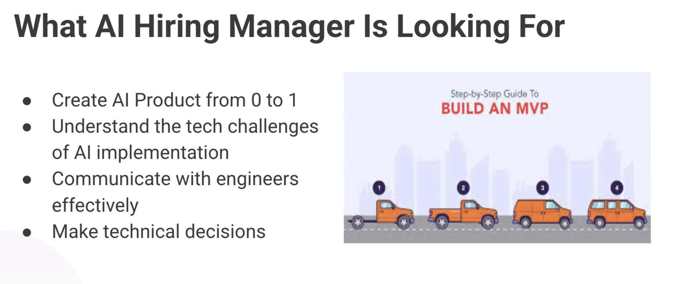

Presentations

Week 4 Team Match

Pitch Includes:

1. Overview
2. Customer Persona

2. Marcus Rodriguez - The Overwhelmed Optimizer (B2C - Power User)

Pain: "I have 1M+ points but spend 8 hours researching each trip"

Goal: Book trips confidently without analysis paralysis

Value Prop: "Get THE answer in 30 seconds, not 47 options"

Key Trait: Tech-savvy but time-starved, wants expert verdict

4. Sarah & David Kim - The Aspiring Family Hacker (B2C - Growth)

Pain: "I'm a beginner, terrified of wasting our limited points"

Goal: Prove to skeptical husband that travel hacking works

Value Prop: "Book Hawaii family trip in 10 minutes, save $6,250"

Key Trait: Motivated but overwhelmed, needs beginner-friendly guidance

1. Voice of Customer review results
2. AI hypothesis Validation results
3. Roadmap
4. Preliminary mockup
5. Any additional progress update
6. What type of tech resources are you looking for? 2Dev(IOS, backend),1 1ML

Meeting Notes

# Feb 6, 2026

Team meeting

### **Team Expansion & Scope Decisions**

* Added Pranay to team (Microsoft TPM, 16-18 years experience, Seattle-based)
  + Provides execution support and tech stack expertise
  + Bandwidth backup for busy schedules
* Agreed to focus on B2C for MVP, defer B2B to Phase 2
  + B2B requires significantly different user flows (similar to SAP Concur)
  + Time constraint (3 weeks) necessitates descoping
  + B2C features will serve as foundation for future B2B extension

### **Competitive Analysis Findings**

* RewardWise positioned well against competitors
* Pricing strategy deferred - requires separate workstream and A/B testing
* B2B market analysis (30,000 businesses TAM) moved to Phase 2

### **Product Strategy & User Experience Concerns**

* Core value proposition: Single-session verdict (cash vs points recommendation)
* Major UX challenge: Award availability typically <20% on first search
  + Users may be dissatisfied when only cash option available
  + Monitoring/alerts feature would require significant technical complexity
  + Need user interviews to validate if instant verdict provides sufficient value
* Booking integration trade-offs:
  + MVP will not include booking (API complexity, contract requirements)
  + Deep linking to airline websites as interim solution
  + Potential future focus on specific routes/airlines with easier API access

### **Technical Architecture & AI Implementation**

* Multi-layer approach planned:
  + LLMs for intent parsing and verdict explanation
  + ML models for decision making and prediction
  + RAG integration under consideration
  + Chatbot functionality evaluation ongoing
* Platform decision pending user interviews (mobile vs web first)
  + Assumption: busy professionals prefer mobile
  + Need iOS/API compatibility confirmation

### **User Interview research questions**

1. Value of instant verdict vs. availability constraints

Does a one-shot “cash vs points” verdict feel valuable if:

* + There is no award availability most of the time
  + The recommendation is often “cash” only

Will users come back to the app even when they frequently see “cash only”?

1. Need for monitoring/alerts

* Would users strongly want alerts/monitoring when there is no award space?
* Is “come back and check later” acceptable, or do they expect automated alerts?

1. Platform preference

* Do target users prefer to use this as:
  + Mobile-first (iOS/Android)
  + Web-first
  + Or truly need both?

1. Booking & flow expectations

* Is it acceptable that MVP does not support in-app booking (only deep links)?
* How important is fully end‑to‑end booking in the same session?

### **Next Steps**

* User interviews (Eshma leading) - Please include questions from the group discussion today
* Developer presentation due Feb 10th at 7am PST
  + Divide slides among team members so that folks have an opportunity to present what they worked hard on
  + Include competitor analysis findings
  + Sabby unavailable (flight) - team to present
  + Smital to create google slides so that the team can work offline to upload their content (Sabby can take the lead in creating the final presentation draft)
* Team meetings scheduled: Feb 9th and Feb 12th, 4pm PST
* Smital unavailable Feb 13th, 16th-17th (anniversary trip)
* All team members review Sebas wireframes and prototypes offline

# 

# Feb 5 2026

Eshma/Sabby

### **User Research Interview Setup**

* Send emails to survey respondents today requesting 15-minute follow-up interviews
  + Draft email by 6pm Toronto time for approval
  + Include calendar link for easy scheduling
  + Target 8-9 friends from original 11 respondents
  + Sarabjit will help nudge friends if needed
* Download Granola AI for interview recording/transcription
* Request PM support from team for each interview call
  + Create signup table in Google Doc for PM volunteers
  + Cannot conduct interviews alone

### **Interview Strategy & Questions**

* Primary objective: Verify product direction and confirm pain points
* Interview flow (15-25 minutes):
  1. Ask about current app usage
  2. Identify what they like about existing solutions
  3. Show prototype/pitch for reaction
  4. Get feedback on proposed direction
* Post interview questions in Discord for team review
* Focus on validation rather than exploration

### **Email Communication**

* Three draft versions created using Gemini AI
* Finalize version and mark clearly at top of document
* Introduce self as UX designer working with Sarabjit
* Reference previous survey participation for context
* Consider PST timezone for scheduling (friends have young kids)
* Be flexible with timing including 10pm Toronto/7pm PST slots

### **Competitor UX Research**

* Analyze 3-4 main competitors already identified
* Document different user flows in industry
* Position RewardWise solution against competitor pros/cons
* Validate approach fits within industry standards

### **Documentation & Next Steps**

* Survey synthesis doc due Monday, February 9th
  + Top 3 pain points validation
  + Top 3 surprises from interviews
  + Bullet point format acceptable initially
* All work goes in shared Google Doc for Claude AI integration
* Strike through old data rather than deleting for context
* Watch recommended YouTube videos to understand travel rewards space
* Target 3-4 solid interviews minimum for synthesis

# 

# Feb 3 2026

The team is moving into a more structured product validation and design phase, with Eshma joining as user research lead to own user interviews, research, and onboarding user stories into Seba led Figma designs. She will define the interview format and outreach plan, focusing on survey respondents who mostly have weekend availability, and partner with Sabby and Seba.

Survey analysis of 39 respondents strongly validates the core problem: a large majority are unsure whether it’s actually worth using their points, despite holding sizable balances (50k–300k+) and traveling 2–6 times per year. This uncertainty is amplified by complex award availability, transfer rules, and the mental overhead of manual comparisons across multiple websites. Users frequently double-check multiple sources, do manual math, and compare cash vs points themselves, leading to frustration and a clear desire for a single system that centralizes availability, comparisons, and guidance. The dominant demographic is 35–54, skewing toward working professionals and family travelers, and 13 respondents have opted into follow-up interviews, giving the team a solid base for qualitative research.

On the technical side, the team is defining an AI/ML strategy tied directly to user flows and product features. They plan to build a user story matrix to identify where segmentation, persona prediction, and multi-agent workflows (API data fetching, ML modeling, and a decision layer) are needed, along with natural language components. A mentor meeting is scheduled to stress-test this approach and get model/stack recommendations. The goal by Friday is to articulate 3–4 viable options per AI use case, focused on off-the-shelf LLMs for the MVP, plus an evaluation framework to measure recommendation accuracy and build user trust.

Competitor analysis shows that existing tools fall into discovery engines, concierge services, cash-only search tools, and DIY ecosystems. While some, like Citro and PointsYeah, excel in either depth of availability or user education and transfer guidance, they still leave users with decision paralysis, weak personalization, and in some cases inaccurate or misleading value judgments. This reinforces RewardWise’s opportunity to differentiate on trustworthy, ranked recommendations rather than raw data alone. The team also surfaced an important strategic dimension: regulatory and commercial risk around ranking issuers and partners, particularly if recommendations consistently de-prioritize certain credit card programs.

Finally, the team identified a potentially high-value B2B angle alongside the B2C vision. Corporate and startup travel—where founders, executives, and finance teams accumulate large point balances—represents an underserved segment that is both incentive-aligned (cash-constrained, value-seeking) and likely to pay for meaningful optimization. Wealth advisors who curate card portfolios for affluent clients are another adjacent segment. Together, these insights validate the core product thesis, sharpen the technical roadmap, and open up a path to higher-value, potentially stickier customer segments.

### **Next Steps**

* Eshma: Kick off user research, UX competitor analysis and user interviews
* Sabby: Send AI stack framework to Anshu tonight for tomorrow’s mentor meeting
* Anshu/Sabby: share AI stack thoughts with the team prior to 2/6 meeting
* Smital: Combine competitor analyses (work with Autumn) into unified document for team discussion on 2/6
* Smital: Work with Sabby on the next weeks’ developer presentation
* Autumn: Start working on PRD (with support from Sabby)
* Friday 2/6 agenda: Competitor analysis deep dive, Prototype/wireframe review

# Jan 30 2026

Attendees: Anshu, Autumn, Sarabjeet (Sabby), Sebas and Smital

**Key Takeaways**

1. Product scope & differentiation
   1. Target problem: optimizing **travel rewards/points** usage, especially for flights.
   2. Strong belief that **international flights** are the primary high‑value use case; domestic has some “sweet spots” but is usually lower value.
   3. Key differentiator vs tools like Gondola/Award Travel:
   4. Not just surfacing data; providing **clear, simple recommendations** (“do X, here’s why”).
   5. **Natural language explanation** layer to “dumb down” complexity for non-expert users.
   6. Desire to include an **AI/chatbot** interface as a baseline expectation for modern products.
2. Early thoughts on target users
   1. Initial hypothesis: **immigrants in North America** traveling internationally (e.g., US/Canada ↔ India/China/other home countries).
   2. Need to choose between focusing MVP on:
      * Economy / premium economy travelers vs
      * Business-class power users.
   3. Premium economy is called out as a fast‑growing, attractive segment on international routes.
3. Platform / form factor discussion
   1. Debate between **web app vs iOS app** for MVP:
      1. Web is easier/faster to ship and easier to staff with devs.
      2. iOS can leverage App Store discovery and better match “on the go” travel behavior.
   2. No final decision; to be informed by:
      * User segmentation (VOC).
      * Dev capacity and PMA dev preferences.
      * Competitor analysis findings.
4. AI & architecture framing
   1. Intention to mirror the **Style Points** structure:
      * Identify **key AI touchpoints** in user journey (e.g., parsing offers, predicting value, dialog, recommendation).
      * For each, define user flow and list candidate models/tools (Gemini, Claude, GPT, RAG, etc.).
   2. Awareness of **cost constraints** (token costs, compute) and need to weigh options, not lock into one model yet.
5. PMA program expectations & timeline
   1. Need to line work up with Nancy’s week-by-week roadmap:
   * Near-term priority on **AI hypothesis**, **VOC**, **competitor analysis**, and **tech stack framing**.
   1. Developer pitch is on **Feb 10**, and the deck must speak clearly to:
   * What we’re building.
   * What AI/ML is involved.
   * What engineering effort is needed (frontend/backend/APIs).
6. Collaboration norms
   1. Use the shared Google Doc as the source of truth: Tabs for roadmap, VOC, PRD, mocks, competitors, APIs, presentations, key links.
   2. Encouragement to **challenge assumptions** (especially Sarabjit’s) and keep the idea flexible: Today’s concept may evolve significantly before/after launch.

**Key Action Items by Owner & ETA**

**Anshu**

* Design and finalize Voice of Customer (VOC) survey (questions + form link)
  + **ETA:** Jan 31, 2026, 12:00 PM PST

**Autumn**

* Co-lead competitor analysis with Smithel; create first-draft comparison in new “Competitor Analysis” tab **ETA:** Feb 3, 2026 (Tuesday, same meeting time)
* Co-own PRD v2 with Sarabjit (structure, content, PM framing) **ETA:** Feb 6, 2026
* Organize ongoing meeting cadence and send calendar invites (accounting for Google Meet limits) **ETA:** Early next week (before Feb 3 meeting)

**Smital**

* Co-lead competitor analysis with Autumn (Gondola, Award Travel, Hopper, others) **ETA:** Feb 3, 2026
* Draft initial structure/outline for developer pitch deck (sections, flow, info needed) **ETA:** Feb 3, 2026
* Own final developer presentation (integrate all workstreams, tune for devs & data scientists) **ETA:** Feb 10, 2026 (developer pitch date)

**Sarabjeet**

* Co-lead tech stack / AI architecture exploration with Anshu; map AI components to user flows and candidate models **ETA:** Feb 3, 2026
* Co-own PRD v2 with Autumn (final sign-off on scope, requirements, prioritization) **ETA:** Feb 6, 2026
* Share Granola meeting notes with full team **ETA:** Immediately after current meeting

**Sebastian (Sebas)**

* Iterate on UX mocks and layout based on initial feedback; document suggestions in shared doc **ETA:** In the next few days (before PRD v2 is finalized)
* Align UX with emerging PRD v2 details in collaboration with Autumn & Sarabjit **ETA:** After Feb 6, 2026 (rolling)

**All Team Members**

* Distribute VOC survey to personal networks and drive at least 2+ responses each **ETA:** As soon as survey is live (starting Jan 31, 2026)
* Add relevant links, research, and notes to the shared Google Doc (Key Links, Competitor Analysis, APIs, Presentations tabs) **ETA:** Ongoing, with first big update by Feb 3, 2026
* Reconvene for workstream readouts (competitors + tech stack) **ETA:** Feb 3, 2026 (same time as this meeting)

**Feb 6th 2026**

Pricing (later in scope)

Latency check for services

Why are other competitors not providing suggestions?? - RISK

Check how frequently are airline APIs updated for availability or refresh

API compatibility for browser/ios

Technical discussion with Mentor Mark

**LLM Selection Discussion – Notes**

**Discussion Between Mark & Team**

* **Mark** suggested the team be open to using LLMs more broadly in the system.
* He was particularly curious about how we envision **ML and LLM working together**, and how responsibilities would be divided between them.
* We discussed prompt engineering as a potential starting approach.
* **Mark** agreed that prompt engineering makes sense initially.
* He also suggested that fine-tuning could be explored, though not necessarily as the first step.
* He requested to be looped in before we finalize the LLM strategy or make a conclusive decision.

**Broader Themes Discussed**

* When should we rely on classical ML vs LLM?
* Whether LLM should be used only for interpretation/explanation or also decision-making.
* Trade-offs between:
  + Prompt engineering
  + Fine-tuning
  + Hybrid ML + LLM approach

**Action Items**

* Speak with someone with a stronger ML background (Sabby?)  
  → Validate whether certain predictive components should be handled via classical ML instead of LLM.
* Test structured prompting using ChatGPT (or similar models)  
  → Check how well prompting supports our architecture assumptions.
* Start with prompt engineering for the LLM layer.
* Consider fine-tuning later if consistent performance gaps are observed.

Q&A

**Where AI adds genuine value:**

1. **Combinatorial scale**: A user with 3 programs facing 14+ transfer partners per program, dynamic availability, and multiple routing options creates thousands of path combinations. AI evaluates these in seconds vs. hours of manual research.
2. **Personalization over time**: AI learns user preferences—do they prioritize luxury or value? Prefer direct flights? Have blackout dates? The system improves with each interaction (RLHF).
3. **Natural language input**: Users say "Tokyo in spring, business class, flexible dates." AI interprets intent without forcing users into rigid search forms.
4. **Opportunity cost reasoning**: "Use points now or save for later?" requires weighing depreciation rates, upcoming trips, seasonal availability patterns—a judgment call AI can model.
5. **Pattern recognition**: AI detects sweet spots (e.g., "United opens partner availability 330 days out") that static rules miss.

**The real answer:** MVP could ship without AI—manual concierge proves this. AI becomes essential at scale: you can't have humans research every $39 request profitably. AI is the path from service to software margins.

If pressed: "AI makes optimization accessible to normal people. Experts don't need us. We're automating what power users do manually."

Requirements

**Final signed-off version of PRD for 1st MVP goes here**

User Flows

### **Feb 3, 3026**

### **FLOW 1: Onboarding**

**Version A (control for A/B testing) Customer lands on site -> Sign up first -> AI Wizard outputs:**

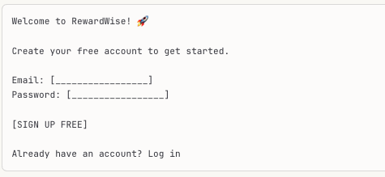

**Version A (test for A/B testing) Customer lands on site -> No sign-up required -> AI Wizard outputs:**

### 

↓ *After search runs* ↓

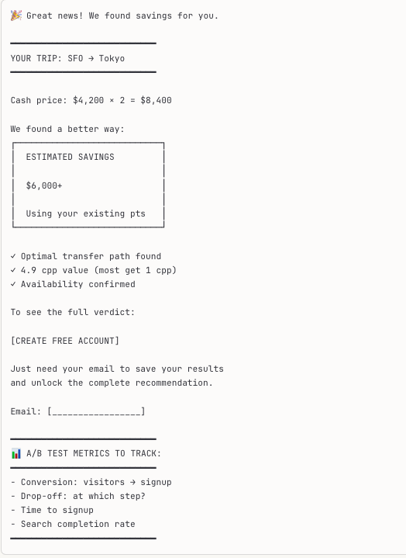

### 

### **FLOW 2: Wallet Unification**

**Customer enters/updates point balances -> AI Wizard outputs**

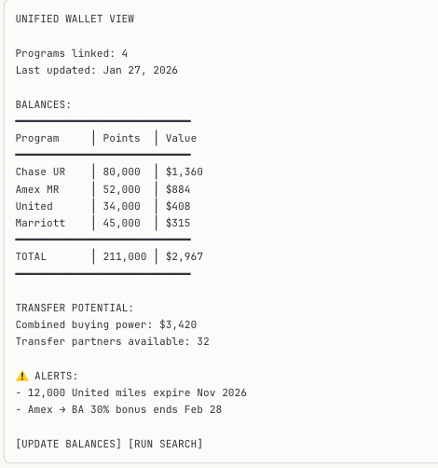

### 

### **Flow 3: Cash vs Points Quick Check**

**Logged in Customer inputs single flight -> AI Wizard outputs:**

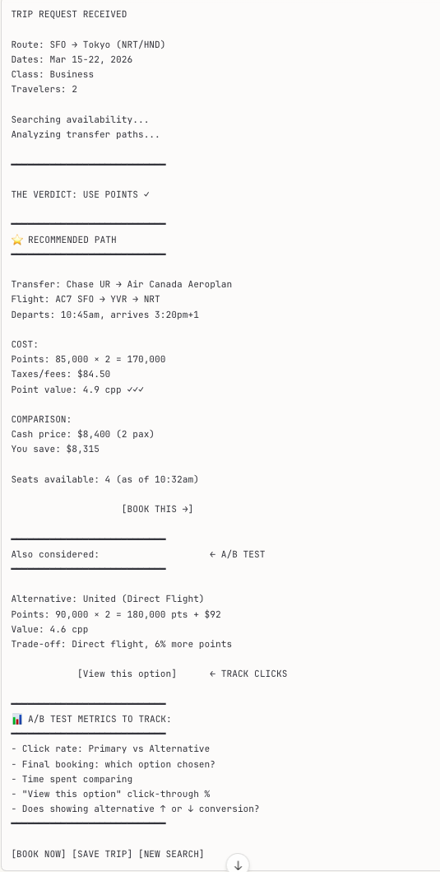

### **FLOW 4: Cash vs Points Quick Check**

**Customer inputs single flight for quick comparison -> AI Wizard outputs**

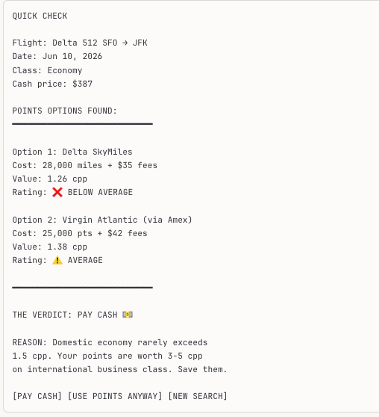

### 

### **FLOW 5: Award Availability Alert**

**Customer sets watchlist for a trip -> AI Wizard outputs:**

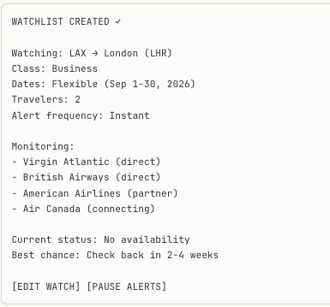

**↓ *3 weeks later* ↓**

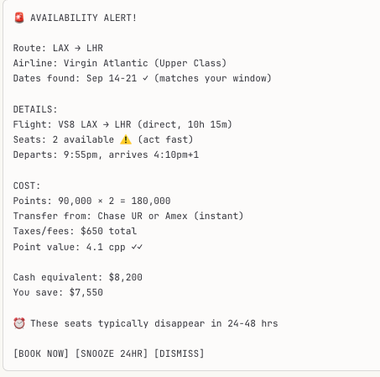

### **FLOW 6: Concierge Request (Simple)**

**Customer submits domestic concierge request-> AI WIZARD outputs:**

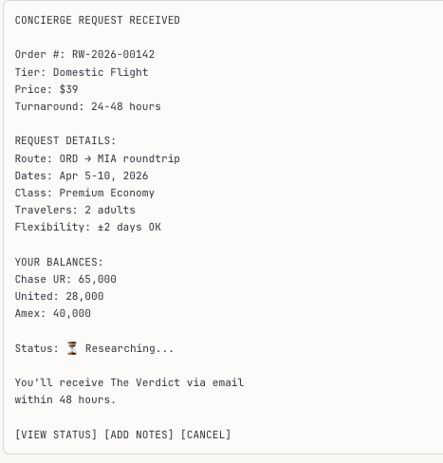

**↓ *36 hours later* ↓**

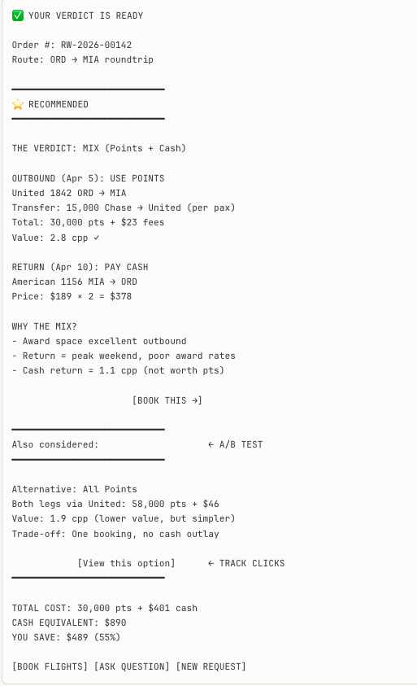

### **FLOW 7: Concierge Request (Simple)**

**Customer submits premium concierge request -> AI WIZARD outputs:**

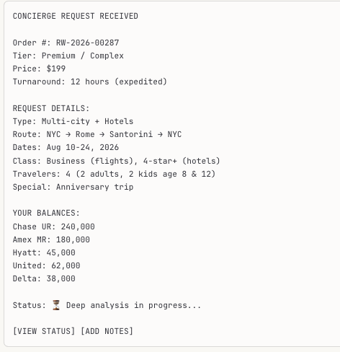

**↓ *10 hours later* ↓**

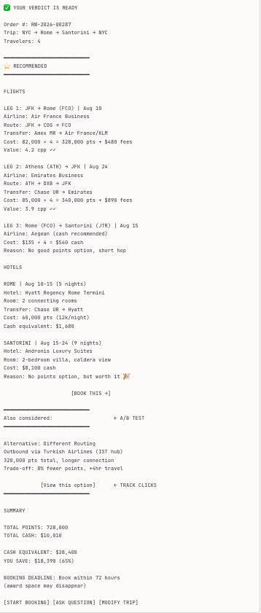

### **FLOW 8: Points Health Check (Quarterly Review)**

**Customer requests portfolio review -> AI Wizard outputs:**

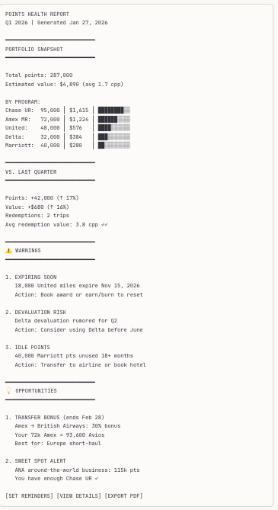

### **FLOW 9: Transfer Path Optimizer**

**The customer asks "how do I get to Bali?"-> AI Wizard outputs:**

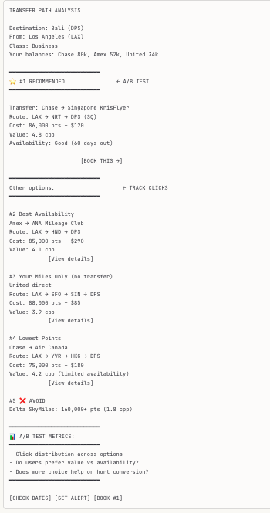

### **FLOW 10: Preference Learning (Post-Trip Feedback)**

**Customer provides feedback after trip-> AI Wizard outputs:**

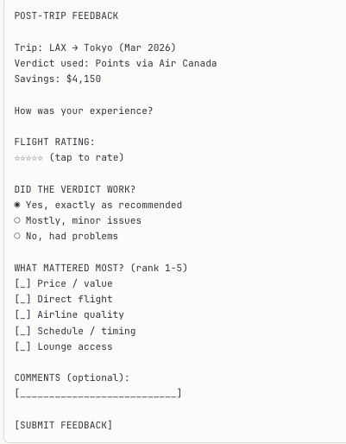

**↓ *After submission* ↓**

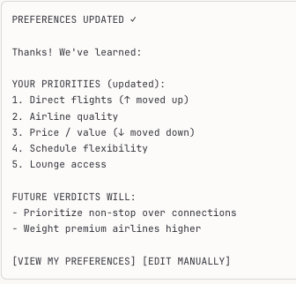

### **FLOW 11: Subscription Management**

**Customer views account/billing-> AI Wizard outputs:**

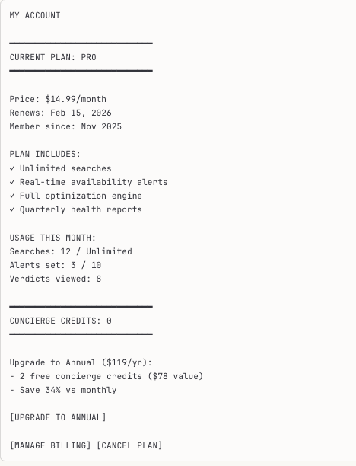

### **FLOW 12: Free Tier UpSell**

**Free user hits search limit -> AI Wizard** **outputs:**

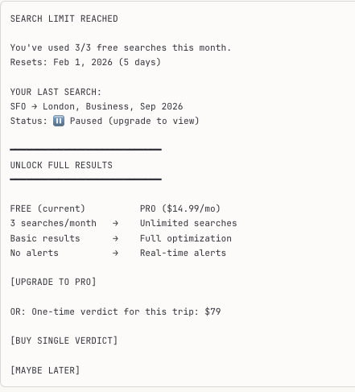

## **A/B Test Summary**

| **Test** | **Flow** | **What We're Testing** | **Metrics** |
| --- | --- | --- | --- |
| **A: Delayed Signup** | Onboarding | No signup required upfront. Run free search, tease savings, then ask for signup. | Signup conversion %, drop-off points, time-to-signup |
| **B: Alternative Display** | Verdict, Concierge, Path Optimizer | Show recommended option prominently + one alternative in smaller print | Click distribution, final booking choice, does showing alternatives ↑ or ↓ conversion? |

**Key Questions A/B Tests Will Answer:**

1. **Delayed Signup**: Does letting users "try before they buy" increase or decrease signups? Does it attract higher-intent users?
2. **Alternative Options**: Do users trust the recommendation more when they see we considered alternatives? Or does choice paralysis hurt conversion?

PRD v1

# **Parallax MVP Product Requirements Document**

## **Document Control**

| **Field** | **Value** |
| --- | --- |
| Version | 1.0 |
| Last Updated | January 2026 |
| Timeline | 11 weeks to launch |
| Status | Draft for Review |

## **1. Product Vision & Objectives**

### **1.1 Vision Statement**

Parallax tells you exactly how to use your points—one recommendation, no comparison shopping, no second-guessing.

### **1.2 MVP Objective**

Deliver a functional tool that provides **accurate, high-confidence redemption recommendations** for a constrained set of trip types, proving the core value proposition before expanding scope.

### **1.3 Success Criteria (Launch + 90 Days)**

| **Metric** | **Target** | **Rationale** |
| --- | --- | --- |
| Recommendation accuracy | >95% | Trust is fatal risk; must validate quality |
| User activation (complete first query) | >60% of signups | Proves UX simplicity thesis |
| Return usage (2+ queries in 90 days) | >30% of activated users | Proves ongoing value, not curiosity |
| Distribution wedge conversion | >5% of reachable audience signs up | Validates founder network leverage |
| NPS | >40 | Indicates trust formation |

### **1.4 Strategic Constraints (from Analysis)**

These are non-negotiable based on the strategic assessment:

1. **No real-time scraping** — Legal/technical fragility; static data only
2. **No in-app booking** — Out of scope; link out to airline/hotel
3. **Constrained recommendation scope** — High-confidence scenarios only; refuse uncertain cases
4. **Confidence transparency** — Every recommendation shows confidence level and caveats
5. **Savings framing, not optimization** — "Your points are worth $X" not "This is optimal"

## **2. Target User**

### **2.1 Primary Persona: The Time-Poor Accumulator**

| **Attribute** | **Specification** |
| --- | --- |
| Trip frequency | 3-6 trips/year |
| Card portfolio | 2-4 premium travel cards |
| Points behavior | Accumulates intentionally, redeems suboptimally |
| Annual card fees | $95-695 |
| Decision style | Wants "the answer," not options to evaluate |
| Technical comfort | Uses apps daily; not a power user |
| Pain point | "I know my points are worth something, but figuring out how to use them takes hours" |

### **2.2 Anti-Persona: The Churner**

| **Attribute** | **Why They're Out of Scope** |
| --- | --- |
| 10+ cards, manufactured spending | Needs power-user flexibility we won't provide |
| Optimizes to the cent | Will reject our constrained recommendations |
| Enjoys the game | Doesn't want "the answer"—wants the puzzle |
| Active on r/churning daily | Already has tools and community knowledge |

**Design implication**: If a feature would delight the churner but confuse the accumulator, cut it.

## **3. Core User Flows**

### **3.1 Flow 1: Onboarding (First-Time User)**

[Landing Page]

↓

[Value prop: "Stop guessing. Get the verdict."]

↓

[Sign up (email + password, or OAuth)]

↓

[Card Portfolio Setup]

- Select cards from list (top 50 travel cards)

- Enter points balances manually

↓

[Confirmation: "You're ready to search"]

↓

[Redirect to Trip Search]

**Design notes**:

* Card selection via searchable dropdown, not free text
* Show card images for recognition
* Points balance entry is manual (no aggregator integrations in MVP)
* Allow "I'll add balances later" skip option (enables exploration before commitment)

### **3.2 Flow 2: Trip Search → Verdict**

[Trip Search Form]

- Origin (airport code or city)

- Destination (airport code or city)

- Dates (departure + return, or one-way)

- Travelers (1-4, economy class only in MVP)

↓

[Processing Screen: "Analyzing your options..."]

↓

[DECISION GATE: Is this a high-confidence scenario?]

↓ ↓

YES NO

↓ ↓

[The Verdict] [Out of Scope Message]

- Recommendation "We can't confidently recommend

- Savings calculation this trip yet. Here's why..."

- Confidence tier [Reason: international premium cabin /

- Caveats partner award complexity / etc.]

- "Book on [airline]" CTA [Workaround suggestion]

↓

[Feedback prompt: "Was this helpful?"]

### **3.3 Flow 3: Returning User**

[Login]

↓

[Dashboard]

- Quick search (pre-filled origin from profile)

- Recent searches (last 5)

- Points summary (balances by program)

↓

[Trip Search or Portfolio Update]

### **3.4 Flow 4: Portfolio Management**

[Dashboard → "My Cards"]

↓

[Card List]

- Card name + image

- Points balance (editable inline)

- Last updated date

↓

[Add Card] or [Update Balance]

↓

[Save → Confirmation toast]

## **4. Feature Requirements**

### **4.1 Priority Definitions**

| **Priority** | **Definition** | **MVP Inclusion** |
| --- | --- | --- |
| P0 | Must have for launch; product doesn't work without it | Yes |
| P1 | Should have; significant value add but not blocking | Post-launch (weeks 12-20) |
| P2 | Nice to have; future roadmap | 6+ months |

### **4.2 P0 Features (MVP Scope)**

#### **4.2.1 User Authentication**

| **Requirement** | **Specification** |
| --- | --- |
| Sign-up methods | Email/password; Google OAuth |
| Password requirements | 8+ chars, 1 number, 1 special char |
| Session duration | 30 days (remember me default) |
| Password reset | Email-based token, 1-hour expiry |

#### **4.2.2 Card Portfolio Management**

| **Requirement** | **Specification** |
| --- | --- |
| Supported cards | Top 50 US travel credit cards (see Appendix A) |
| Data captured per card | Card ID, points balance, date added, last balance update |
| Points programs derived | Automatically mapped from card (e.g., Chase Sapphire → Ultimate Rewards) |
| Balance entry | Manual input; integer values only |
| Portfolio limit | 10 cards per user (MVP) |

#### **4.2.3 Trip Search**

| **Requirement** | **Specification** |
| --- | --- |
| Search parameters | Origin, destination, departure date, return date (optional), travelers (1-4) |
| Supported trip types | Round-trip, one-way |
| Cabin class | Economy only (MVP) |
| Airport matching | Autocomplete from airport database; accept city names → map to primary airport |
| Date constraints | Today + 1 day through Today + 330 days |

#### **4.2.4 The Verdict (Core Recommendation Engine)**

| **Requirement** | **Specification** |
| --- | --- |
| Output format | Single recommendation with supporting data |
| Recommendation types | (1) Use points on Program X, (2) Pay cash, (3) Out of scope |
| Savings calculation | Cash price – (points required × cpp value) = savings |
| Confidence tiers | High Confidence, Likely Accurate, Verify Before Booking |
| Mandatory caveats | "Award availability changes frequently. Verify on [airline] before booking." |
| Booking CTA | Deep link to airline/hotel search page (not booking page—availability not guaranteed) |

**Verdict display elements**:

┌─────────────────────────────────────────────────────────┐

│ THE VERDICT │

│ │

│ Use your Chase Ultimate Rewards points │

│ Transfer to United MileagePlus │

│ │

│ Points required: 35,000 × 2 passengers = 70,000 pts │

│ Cash price: $487 × 2 = $974 │

│ Your savings: ~$624 (1.9¢ per point) │

│ │

│ [HIGH CONFIDENCE] │

│ │

│ ⚠️ Award availability changes frequently. │

│ Verify on united.com before booking. │

│ │

│ [Search on United →] │

│ │

│ ───────────────────────────────────────────────────── │

│ Why this recommendation? │

│ • United has standard saver availability on this route │

│ • 1.9¢/point exceeds the 1.5¢ cash-out floor │

│ • No transfer bonus active (checked 1/15/2026) │

└─────────────────────────────────────────────────────────┘

#### **4.2.5 Out-of-Scope Handling**

| **Scenario** | **User Message** | **Tracking** |
| --- | --- | --- |
| International premium cabin | "We don't yet support business/first class searches. For these trips, award availability is highly dynamic and our static data can't reliably recommend." | Log: out_of_scope_premium_cabin |
| Partner award complexity | "This route involves complex partner awards we can't confidently evaluate yet." | Log: out_of_scope_partner |
| No points advantage | "For this trip, paying cash is your best option. Your points are worth more saved for a future trip." | Log: verdict_pay_cash |
| Insufficient data | "We don't have reliable data for this route yet." | Log: out_of_scope_no_data |

#### **4.2.6 Cash Price Comparison**

| **Requirement** | **Specification** |
| --- | --- |
| Data source | Google Flights (via unofficial API) or Amadeus (if licensing feasible in timeline) |
| Refresh frequency | Daily for popular routes; on-demand for long-tail |
| Display | Show cash price as comparison baseline |
| Fallback | If no cash price available, show "Cash price unavailable—verify on Google Flights" |

#### **4.2.7 Feedback Collection**

| **Requirement** | **Specification** |
| --- | --- |
| Prompt timing | After verdict display (non-blocking) |
| Input type | Binary (helpful / not helpful) + optional free text |
| Data captured | User ID, search ID, rating, comment, timestamp |
| Use case | Quality monitoring; error detection; roadmap prioritization |

#### **4.2.8 Basic Analytics Instrumentation**

| **Event** | **Data Captured** |
| --- | --- |
| user_signup | Source (founder network tag, organic, referral), timestamp |
| portfolio_setup_complete | Cards added, total points balance |
| search_initiated | Origin, destination, dates, travelers |
| verdict_displayed | Recommendation type, confidence tier, savings amount |
| verdict_cta_clicked | Airline/hotel, timestamp |
| feedback_submitted | Rating, comment |
| out_of_scope_displayed | Reason category |

### **4.3 P1 Features (Post-Launch)**

| **Feature** | **Description** | **Dependency** |
| --- | --- | --- |
| Hotel recommendations | Extend verdict to hotel loyalty programs | Requires hotel award chart data build |
| Business class support | High-confidence business class routes (limited set) | Requires availability data partnership or caching |
| Transfer bonus alerts | Notify users of active point transfer bonuses | Requires monitoring system |
| Trip history | View past verdicts and whether user booked | Requires user confirmation flow |
| Multi-city search | Support open-jaw and multi-segment trips | Engine complexity increase |

### **4.4 P2 Features (Future Roadmap)**

| **Feature** | **Description** | **Strategic Notes** |
| --- | --- | --- |
| In-app booking | Complete award booking within Parallax | Major technical/partnership lift; trust must be proven first |
| Automated balance sync | Connect to loyalty accounts for real-time balances | Aggregation partnerships or scraping; legal complexity |
| Premium subscription | Unlimited searches, advanced features | Requires proven value prop |
| Concierge service | Human-assisted complex bookings | High-margin upsell; builds on trust foundation |

## **5. Technical Requirements**

### **5.1 Architecture Overview**

┌─────────────┐ ┌─────────────┐ ┌─────────────┐

│ Client │────▶│ API │────▶│ Database │

│ (Web App) │◀────│ (Node/ │◀────│ (Postgres) │

│ │ │ Python) │ │ │

└─────────────┘ └──────┬──────┘ └─────────────┘

│

┌─────▼──────┐

│ Static │

│ Data │

│ (Award │

│ Charts) │

└─────┬──────┘

│

┌─────▼──────┐

│ External │

│ APIs │

│ (Cash │

│ Prices) │

└────────────┘

### **5.2 Platform Requirements**

| **Component** | **Specification** |
| --- | --- |
| Web app | React (Next.js) or similar; responsive design (mobile-first) |
| API | Node.js or Python (FastAPI); RESTful |
| Database | PostgreSQL |
| Hosting | Vercel (frontend) + Railway/Render (backend) or equivalent |
| Auth | Auth0 or Supabase Auth |
| Analytics | Mixpanel or Amplitude (free tier sufficient for MVP) |

### **5.3 Performance Requirements**

| **Metric** | **Target** |
| --- | --- |
| Search → Verdict latency | <3 seconds (p95) |
| Page load | <2 seconds (p95) |
| Uptime | 99% (MVP acceptable; tighten post-launch) |

### **5.4 Security Requirements**

| **Requirement** | **Specification** |
| --- | --- |
| Data encryption | TLS in transit; AES-256 at rest |
| Password storage | bcrypt hashing |
| PII handling | Minimal collection; no SSN, no full card numbers |
| Points balances | Stored encrypted; user-provided only (no account access) |

## **6. Data Requirements**

### **6.1 Static Data: Award Charts**

| **Data Set** | **Source** | **Refresh Frequency** | **MVP Scope** |
| --- | --- | --- | --- |
| Airline award charts | Manual curation from public sources | Weekly review; update on devaluation news | Top 10 US airline programs |
| Transfer partner mappings | Manual curation | Monthly | Chase UR, Amex MR, Citi TYP, Capital One, Bilt |
| Sweet spot routes | Manual curation from points blogs/communities | Bi-weekly | Top 50 domestic routes; top 20 international economy routes |

### **6.2 Supported Programs (MVP)**

**Credit Card Points Programs**:

1. Chase Ultimate Rewards
2. American Express Membership Rewards
3. Citi ThankYou Points
4. Capital One Miles
5. Bilt Rewards

**Airline Programs** (direct earn + transfer partners):

1. United MileagePlus
2. American AAdvantage
3. Delta SkyMiles
4. Southwest Rapid Rewards
5. JetBlue TrueBlue
6. Alaska Mileage Plan

**Hotel Programs** (P1—not MVP):

* Deferred to post-launch

### **6.3 Dynamic Data: Cash Prices**

| **Requirement** | **Specification** |
| --- | --- |
| Source | Google Flights (preferred) or Amadeus |
| Coverage | All searchable routes |
| Caching | 24-hour cache for popular routes; real-time fetch for long-tail |
| Fallback | Display "price unavailable" with link to Google Flights |

### **6.4 Data Quality Monitoring**

| **Check** | **Frequency** | **Alert Threshold** |
| --- | --- | --- |
| Award chart staleness | Daily | >14 days since last update |
| Cash price API errors | Hourly | >5% failure rate |
| User-reported errors | Real-time | Any report triggers manual review |

## **7. Recommendation Engine Logic**

### **7.1 Decision Tree (Simplified)**

INPUT: User portfolio, trip parameters

│

▼

[Is route in supported set?]

│

NO → Return "Out of Scope" with reason

│

YES

│

▼

[Fetch cash price for route]

│

FAIL → Return "Cash price unavailable" with caveat

│

SUCCESS

│

▼

[For each points program user has:]

│

├─▶ Calculate points required (award chart lookup)

├─▶ Calculate cpp value (cash price ÷ points)

├─▶ Compare to program's floor value (e.g., 1.5cpp for UR cash out)

│

▼

[Select best option:]

│

├─▶ If best cpp > floor value + threshold → Recommend points

├─▶ If best cpp ≈ floor value → Recommend cash (save points)

├─▶ If no points option viable → Recommend cash

│

▼

[Assign confidence tier based on data freshness + route coverage]

│

▼

[Return Verdict]

### **7.2 Confidence Tier Assignment**

| **Tier** | **Criteria** |
| --- | --- |
| **High Confidence** | Route is in "sweet spot" list; award chart updated <7 days; cash price fetched <24 hours |
| **Likely Accurate** | Route in supported set; award chart updated <14 days; cash price fetched <48 hours |
| **Verify Before Booking** | Any data >14 days old; route not in sweet spot list; edge case routing |

### **7.3 Savings Calculation**

savings = cash_price - (points_required × floor_cpp_value)

Example:

cash_price = $487

points_required = 35,000

floor_cpp (UR) = 1.5¢

savings = $487 - (35,000 × $0.015) = $487 - $525 = -$38

→ This means paying cash is better; points are worth more saved.

**Display logic**:

* If savings > 50→"Yoursavings: 50 → "Your savings: ~ 50→"Yoursavings: X"
* If savings $0-50 → "Marginal savings; consider convenience factors"
* If savings < $0 → "Pay cash; your points are worth more saved"

## **8. UX/UI Requirements**

### **8.1 Design Principles**

1. **One answer, not options**: Every screen drives toward a single recommendation
2. **Confidence is visible**: Never hide uncertainty; calibrate expectations
3. **Mobile-first**: Primary use case is "checking before I book on my phone"
4. **Speed over polish**: MVP aesthetic is clean, not beautiful; function over form

### **8.2 Key Screens**

| **Screen** | **Purpose** | **Key Elements** |
| --- | --- | --- |
| Landing | Convert visitor → signup | Value prop, single CTA, no feature list |
| Onboarding: Cards | Capture portfolio | Card selector, balance inputs, skip option |
| Dashboard | Returning user home | Quick search, recent searches, points summary |
| Search | Trip input | Minimal form: origin, destination, dates, travelers |
| Verdict | Core value delivery | Recommendation, savings, confidence, caveats, CTA |
| Out of Scope | Graceful degradation | Clear explanation, workaround, feedback prompt |
| Portfolio | Card management | List view, inline editing, add card |

### **8.3 Responsive Breakpoints**

| **Breakpoint** | **Target** |
| --- | --- |
| Mobile | 320-767px (primary) |
| Tablet | 768-1023px |
| Desktop | 1024px+ |

### **8.4 Accessibility Requirements**

| **Requirement** | **Specification** |
| --- | --- |
| WCAG compliance | Level AA |
| Keyboard navigation | All interactive elements reachable |
| Screen reader | Semantic HTML; ARIA labels where needed |
| Color contrast | 4.5:1 minimum |

## **9. Go-to-Market Requirements**

### **9.1 Launch Channels (Founder Network)**

| **Channel** | **Audience Size** | **Expected Conversion** | **Week** |
| --- | --- | --- | --- |
| Personal newsletter | ~10,000 | 8-12% | Week 11 |
| LinkedIn (founder posts) | ~50,000 reach | 2-4% | Week 11 |
| Warm intros to tech Slack communities | ~15,000 | 5-8% | Week 11-12 |
| Direct outreach to target personas | ~500 | 15-20% | Week 10-11 (beta) |

### **9.2 Pre-Launch (Beta)**

| **Activity** | **Timing** | **Purpose** |
| --- | --- | --- |
| Closed beta | Weeks 9-10 | 50-100 users; quality validation |
| Bug fixes | Week 10 | Address critical issues |
| Feedback interviews | Week 10 | Qualitative signal on value prop |

### **9.3 Launch Messaging**

**Headline**: Stop guessing how to use your points.

**Subhead**: Parallax analyzes your cards and tells you exactly how to book—one recommendation, no spreadsheets.

**Proof points**:

* "The average family leaves $400/year on the table with suboptimal redemptions"
* "We do the math so you don't have to"

**CTA**: Get your first verdict free.

### **9.4 Instrumentation for Distribution Wedge Tracking**

| **Metric** | **Tracking Method** |
| --- | --- |
| Source attribution | UTM parameters on all launch links |
| Founder network vs. organic | Source tag at signup |
| Cohort retention | Weekly cohort analysis starting Week 12 |
| Decay signal | When founder-network signups drop below 100/week, trigger paid acquisition planning |

## **10. Risk Register & Mitigations**

| **Risk** | **Likelihood** | **Impact** | **Mitigation** | **Owner** |
| --- | --- | --- | --- | --- |
| Recommendation error destroys trust | Medium | Critical | Constrain scope; confidence tiers; recovery playbook | Product |
| Cash price API unreliable | Medium | High | Multiple fallbacks; cache aggressively; display caveats | Engineering |
| Award chart data stale | High | Medium | Weekly review process; user error reporting; staleness alerts | Data |
| Competitors ship similar in 11 weeks | Low | Medium | Speed; distribution wedge; focus on quality over features | Founder |
| User onboarding friction too high | Medium | Medium | Skip options; progressive disclosure; monitor drop-off | Product |
| Google Flights API access revoked | Low | High | Amadeus backup; manual price entry fallback | Engineering |

## **11. Timeline & Milestones**

### **11.1 11-Week Development Schedule**

| **Week** | **Phase** | **Deliverables** |
| --- | --- | --- |
| 1 | Foundation | Architecture finalized; dev environment; auth flow |
| 2 | Core Data | Award chart data structure; initial data entry (top 3 programs) |
| 3 | Portfolio | Card database; portfolio CRUD; user data model |
| 4 | Search | Trip search form; airport autocomplete; input validation |
| 5 | Engine v1 | Basic recommendation logic; single program support |
| 6 | Engine v2 | Multi-program comparison; savings calculation; confidence tiers |
| 7 | Verdict UI | Verdict display; out-of-scope handling; CTAs |
| 8 | Cash Prices | External API integration; caching; fallbacks |
| 9 | Polish + Beta | Bug fixes; UX refinement; 50-user closed beta |
| 10 | Beta Feedback | Critical fixes; feedback interviews; launch prep |
| 11 | Launch | Public launch via founder channels |

### **11.2 Key Checkpoints**

| **Checkpoint** | **Week** | **Criteria** |
| --- | --- | --- |
| Technical feasibility confirmed | 2 | Cash price API access validated; no blockers |
| Core loop functional | 6 | End-to-end search → verdict works (ugly OK) |
| Beta-ready | 9 | Stable enough for 50 users; critical bugs fixed |
| Launch-ready | 11 | Beta feedback addressed; launch assets ready |

## **12. Success Metrics & Monitoring**

### **12.1 North Star Metric**

**Accurate Verdicts Delivered**: Number of verdicts with "High Confidence" or "Likely Accurate" rating AND no user-reported error within 7 days.

### **12.2 Supporting Metrics**

| **Category** | **Metric** | **Target (90 days)** |
| --- | --- | --- |
| Acquisition | Signups | 5,000 |
| Activation | Portfolio setup complete | 60% of signups |
| Engagement | Searches per activated user | 3+ |
| Quality | User-reported errors | <2% of verdicts |
| Retention | Return within 30 days | 40% |
| Satisfaction | NPS | >40 |

### **12.3 Monitoring Dashboard**

Real-time visibility into:

* Signups (daily, by source)
* Searches (daily, by route category)
* Verdict distribution (points vs. cash vs. out-of-scope)
* Error rate (API failures, user reports)
* Funnel conversion (landing → signup → portfolio → search → verdict)

## **13. Appendices**

### **Appendix A: Supported Credit Cards (MVP)**

**Chase**

1. Chase Sapphire Preferred
2. Chase Sapphire Reserve
3. Chase Freedom Flex
4. Chase Freedom Unlimited
5. Ink Business Preferred

**American Express** 6. Amex Platinum 7. Amex Gold 8. Amex Green 9. Amex Blue Business Plus 10. Amex Business Platinum

**Citi** 11. Citi Premier 12. Citi Strata Premier 13. Citi Double Cash 14. Citi Custom Cash

**Capital One** 15. Venture X 16. Venture 17. Spark Miles

**Bilt** 18. Bilt Mastercard

**Co-branded Airline** 19. United Explorer 20. United Club Infinite 21. Delta SkyMiles Gold 22. Delta SkyMiles Platinum 23. Delta SkyMiles Reserve 24. AAdvantage Aviator Red 25. Southwest Rapid Rewards Priority 26. Southwest Rapid Rewards Plus 27. JetBlue Plus 28. Alaska Airlines Visa

*(Continue to 50 based on market share data)*

### **Appendix B: Supported Routes (MVP)**

**Domestic Sweet Spots** (top 30):

* SFO ↔ JFK
* LAX ↔ NYC area
* ORD ↔ coastal hubs
* DFW ↔ major metros
* (Full list TBD based on search volume data)

**International Economy** (top 20):

* US ↔ London
* US ↔ Paris
* US ↔ Tokyo
* US ↔ Cancun
* US ↔ major Caribbean destinations
* (Full list TBD)

### **Appendix C: Error Recovery Playbook**

**Trigger**: User reports recommendation error (via feedback or support)

**Response Protocol**:

1. **Acknowledge** (within 4 hours): "Thank you for reporting this. We're investigating."
2. **Investigate** (within 24 hours):
   * Was award chart data stale?
   * Was cash price inaccurate?
   * Was availability assumption wrong?
   * Was calculation logic flawed?
3. **Resolve**:
   * Update data if stale
   * Fix logic if flawed
   * Adjust confidence tier if systemic
4. **Compensate** (if user experienced material harm):
   * $25-50 credit toward future premium service
   * Personal apology from founder (for egregious cases)
5. **Close Loop**: "We've fixed [X]. Thank you for helping us improve."

### **Appendix D: Competitive Response Scenarios**

| **Scenario** | **Likelihood** | **Response** |
| --- | --- | --- |
| Point.me adds "single recommendation" mode | Medium | Differentiate on simplicity of overall UX; they'll likely bolt it onto power-user tool |
| Google Flights adds points support | Low (near-term) | Focus on multi-program optimization they won't do; build trust moat before they move |
| New entrant copies Parallax exactly | Low | Speed advantage; distribution wedge; iterate faster |
| Incumbent travel blogger launches tool | Medium | Their audience is churners; ours is accumulators; different segments |

## **14. Open Questions (Requiring Decision)**

| **Question** | **Options** | **Recommendation** | **Decision Owner** |
| --- | --- | --- | --- |
| Cash price data source | Google Flights (unofficial) vs. Amadeus (licensed) | Start with Google; Amadeus as fallback | Engineering |
| Free tier limits | Unlimited vs. 3 searches/month | 5 searches/month free; forces decision on value | Product |
| Account required for first search | Yes vs. allow anonymous first search | Allow one anonymous search to reduce friction | Product |
| MVP web-only or include mobile app | Web-only vs. React Native | Web-only; mobile web is sufficient | Engineering |

*End of PRD*

**Next Steps**:

1. Review with engineering for feasibility sign-off (especially cash price API)
2. Finalize supported card/route list based on data availability
3. Begin Week 1 sprint

PRD v2

[PRDv2] RewardWise

# Problem Scoping

AI Architecture

# 

**Executive Summary 2**

**RewardWise AI Architecture 3**

Technology Stack Summary 3

User Scenarios 4

**Frequently Asked Questions 8**

WITH RAG 8

Step 1: Retrieve Transfer Rules at Query Time 8

Step 2: ML Receives Complete Features 9

Step 3: ML Ranks Paths 9

When Chase Removes Virgin as Partner 9

Side-by-Side 10

The Point 10

The Difference 12

Three Ways We'd Know to Suggest Amritsar 12

1. User Tells Us (LLM Intent Parsing) 12

What If User Just Says "Toronto to Delhi"? 15

Summary 15

# 

# **Executive Summary**

RewardWise is a travel rewards optimization platform that combines deterministic logic with a multi-layered AI architecture to deliver accurate, explainable financial recommendations on whether to pay cash or use loyalty points.

The system begins when a user provides travel details, such as a Toronto to Delhi trip with 180K Chase points, which are first processed by an intent-parsing layer (LLM) that extracts structured fields like origin, destination, cabin class, and any onward travel context, asking clarifying follow-up questions when needed. The system then queries a fact-retrieval layer (RAG) at runtime to pull up-to-date program rules, transfer partner availability, transfer ratios, and any recent partnership changes; for example, confirming that Chase transfers 1:1 to United, Air France, and Virgin Atlantic. These facts are fed into a feature table that powers a ranking and scoring layer (ML), which evaluates all accessible redemption paths based on points required, cents-per-point value, transfer speed, seat availability from the Seats API, and historical booking patterns, ultimately outputting the best path along with a confidence score. For instance, the ML layer might determine that transferring 60K Chase points to Virgin Atlantic to book ANA yields 5.2¢ per point with a 94% confidence and $1,200 in savings.

This structured verdict is then handed back to the explanation layer (LLM), which translates the recommendation into plain English for the user. The system is designed to be self-correcting: if a partnership changes, say Chase removes Virgin as a transfer partner the fact-retrieval layer (RAG) is updated and the ranking layer (ML) automatically stops scoring that path, ensuring the verdict stays current without manual intervention. For multi-leg journeys, such as continuing from Delhi to Amritsar (~500KM from Delhi), the same pipeline applies. The intent parser (LLM) detects the onward destination, deterministic rules trigger parallel searches, and the ranking layer (ML) evaluates routes across both legs before the explanation layer (LLM) presents a unified recommendation. The MVP strategy favors fast, cost-efficient models (e.g., GPT-4o Mini) for the LLM layers, as they are affordable, reliable for structured formatting, and easily swappable as needs evolve. Performance and accuracy of each component can be systematically measured and improved over time (Evals- Human, code, LLM as a judge ), ensuring that the entire pipeline from intent parsing (LLM) through fact retrieval (RAG) to path ranking (ML) remains robust, trustworthy, and continuously optimized. We will base our success on the ability to reduce user decision time by ≥50% vs. today, ≥30% increase in repeat usage within 60 days, and ≥20% free-to-paid conversion for power users.

The end-to-end interaction between LLM, RAG, and ML layers is detailed in **Appendix A.**

# 

# 

# **RewardWise AI Architecture**

## Technology Stack Summary

| **🧠 LLM**  • Claude / GPT-4  • Intent parsing  • Report generation  • Verdict explanation | **🤖 Agentic**  • Seats.aero polling  • Plaid bank sync  • Award chart fetch  • Multi-step orchestration | **📊 ML Models**  • XGBoost (decisions)  • LambdaMART (ranking)  • Prophet (forecasting)  • Cox (survival) | **🔍 RAG + Embed**  • Route embeddings  • User embeddings  • Award chart retrieval  • Semantic search | **✅ Eval**  • Confidence calibration  • A/B testing  • SHAP explanations  • Accuracy tracking |
| --- | --- | --- | --- | --- |

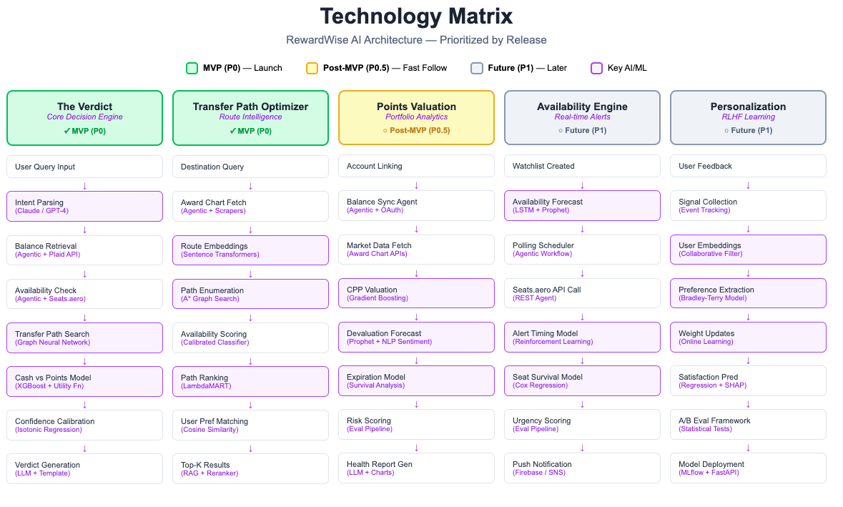

| User | LLM | Agent | API | ML Model | Output |
| --- | --- | --- | --- | --- | --- |

## User Scenarios

**1. The Verdict (Core Decision)- MVP P0**

| "I want to fly to Tokyo in March, business class" |
| --- |

↓

| LLM: Parse Intent (destination, dates, class, travelers) |
| --- |

↓

| Agent: Fetch Balances | → | Bank/Loyalty APIs |
| --- | --- | --- |

↓

| Agent: Check Availability | → | Seats.aero API |
| --- | --- | --- |

↓

| ML: Transfer Path Optimizer (rank 100+ paths by cpp) |
| --- |

↓

| ML: Cash vs Points Decision Engine (opportunity cost) |
| --- |

↓

| ML: Confidence Calibration |
| --- |

↓

| **THE VERDICT: Use Points (92% confidence) | Save $8,315** |
| --- |

**2. Availability Engine + Alerts - NOT MVP (P1)**

| User sets watchlist: "LAX → London, Sep, Business" |
| --- |

↓

| ML: Availability Forecast (when will seats open?) |
| --- |

↓

| Agent: Poll Availability (every 4hr) | → | Seats.aero API |
| --- | --- | --- |

↓

| ML: Optimal Alert Timing (minimize false alarms) |
| --- |

↓

| ML: Seat Disappearance Predictor (19hr until gone) |
| --- |

↓

| **🚨 ALERT: 2 seats found! Book within 19 hours** |
| --- |

**3. Transfer Path Optimizer - MVP (P0)**

| User: 80k Chase + 52k Amex → Bali? |
| --- |

↓

| Agent: Fetch Award Charts | → | Partner Program Data |
| --- | --- | --- |

↓

| ML: Path Enumeration (A* graph search, 127 paths) |
| --- |

↓

| ML: Availability Confidence (P per route) |
| --- |

↓

| ML: Path Ranking (LambdaMART, user prefs) |
| --- |

↓

| **#1: Chase → Singapore (4.8 cpp, 91% conf) | #2: Amex → ANA (4.1 cpp, 93% conf)** |
| --- |

**4. Points Valuation Engine - NOT MVP (P0.5)**

| User links accounts / enters balances |
| --- |

↓

| Agent: Sync Balances | → | Bank/Loyalty APIs |
| --- | --- | --- |

↓

| ML: Dynamic CPP Valuation (47 features, market data) |
| --- |

↓

| ML: Devaluation Risk (Prophet) |  | ML: Expiration Risk (Survival) |
| --- | --- | --- |

↓

| **Total: 211k pts = $2,967 value | ⚠️ United: 67% devaluation risk by Q3** |
| --- |

**5. Personalization (RLHF) - NOT MVP (P1)**

| User completes trip + provides feedback |
| --- |

↓

| ML: Preference Extraction (Bradley-Terry) |
| --- |

↓

| Signals: Ratings | Clicks | Bookings | Complaints |
| --- |

↓

| ML: Update User Preference Weights |
| --- |

↓

| ML: Satisfaction Predictor (pre-screen future recs) |
| --- |

↓

| **Learned: Direct flights +0.13 weight | Future verdicts adjusted** |
| --- |

**AI Component Summary**

| **Feature** | **Priority** | **Key Technologies** | **Rationale** |
| --- | --- | --- | --- |
| The Verdict | ✓ MVP (P0) | LLM, Seats.aero Agent, XGBoost, GNN | Core value prop — the single verdict |
| Transfer Path | ✓ MVP (P0) | A* Search, Embeddings, LambdaMART, RAG | Required for Verdict to work |
| Valuation Engine | Post-MVP (P0.5) | XGBoost, Prophet, Survival Analysis | Enhances wallet view, not blocking launch |
| Availability Alerts | Future (P1) | LSTM, RL, Cox Regression, Firebase | Nice-to-have, requires complex infra |
| Personalization | Future (P1) | RLHF, Bradley-Terry, Collab Filter | Needs user data first, later phase |

# Frequently Asked Questions

**FAQ 1: Why do I need RAG? What is the user experience with both RAG and ML?**

We need LLM regardless to understand user intent. With ML, we need to rank the best value for the user in order to deliver the VERDICT. With RAG, that VERDICT is based on facts and latest information, thereby providing legitimacy and accuracy to our recommendation e.g. transfer 60K Chase points to Virgin Atlantic in order to get the ANA flight from LAX to Tokyo.

## **WITH RAG**

### **Step 1: Retrieve Transfer Rules at Query Time**

Query: "What programs can Chase UR transfer to?"

Retrieved:

- Chase → United: 1:1, instant

- Chase → Virgin Atlantic: 1:1, instant

- Chase → Air France: 1:1, instant

- Chase → Hyatt: 1:1, instant

- [12 more partners...]

### **Step 2: ML Receives Complete Features**

| **Feature** | **Value** | **Source** |
| --- | --- | --- |
| virgin_points_required | 60,000 | Seats.aero |
| united_points_required | 88,000 | Seats.aero |
| user_chase_balance | 180,000 | User input |
| chase_transfers_to_virgin | 1 | **RAG** |
| chase_transfers_to_united | 1 | **RAG** |
| transfer_ratio_virgin | 1.0 | **RAG** |
| transfer_ratio_united | 1.0 | **RAG** |
| transfer_time_virgin | 0 (instant) | **RAG** |
| transfer_time_united | 0 (instant) | **RAG** |

### **Step 3: ML Ranks Paths**

ML sees all accessible options with complete features:

| **Path** | **Points** | **Accessible** | **CPP** | **ML Score** |
| --- | --- | --- | --- | --- |
| Chase → Virgin → ANA | 60,000 | ✅ | 5.2¢ | **0.94** |
| Chase → Air France → JAL | 72,000 | ✅ | 4.3¢ | 0.81 |
| Chase → United → ANA | 88,000 | ✅ | 3.5¢ | 0.72 |

**ML output:** Virgin Atlantic, 60K, 94% confidence. ✅ **Optimal.**

### **When Chase Removes Virgin as Partner**

Update RAG doc: Remove "Chase → Virgin Atlantic" from transfer rules.

**Next query, RAG returns:**

- Chase → United: 1:1, instant

- Chase → Air France: 1:1, instant

- [Virgin Atlantic not listed]

**ML receives:**

| **Feature** | **Value** |
| --- | --- |
| chase_transfers_to_virgin | 0 |
| chase_transfers_to_united | 1 |

**ML output:** Air France at 72K (next best accessible option). ✅ **Correct, no retraining needed.**

## **Side-by-Side**

| **Scenario** | **Without RAG (Hardcoded)** | **Without RAG (Incomplete)** | **With RAG** |
| --- | --- | --- | --- |
| Day 1: Normal state | ✅ Virgin 60K | ❌ United 88K | ✅ Virgin 60K |
| Day 30: Chase drops Virgin | ❌ Still recommends Virgin (user can't book) | ✅ United 88K (but was always suboptimal) | ✅ Air France 72K |
| Time to fix | Days (code deploy + retrain) | N/A | Minutes (update doc) |

## **The Point**

**ML doesn't know facts. ML learns patterns from data.**

* "60K < 88K" → ML can rank this
* "Chase transfers to Virgin" → ML can't learn this from booking history; it's a fact about the world

**RAG feeds facts to ML as features at query time.** Without it, ML either operates on stale facts (dangerous) or incomplete facts (suboptimal).

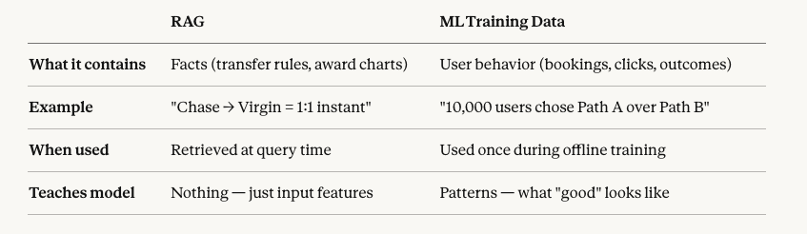

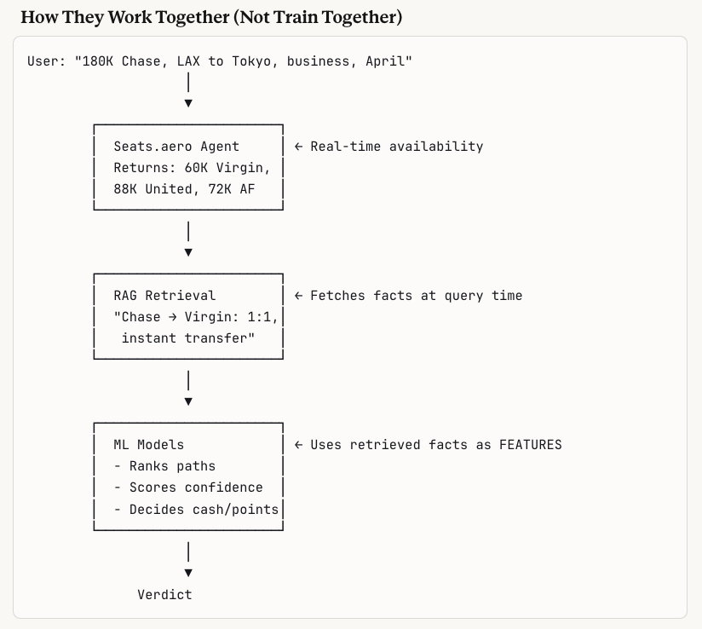

User Example 2 -> Toronto to Delhi, but final destination Amritsar

## **The Difference**

| **Scenario** | **Type** | **Solution** |
| --- | --- | --- |
| Tokyo → NRT, HND | Same city, multiple airports | Deterministic lookup |
| Delhi vs Amritsar | Different cities, 450km apart | Requires **user context** |

You can't just search every nearby city — that doesn't scale. You need a reason to know Amritsar is relevant.

## **Three Ways We'd Know to Suggest Amritsar**

### **1. User Tells Us (LLM Intent Parsing)**

**User types:** *"Toronto to Delhi, but I'm actually going to Amritsar"*

**LLM parses:**

json

{

"origin": "YYZ",

"destination": "DEL",

"final_destination": "Amritsar",

"cabin": "economy"

}

```

**System searches:** DEL + ATQ (Amritsar)

**No magic needed — user gave us the context.**

---

### 2. User Profile (Stored Preferences)

During onboarding or account setup:

> "What's your home city?" → **Amritsar**

Now when user searches "Toronto to Delhi":

**System logic:**

```

User home = Amritsar

Search destination = Delhi

Amritsar is 450km from Delhi

→ Also search ATQ as alternative

**This is a simple rule, not ML:**

python

if user.home_city and distance(user.home_city, search_destination) < 500km:

also_search(user.home_city)

```

---

### 3. Learned Behavior (Personalization ML — P1)

User has no profile, but over 6 months:

- Searches "Toronto → Delhi" 4 times

- Always books onward flight DEL → ATQ

- Or closes app and books ATQ directly elsewhere

**ML learns:** This user's Delhi searches should include Amritsar.

**This is the P1 Personalization feature from our matrix** — collaborative filtering / preference learning. Not MVP.

---

## The Flow (MVP)

```

User: "Toronto to Delhi, visiting family in Amritsar"

│

▼

LLM Intent Parsing

→ origin: YYZ

→ destination: DEL

→ final_destination: Amritsar ← LLM catches this

│

▼

Deterministic Expansion

→ Delhi = [DEL]

→ Amritsar = [ATQ]

│

▼

Seats.aero Agent

→ Query YYZ→DEL AND YYZ→ATQ

│

▼

ML Ranking

→ Compares all paths

→ Maybe ATQ is 40K points vs DEL at 80K

│

▼

Verdict: "Fly direct to Amritsar, save 40K points"

## **What If User Just Says "Toronto to Delhi"?**

**No mention of Amritsar, no profile.**

| **Approach** | **MVP?** | **How** |
| --- | --- | --- |
| Ask clarifying question | ✅ Yes | LLM: *"Are you staying in Delhi or traveling onward? I can check nearby cities too."* |
| Search nearby cities automatically | ❌ No | Doesn't scale — which cities? 500km radius = dozens |
| Learn from past behavior | ❌ P1 | Personalization ML |

**MVP answer:** LLM asks a clarifying question if destination is a major hub with common onward travel patterns (Delhi, London, NYC).

## **Summary**

| **Signal** | **Source** | **When** |
| --- | --- | --- |
| User explicitly mentions Amritsar | LLM intent parsing | Query time |
| User profile has home city | Stored preferences | Query time |
| User always books DEL → ATQ | Personalization ML | Learned over time (P1) |
| No signal | LLM asks clarifying question | Query time |

**Not RAG. Not deterministic lookup. It's user context — either explicit, stored, or learned.**

**Appendix A – End-to-End AI Decision Flow (LLM + RAG + ML)**

This appendix shows end to end describes how Rewardwise combines LLM, RAG, ML, and deterministic logic to generate a high-confidence “cash vs. points” verdict.

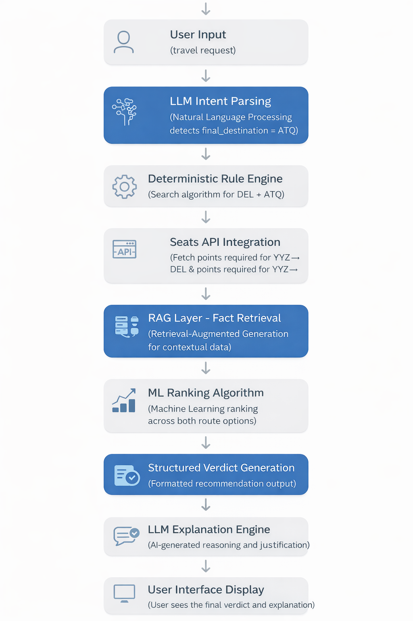

ML Models

# **RewardWise**

User Flows with ML Models

Product Specification Document

# **Flow 1: Onboarding**

Customer signs up for RewardWise

### **ML Models Running:**

| **Model** | User Segmentation Classifier |
| --- | --- |
| **Type** | Multi-class classification |
| **Input** | Signup data, programs selected, balances |
| **Output** | User persona (casual/frequent/enthusiast/hacker) |
| **Purpose** | Personalize UX + recommendation depth from first interaction |

| **Model** | LTV Prediction |
| --- | --- |
| **Type** | Regression |
| **Input** | Programs, balances, travel preferences |
| **Output** | Predicted lifetime value ($) |
| **Purpose** | Prioritize high-value users for concierge outreach |

### **App Output:**

| Welcome to RewardWise! 🚀    Quick setup (2 min):    Step 1: Which programs do you have?  ☑ Chase Ultimate Rewards  ☑ Amex Membership Rewards  ☑ United MileagePlus    Step 2: Enter balances (approximate OK)  Chase UR: [_______] pts  Amex MR: [_______] pts    ━━━━━━━━━━━━━━━━━━━━━━━━━━  🤖 ML INSIGHT (internal)  User Segment: "Aspirational Frequent" (78% conf)  Predicted LTV: $340/year  Churn risk: Low (0.12)  ━━━━━━━━━━━━━━━━━━━━━━━━━━ |
| --- |

# **Flow 2: Wallet Unification**

Customer enters/updates point balances

### **ML Models Running:**

| **Model** | Points Valuation Engine |
| --- | --- |
| **Type** | Dynamic pricing regression |
| **Input** | Program, balance, historical redemptions, market data |
| **Output** | Real-time cpp valuation per program |
| **Features** | 47 inputs inc. seasonality, route popularity, cabin class |
| **Refresh** | Every 6 hours |

| **Model** | Devaluation Risk Predictor |
| --- | --- |
| **Type** | Time-series forecasting (Prophet) |
| **Input** | Historical award charts, airline financials, news sentiment |
| **Output** | Devaluation probability (0-1) + expected % loss |
| **Horizon** | 3, 6, 12 month forecasts |

| **Model** | Expiration Risk Scorer |
| --- | --- |
| **Type** | Survival analysis |
| **Input** | Last activity, program rules, user behavior patterns |
| **Output** | Days until expiration risk |
| **Alert threshold** | < 90 days |

### **App Output:**

| UNIFIED WALLET VIEW    Programs linked: 4  Last updated: Jan 27, 2026    BALANCES & VALUATIONS:  ━━━━━━━━━━━━━━━━━━━━━━━━━━━━━━━━━━━━━━━  Program │ Points │ Value │ cpp │ Risk  ━━━━━━━━━━━━━━━━━━━━━━━━━━━━━━━━━━━━━━━  Chase UR │ 80,000 │ $1,360 │ 1.70 │ Low  Amex MR │ 52,000 │ $884 │ 1.70 │ Low  United │ 34,000 │ $408 │ 1.20 │ ⚠️ Med  Marriott │ 45,000 │ $315 │ 0.70 │ ⚠️ Med  ━━━━━━━━━━━━━━━━━━━━━━━━━━━━━━━━━━━━━━━    🤖 ML CONFIDENCE SCORES:  • Valuation accuracy: 94% (±$180)  • Based on 12,847 recent redemptions    ⚠️ ML-DETECTED RISKS:  • United: 67% chance of 10-15% devaluation by Q3  • 12,000 United miles: 89% expire probability by Nov |
| --- |

# **Flow 3: The Verdict (Core Trip Search)**

Customer inputs trip request and receives recommendation

### **ML Models Running:**

| **Model** | Availability Prediction Network |
| --- | --- |
| **Type** | LSTM + Attention (sequence model) |
| **Input** | Route, dates, class, historical availability patterns, seasonality |
| **Output** | P(availability) per program/date |
| **Training data** | 2.3M historical award searches |
| **Accuracy** | 87% at 30-day horizon |

| **Model** | Transfer Path Optimizer |
| --- | --- |
| **Type** | Graph neural network + beam search |
| **Input** | User balances, all transfer partners, award charts, availability scores |
| **Output** | Ranked paths with expected value |
| **Search space** | 847 paths evaluated |
| **Optimization** | Max cpp subject to availability |

| **Model** | Cash vs Points Decision Engine |
| --- | --- |
| **Type** | Multi-armed bandit + utility function |
| **Input** | Cash price, points cost, user prefs, future trip probability, point decay |
| **Output** | POINTS / CASH / WAIT + confidence |
| **Key feature** | Considers opportunity cost of future trips |

| **Model** | Confidence Calibration |
| --- | --- |
| **Type** | Isotonic regression (post-hoc) |
| **Input** | Raw model predictions |
| **Output** | Calibrated confidence score |
| **Purpose** | "92% confident" means 92% accurate |

### **App Output:**

| THE VERDICT: USE POINTS ✓  Confidence: 92% ██████████░    RECOMMENDED PATH:  Transfer: Chase UR → Air Canada Aeroplan  Flight: AC7 SFO → YVR → NRT    COST:  Points: 85,000 × 2 = 170,000  Taxes/fees: $84.50  Point value: 4.9 cpp ✓✓✓    Cash price: $8,400 (2 pax)  You save: $8,315    ━━━━━━━━━━━━━━━━━━━━━━━━━━  🤖 ML MODEL OUTPUTS  ━━━━━━━━━━━━━━━━━━━━━━━━━━  Verdict confidence: 92%  ├─ Availability confidence: 96%  ├─ Valuation confidence: 94%  ├─ Opportunity cost model: 88%  └─ Path optimality: 91% |
| --- |

# **Flow 4: Cash vs Points Quick Check**

Customer inputs single flight for quick comparison

### **ML Models Running:**

| **Model** | Redemption Value Classifier |
| --- | --- |
| **Type** | Gradient boosting (XGBoost) |
| **Input** | Route, cabin, cash price, pts cost, day of week, days until departure |
| **Output** | Rating (poor/avg/good/excellent) |
| **Threshold** | >2.0 cpp = good (domestic), >3.5 cpp = good (international) |

| **Model** | Future Trip Value Estimator |
| --- | --- |
| **Type** | User embedding + collaborative filter |
| **Input** | User travel history, preferences, similar users' redemption patterns |
| **Output** | Expected future cpp if points saved |
| **Purpose** | Calculate true opportunity cost |

### **App Output:**

| QUICK CHECK    Flight: Delta 512 SFO → JFK  Cash price: $387    POINTS OPTIONS SCORED:    Option 1: Delta SkyMiles  Cost: 28,000 miles + $35  Value: 1.26 cpp  ML Rating: 0.23 ❌ POOR (Confidence: 96%)    OPPORTUNITY COST MODEL:  ━━━━━━━━━━━━━━━━━━━━━━━━━━  Your historical avg: 3.2 cpp  Predicted future trip value: 3.4 cpp  Opportunity cost: -$599 💸    THE VERDICT: PAY CASH 💵  Confidence: 89% |
| --- |

# **Flow 5: Award Availability Alert**

Customer sets watchlist and receives availability notifications

### **ML Models Running:**

| **Model** | Availability Forecast Model |
| --- | --- |
| **Type** | Temporal convolutional network |
| **Input** | Route, historical patterns, airline release schedules, holidays |
| **Output** | P(availability) over next 90 days |
| **Updates** | Every 4 hours |

| **Model** | Optimal Alert Timing |
| --- | --- |
| **Type** | Reinforcement learning (DQN) |
| **Input** | Availability probability, user response patterns, booking lead time |
| **Output** | When to alert (balance false alarms vs. missed opportunities) |
| **Reward** | Successful bookings |

| **Model** | Seat Disappearance Predictor |
| --- | --- |
| **Type** | Survival analysis (Cox regression) |
| **Input** | Route popularity, seats remaining, days until departure, cabin class |
| **Output** | Estimated hours until seats gone |
| **Purpose** | Create urgency calibration |

### **App Output (Alert Triggered):**

| 🚨 AVAILABILITY ALERT!    Route: LAX → LHR  Airline: Virgin Atlantic (Upper Class)  Seats available: 2    ━━━━━━━━━━━━━━━━━━━━━━━━━━  🤖 ML URGENCY ASSESSMENT  ━━━━━━━━━━━━━━━━━━━━━━━━━━  Survival model prediction:  ├─ P(available in 12hr): 72%  ├─ P(available in 24hr): 41%  ├─ P(available in 48hr): 18%  └─ Median time to gone: 19 hours    Urgency score: 0.87 HIGH ⚠️  Alert confidence: 94%    ⏰ ML estimates 19 hours until seats gone |
| --- |

# **Flow 6: Concierge Request (Simple)**

Customer submits domestic concierge request

### **ML Models Running:**

| **Model** | Request Complexity Classifier |
| --- | --- |
| **Type** | Multi-label classification |
| **Input** | Route, dates, travelers, balances, special requests |
| **Output** | Complexity score (0-1), tier assignment |
| **Purpose** | Route to appropriate service level |

| **Model** | Savings Potential Estimator |
| --- | --- |
| **Type** | Regression ensemble |
| **Input** | Trip params, user balances, market conditions |
| **Output** | Expected savings range ($) with percentiles |
| **Purpose** | Set user expectations, prioritize requests |

| **Model** | Auto-Research Engine |
| --- | --- |
| **Type** | LLM + structured retrieval (RAG) |
| **Input** | Trip request, award charts, availability data |
| **Output** | Draft verdict for human review |
| **Human-in-loop** | Required for final approval |

### **App Output:**

| CONCIERGE REQUEST RECEIVED    Order #: RW-2026-00142  Tier: Domestic Flight ($39)    ━━━━━━━━━━━━━━━━━━━━━━━━━━  🤖 ML PRE-ANALYSIS  ━━━━━━━━━━━━━━━━━━━━━━━━━━  Complexity score: 0.31 (Low)  Routing: Auto-research → Human review    Savings potential estimate:  ├─ P10 (conservative): $180  ├─ P50 (expected): $420  ├─ P90 (optimistic): $780  └─ Confidence: 82%    Estimated completion: 18 hours |
| --- |

# **Flow 7: Concierge Request (Complex)**

Customer submits premium multi-city concierge request

### **ML Models Running:**

| **Model** | Multi-City Route Optimizer |
| --- | --- |
| **Type** | Constraint optimization + GNN |
| **Input** | Cities, dates, preferences, balances |
| **Output** | Optimal sequencing + booking combination |
| **Constraints** | Connection times, visa requirements, seasons |

| **Model** | Hotel Points vs Cash Comparator |
| --- | --- |
| **Type** | Dynamic pricing regression |
| **Input** | Property, dates, room type, loyalty status |
| **Output** | Points value vs. cash (cpp) per property |
| **Data** | Scraped cash rates + award charts |

| **Model** | Peak Season Availability Predictor |
| --- | --- |
| **Type** | Seasonal decomposition + LSTM |
| **Input** | Destination, dates, historical data |
| **Output** | Availability likelihood, urgency flags |
| **Alert** | High demand periods flagged |

| **Model** | Family Travel Optimizer |
| --- | --- |
| **Type** | Custom constraint satisfaction |
| **Input** | Party composition, ages, special needs |
| **Output** | Adjusted recommendations for families |
| **Handles** | Child policies, seat configurations |

### **App Output:**

| ✅ YOUR VERDICT IS READY    Trip: NYC → Rome → Santorini → NYC    ━━━━━━━━━━━━━━━━━━━━━━━━━━  🤖 ML OPTIMIZATION SUMMARY  ━━━━━━━━━━━━━━━━━━━━━━━━━━  Routes evaluated: 2,847  Hotel combinations: 342  Total search space: 973,074 options    Overall confidence: 86%  ├─ Flight optimization: 89%  ├─ Hotel optimization: 84%  ├─ Sequencing optimality: 91%  └─ Family constraints: 94%    TOTAL SAVINGS: $18,390 (65%)  Confidence interval: $16,500 — $19,200 |
| --- |

# **Flow 8: Points Health Check**

Customer requests quarterly portfolio review

### **ML Models Running:**

| **Model** | Portfolio Risk Analyzer |
| --- | --- |
| **Type** | Ensemble (devaluation + expiration models) |
| **Input** | All balances, program trends, usage patterns |
| **Output** | Risk score per program + overall portfolio |
| **Factors** | Devaluation, expiration, idle time |

| **Model** | Opportunity Detection Engine |
| --- | --- |
| **Type** | Anomaly detection + recommendation |
| **Input** | Transfer bonuses, sweet spots, user balances, historical patterns |
| **Output** | Ranked opportunities with confidence |
| **Updates** | Daily scan of all programs |

| **Model** | Redemption Efficiency Tracker |
| --- | --- |
| **Type** | Time-series comparison |
| **Input** | User's historical redemptions |
| **Output** | Percentile rank vs. all users |
| **Benchmark** | Platform average cpp by route type |

| **Model** | Personalized Action Recommender |
| --- | --- |
| **Type** | Contextual bandit |
| **Input** | User state, opportunities, urgency levels |
| **Output** | Prioritized action list |
| **Learns from** | User follow-through rates |

### **App Output:**

| POINTS HEALTH REPORT — Q1 2026    Total points: 287,000  Estimated value: $4,890    🤖 PORTFOLIO HEALTH SCORE: 76/100  ├─ Value optimization: 82/100  ├─ Risk management: 68/100 ⚠️  └─ Diversification: 79/100    ⚠️ ML-DETECTED WARNINGS:  1. 18,000 United expire Nov (89% probability)  2. Delta devaluation (67% by Q2, -12% to -18%)    💡 ML-DETECTED OPPORTUNITIES:  1. Amex → BA bonus (30%, ends Feb 28)  2. ANA RTW sweet spot match (score: 0.91) |
| --- |

# **Flow 9: Transfer Path Optimizer**

Customer asks "how do I get to X destination?"

### **ML Models Running:**

| **Model** | Path Enumeration Engine |
| --- | --- |
| **Type** | Graph search (A* with pruning) |
| **Input** | Origin, destination, user balances |
| **Output** | All viable paths (typically 50-200) |
| **Prunes** | Impossible transfers, bad ratios |

| **Model** | Path Ranking Model |
| --- | --- |
| **Type** | Learning-to-rank (LambdaMART) |
| **Input** | Path features (cpp, availability, connection quality, user prefs) |
| **Output** | Ranked paths with scores |
| **Training** | User selection data (clicks/bookings) |

| **Model** | Availability Confidence Estimator |
| --- | --- |
| **Type** | Calibrated classifier |
| **Input** | Route, date range, historical data |
| **Output** | P(availability) with uncertainty bounds |
| **Handles** | Programs without live API data |

### **App Output:**

| TRANSFER PATH ANALYSIS — Bali (DPS)    🔄 ML Pipeline:  ├─ Paths enumerated: 127  ├─ Paths after pruning: 23  └─ Ranking model applied: ✓    #1 ⭐ BEST OVERALL (Score: 0.94)  Chase → Singapore KrisFlyer  86,000 pts + $120 | 4.8 cpp  Availability: 0.82 | Confidence: 91%    #2 BEST AVAILABILITY (Score: 0.89)  Amex → ANA Mileage Club  85,000 pts + $290 | 4.1 cpp  Availability: 0.94 | Confidence: 93%    #5 ❌ AVOID: Delta (160k pts, 1.8 cpp) |
| --- |

# **Flow 10: Preference Learning (RLHF)**

Customer provides feedback after trip to improve future recommendations

### **ML Models Running:**

| **Model** | Preference Extraction (RLHF) |
| --- | --- |
| **Type** | Reward model fine-tuning |
| **Input** | User ratings, implicit signals, trip outcomes, complaints |
| **Output** | Updated user preference weights |
| **Method** | Bradley-Terry preference learning |

| **Model** | Satisfaction Predictor |
| --- | --- |
| **Type** | Regression with user embeddings |
| **Input** | Trip features, user history |
| **Output** | Predicted satisfaction score |
| **Purpose** | Pre-screen recommendations |

| **Model** | Recommendation Calibrator |
| --- | --- |
| **Type** | Online learning (contextual bandit) |
| **Input** | Feedback signals over time |
| **Output** | Adjusted ranking weights per user |
| **Exploration** | 10% explore, 90% exploit |

### **App Output:**

| PREFERENCES UPDATED ✓    ━━━━━━━━━━━━━━━━━━━━━━━━━━  🤖 ML LEARNING SUMMARY  ━━━━━━━━━━━━━━━━━━━━━━━━━━  Feedback processed: +1 trip  Total trips learned: 7  Preference confidence: 84% (↑ from 76%)    UPDATED PREFERENCE WEIGHTS:  ━━━━━━━━━━━━━━━━━━━━━━━━━━  Factor │ Before │ After  Direct flight │ 0.18 │ 0.31 ⬆️  Airline quality │ 0.22 │ 0.26  Price/value │ 0.35 │ 0.24 ⬇️    KEY INSIGHT: You value direct flights  more than estimated. Adjusted threshold. |
| --- |

# **Flow 11: Subscription Management**

Customer views account and billing information

### **ML Models Running:**

| **Model** | Churn Prediction |
| --- | --- |
| **Type** | Gradient boosting classifier |
| **Input** | Usage patterns, engagement, billing history |
| **Output** | P(churn in 30 days) |
| **Action** | Trigger retention if P > 0.4 |

| **Model** | Upgrade Propensity |
| --- | --- |
| **Type** | Logistic regression |
| **Input** | Usage, searches, near-limits behavior |
| **Output** | P(upgrade if offered) |
| **Purpose** | Personalize upsell timing |

| **Model** | Value Realization Tracker |
| --- | --- |
| **Type** | Attribution model |
| **Input** | Bookings, savings, engagement metrics |
| **Output** | $ value delivered to user |
| **Purpose** | Justify subscription ROI |

### **App Output:**

| MY ACCOUNT — PRO ($14.99/mo)    ━━━━━━━━━━━━━━━━━━━━━━━━━━  🤖 YOUR VALUE SUMMARY  ━━━━━━━━━━━━━━━━━━━━━━━━━━  Subscription cost (3 mo): $44.97  Value delivered: $1,847    ROI: 41x your subscription cost ✓    You're in top 15% of value realization  vs. similar Pro users.    PERSONALIZED RECOMMENDATION:  Based on usage, Annual makes sense:  • Save $60.88/year (34%)  • Get 2 free concierge credits    ML confidence: 87% this fits your pattern |
| --- |

# **Flow 12: Free Tier Upsell**

Free user hits search limit and sees upgrade prompt

### **ML Models Running:**

| **Model** | Conversion Likelihood |
| --- | --- |
| **Type** | Propensity model |
| **Input** | User behavior, search patterns, trip value, engagement signals |
| **Output** | P(convert if shown offer) |
| **Action** | Customize offer based on score |

| **Model** | Optimal Offer Selection |
| --- | --- |
| **Type** | Multi-armed bandit |
| **Input** | User segment, conversion history |
| **Output** | Best offer (Pro vs. single verdict) |
| **Learns from** | Conversion outcomes |

| **Model** | Urgency Calibrator |
| --- | --- |
| **Type** | Behavioral model |
| **Input** | Trip dates, search intent signals |
| **Output** | Urgency messaging level |
| **Purpose** | Don't over-pressure low-intent users |

### **App Output:**

| SEARCH LIMIT REACHED    You've used 3/3 free searches.    YOUR LAST SEARCH:  SFO → London, Business, Sep 2026  Status: ⏸️ Paused    ━━━━━━━━━━━━━━━━━━━━━━━━━━  🤖 ML-PERSONALIZED OFFER  ━━━━━━━━━━━━━━━━━━━━━━━━━━  Based on your search (intl business):  Estimated savings potential: $1,200-2,400    We think Pro is right for you:  ├─ Your trip value: HIGH  ├─ Research pattern: Multiple searches  └─ Similar users: 73% upgraded    RECOMMENDED: Pro Monthly ($14.99/mo) |
| --- |

# **ML Model Summary**

| **Flow** | **Models Used** | **Purpose** |
| --- | --- | --- |
| 1. Onboarding | Segmentation, LTV Prediction | Personalize experience, prioritize high-value |
| 2. Wallet | Valuation, Devaluation, Expiration | Dynamic cpp, risk alerts |
| 3. Verdict | Availability, Path Optimizer, Cash/Points, Confidence | Core recommendation engine |
| 4. Quick Check | Redemption Classifier, Future Value | Fast comparison + opportunity cost |
| 5. Alerts | Forecast, Alert Timing, Disappearance | Smart notifications |
| 6. Concierge (Simple) | Complexity, Savings, Auto-Research | Route + estimate |
| 7. Concierge (Complex) | Multi-City, Hotel, Peak Season, Family | Deep analysis |
| 8. Health Check | Risk, Opportunity, Efficiency, Recommender | Quarterly review |
| 9. Transfer Paths | Enumeration, Ranking, Confidence | Route optimization |
| 10. Preferences | RLHF, Satisfaction, Calibrator | Personalization |
| 11. Subscription | Churn, Upgrade, Value Tracker | Retention + upsell |
| 12. Upsell | Conversion, Offer Selection, Urgency | Monetization |

API

<https://developers.seats.aero/reference/getting-started-p>

Except for the live search endpoint: <https://developers.seats.aero/reference/live-search>, other endpoints can be accessed by pro users at 1000 calls daily. [autumnlirec@gmail.com](mailto:autumnlirec@gmail.com)is a pro user. Happy to hook up my account for our app. For our MVP this feels sufficient to me if we need to use it

Mocks

**Landing Page Join Page** **Log in Page**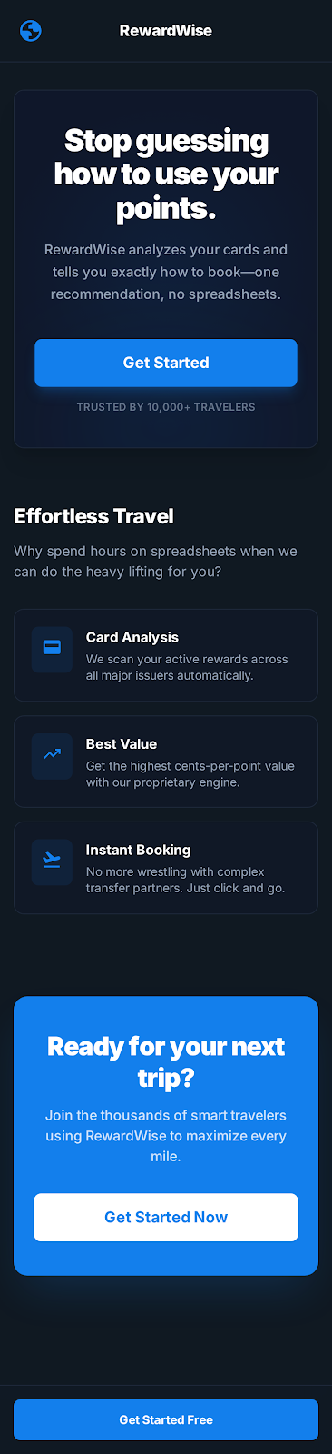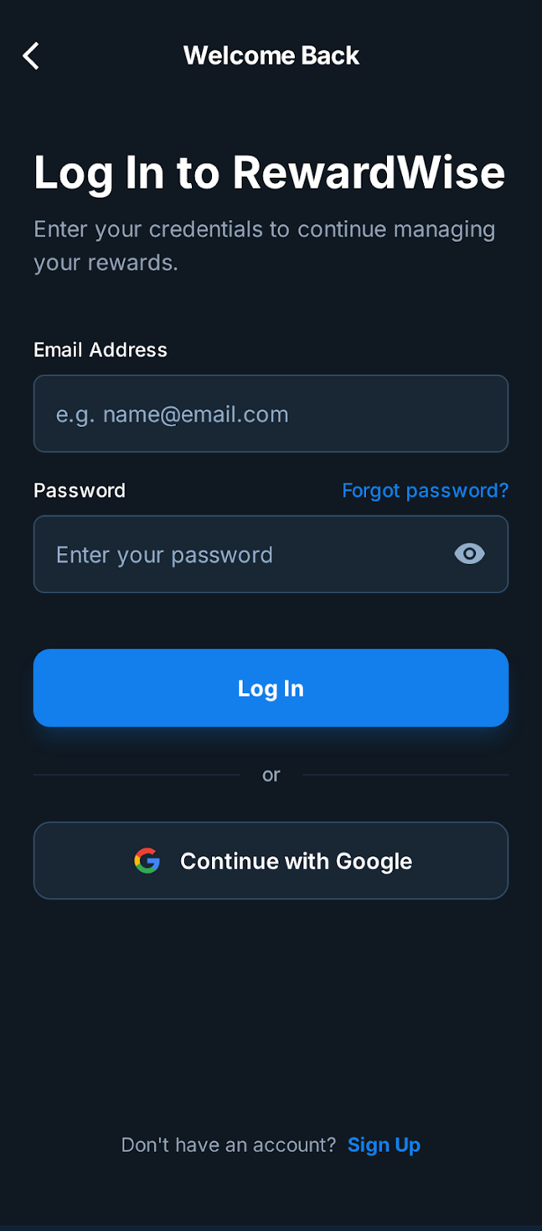

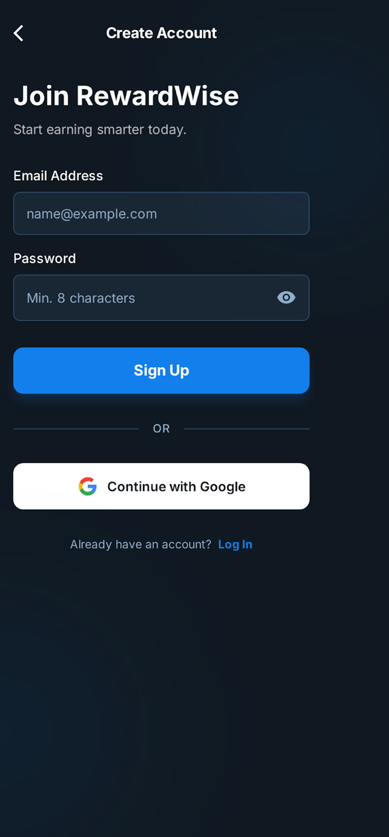

**Wallet Setup Dashboard/Home Page**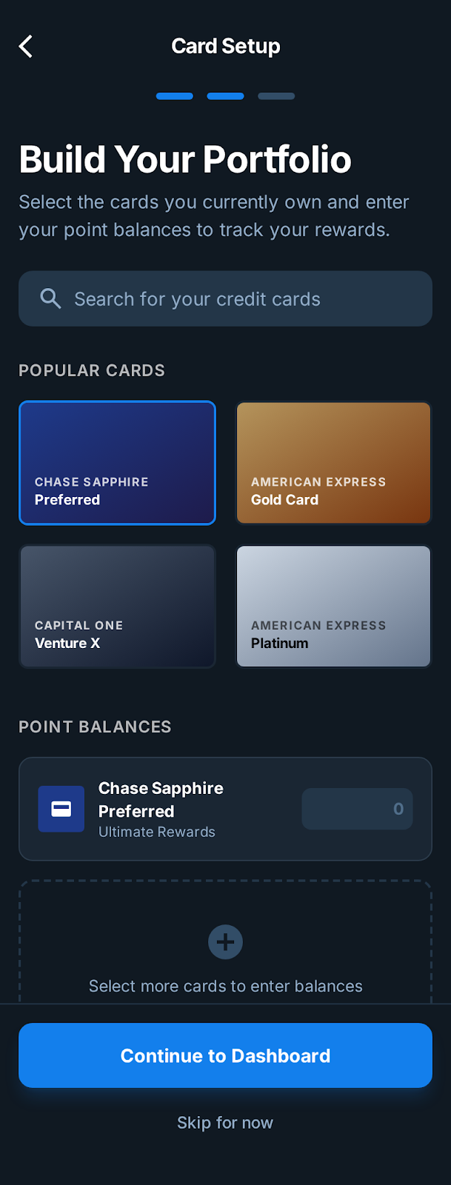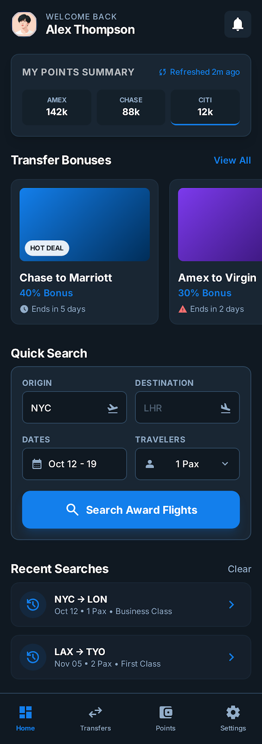

**Verdict** 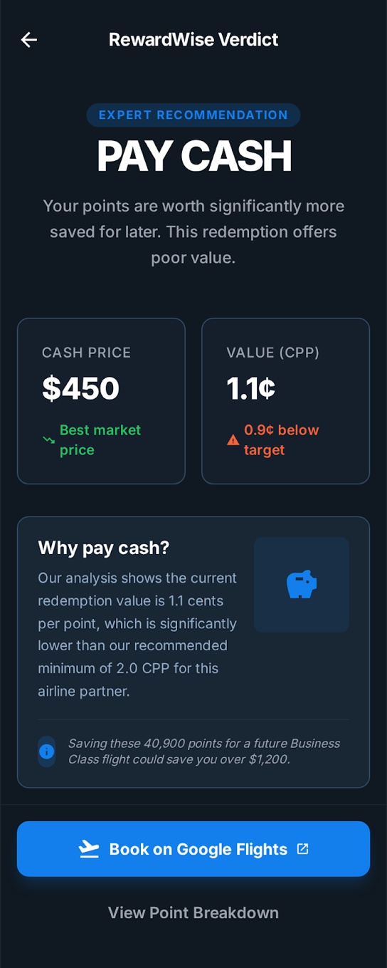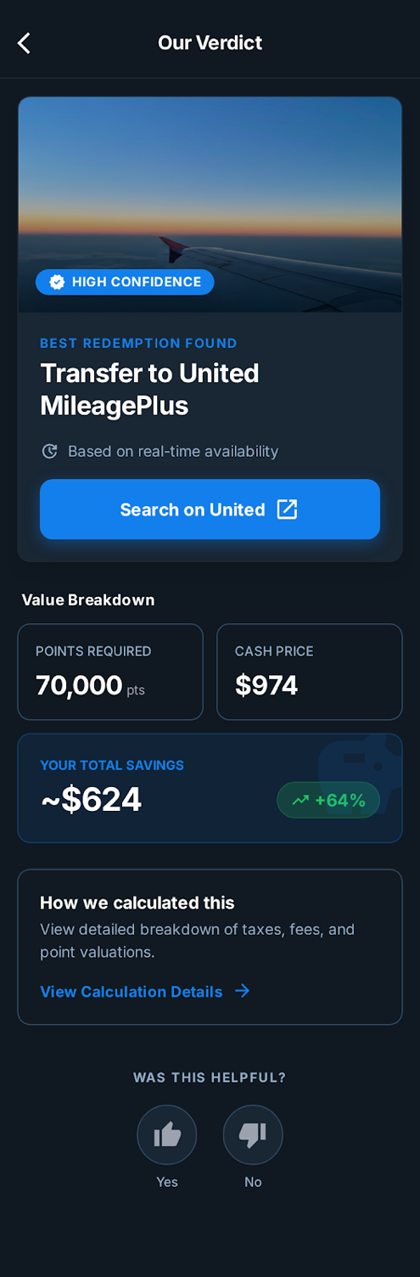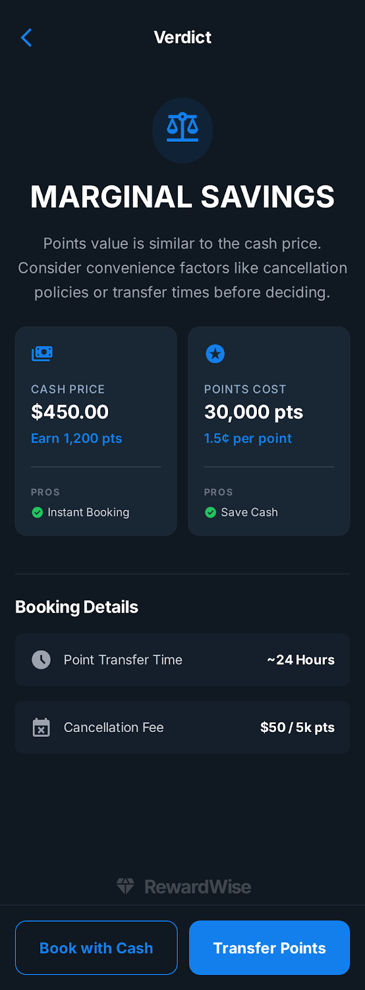

**Profile Settings Search History**

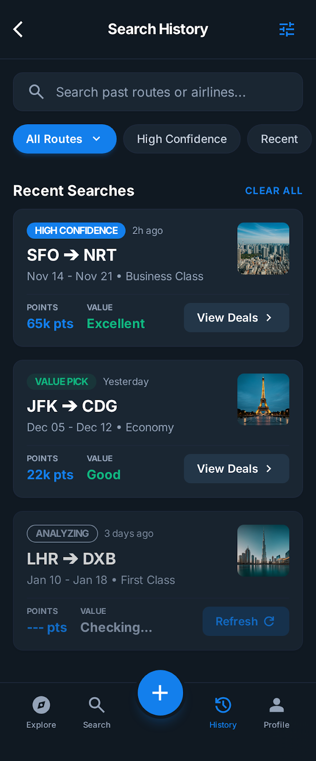

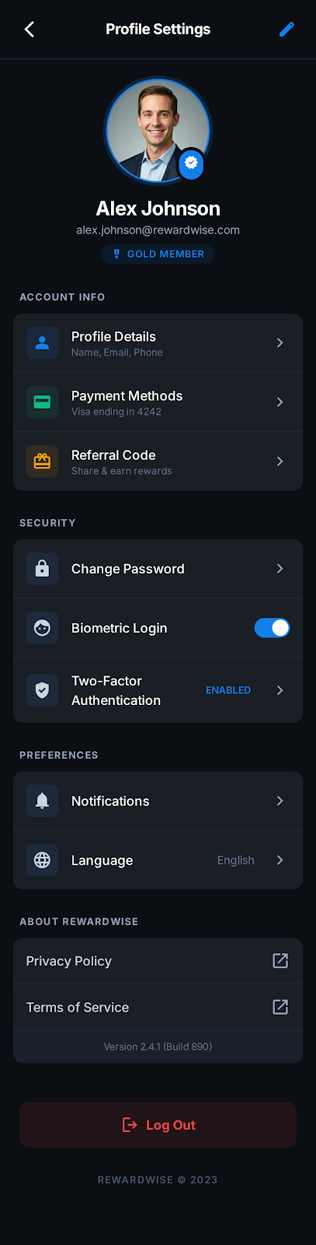

**Dashboard**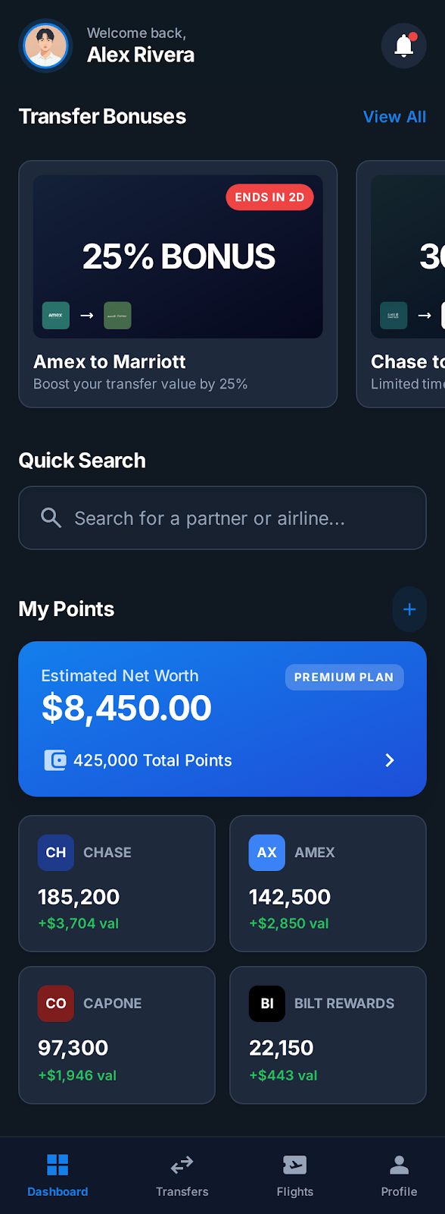

Seba's notes

Modifications Based on the userflows

In the first user flow, the parameters are met because this flow represents the happy path and the core structure of the experience.

In the second user flow, I added a different points balance for each card on Screen 5 (80,000 points for the Amex card and 50,000 points for the other card). Additionally, on Screen 6, I updated the alerts to inform users that their points will expire in 6 days.

In the third user flow, the flight class is already defined. The flight number, approximate departure and arrival times, and seat availability are added to the Quick Search results. On Screen 7, the cash price and the estimated savings are displayed

In Flow 4, Screen 8 shows a recommendation to pay with cash, and the final verdict supports that suggestion. Meanwhile, Screen 7 displays the number of points required if the user chooses to pay with points instead of cash.

In Flow 5, flight details are already visible in the Quick Search, including the selected flight and estimated travel dates. I also added one additional airline option below United on Screen 7.

From User Flow 6, I can see the option to use points or cash, which is already shown on Screen 7, and the CPP (Cost Points) is already included in the total

In Flow 7, we can see the points on each card in Screen 5, the dates and route in Screen 6, as well as the class, number of travelers, and tier in the quick search of the screen 6

From a UX perspective, I’d recommend prioritizing the core happy path before expanding into additional features like Hotels or Pro plans. Flows 8 to 12 introduce extra complexity that doesn’t seem essential to the primary booking experience.

Modifications based my criteria as UX designer

I added an additional password recovery screen after the login page.

On the Wallet Setup screen, I updated the copy from ‘Select your cards and enter your point balances’ to a clearer version that explains the purpose of the step: tracking rewards and personalizing offers. This version is more effective because it better communicates the value to users.

I believe the best option is to remove the third ‘Marginal Savings’ comparison screen and consolidate decision-making into a single verdict view. By replacing generic calls to action with outcome-driven actions (‘Book with Cash’ / ‘Book and Transfer Points’) and reframing the value as ‘Points Cost,’ I reduced cognitive load and streamlined the path to conversion.

Why pay with cash?Screen 8

This redemption requires a high number of points for a relatively low cash price, resulting in a high cost per point. Paying in cash allows users to preserve their points for redemptions with better value and efficiency

I removed the second dashboard because it did not provide meaningful profile details and did not support the core user goals

I created a dedicated Booking Details screen to give users immediate access to their current reservation after payment, instead of sending them to the full History list. This reduces cognitive load and keeps the focus on the most recent booking

Although the profile shows Gold Member status and a Rewardwise-affiliated email, I intentionally chose not to expand this feature, as it was not directly related to the core user flow or the main problem being solved

The wireframes where you can put comments

<https://www.figma.com/design/o2epKrzaAdY4RGif18lXmh/Rewardwise?node-id=0-1&p=f>

<https://www.figma.com/proto/o2epKrzaAdY4RGif18lXmh/Rewardwise?node-id=4-22&t=8FHadm5xWIpRT3dF-1&scaling=scale-down&content-scaling=fixed&page-id=0%3A1&starting-point-node-id=4%3A22>

The Interactive Prototype

User Survey

# **RewardWise Market Validation Survey**

**Estimated time: 1-2 minutes**

## **MUST HAVE (Core Questions - 6 questions)**

### **Q1. Screening**

**How many rewards programs (credit card, airline, hotel) do you have points in?**

* None *(End survey)*
* 1
* 2-3
* 4+

### **Q2. Current Behavior**

**When booking travel, how do you decide whether to pay cash or use points?**

* I have a clear system
* I guess based on gut feel
* I always use one method (cash or points)
* I find it confusing

### **Q3. Pain Validation**

**Have you ever regretted how you paid for a trip (e.g., used points when cash was better, or vice versa)?**

* Yes, multiple times
* Yes, once or twice
* No
* Not sure

### **Q4. Time Spent**

**How much time do you typically spend deciding cash vs. points for a trip?**

* < 15 minutes
* 15-60 minutes
* 1-3 hours
* 3+ hours

### **Q5. Value Proposition**

**If a tool gave you a clear verdict—"Use points (4.9¢ value)" or "Pay cash, save points for later"—how useful would that be?**

* Extremely useful
* Somewhat useful
* Not useful

### **Q6. Willingness to Pay**

**How much would you pay for a recommendation that saves you $300+ and removes the guesswork?**

* $0 (free only)
* $1-29
* $30-50
* $50+

## **NICE TO HAVE (Optional - 3 questions)**

### **Q7. Biggest Challenge**

**What makes the cash vs. points decision hard? (Select up to 2)**

* Don't know what my points are worth
* Transfer partners are confusing
* Can't find award availability
* Don't know if I should save points for later
* Taxes/fees make points feel expensive
* Other: _____

### **Q8. Preference**

**Would you prefer:**

* Self-service tool (you search, AI recommends)
* Done-for-you concierge (expert handles it)
* Both options

### **Q9. Open-Ended**

**Describe a recent trip where you weren't sure whether to use cash or points. What did you do?**

*(Free text)*

## **Google Form Setup Instructions**

### **Form Title:**

**Quick Survey: How Do You Use Your Travel Points?**

### **Form Description:**

*Help us build a smarter way to maximize your points. Takes 1-2 minutes. Your answers are anonymous.*

### **Settings:**

* Collect email: OFF
* Limit to 1 response: Optional
* Show progress bar: ON
* Shuffle question order: OFF

### **Section 1: "Quick Questions" (Q1-Q6 required)**

### **Section 2: "Optional - Help Us Learn More" (Q7-Q9 optional)**

### **End Screen Message:**

*Thanks! Want early access to RewardWise? Drop your email at [link] or follow us @RewardWise*

## **Key Metrics from Must-Haves**

| **Question** | **Insight** |
| --- | --- |
| Q1 | Qualify multi-program users (target market) |
| Q2 | Confidence gap = opportunity size |
| Q3 | Regret = pain intensity |
| Q4 | Time spent = willingness to pay for time savings |
| Q5 | Value prop resonance |
| Q6 | Price sensitivity / monetization |

## **Survey Link Structure**

Google Form URL: [Create at forms.google.com]

Recommended distribution:

- Reddit: r/churning, r/awardtravel, r/creditcards

- Facebook: Travel hacking groups

- Twitter/X: Points & miles community

- Friends/family with travel cards

Survey Analysis

**Rewardwise Survey Insights – Simplified Summary**

**1. What Problem Did We Validate?**

Users struggle with one core question:

“Is it actually worth using my points?”

From the survey, the top problems were:

1. Not knowing if it’s worth it (most selected) ~ 73%
2. Too many options to compare ~ 56%
3. Award availability uncertainty
4. Transfer complexity
5. Time + mental effort

Common behaviours:

* Double-checking multiple websites
* Doing the math manually
* Comparing elsewhere before booking

**2. What This Really Means**

The current systems feels:

* Fragmented
* Complex
* Time-consuming
* Mentally exhausting

**3. What frustrates them?**

The users find it very frustrating:

* Finding availability ~ 38.9 %
* Transferring points to hotels, airlines ~ 36%

**4. The Clear Problem Statement**

Travel rewards decisions are complex and time-consuming, leaving even experienced travelers unsure whether they’re making the smart choice between cash and points.

Users have points but lack confidence in deciding when to use them.

**5. What Users Actually Want**

They want:

* A clear answer
* Confidence
* Less second-guessing
* Faster decisions
* Reduced regret

**6. Who Is This Really For?**

Based on responses, the strongest pattern is:

* Age: 35–54 dominant
* Travel frequency: 2–6 trips/year
* Points balance: 50k–300k+
* Behavior: double-checks multiple sources
* Mindset: wants best value but doesn’t enjoy optimizing
* Emotion: afraid of wasting points

**Profile**

* Working professional (often with partner or family)
* Accumulates points naturally through spending
* Travels a few times a year

**Behavioral Traits**

* Double-checks Google Flights + airline site ~ 47.4%
* Feels unsure if it’s worth it ~34%
* Sometimes regrets redemption
* Wants a solid answer quickly

**Core Need of the User :**

Tell me the smart choice so I do not have to overthink it.

**7. Problem Statement (Derived from Survey)**

Travel rewards users struggle to confidently decide whether to use points or pay cash because evaluating value requires comparing multiple programs, doing manual calculations, and navigating fragmented information.

This Survey validates the purpose of Rewardwise i.e. Rewardwise can remove the uncertainty and mental effort of deciding between cash and points by delivering one clear, high-confidence verdict.

StylePilot AI Demo 1/30/26

Sabby:

1. Need to get a video of RewardWise!
2. <https://reliable-shortbread-8e3ba6.netlify.app/>

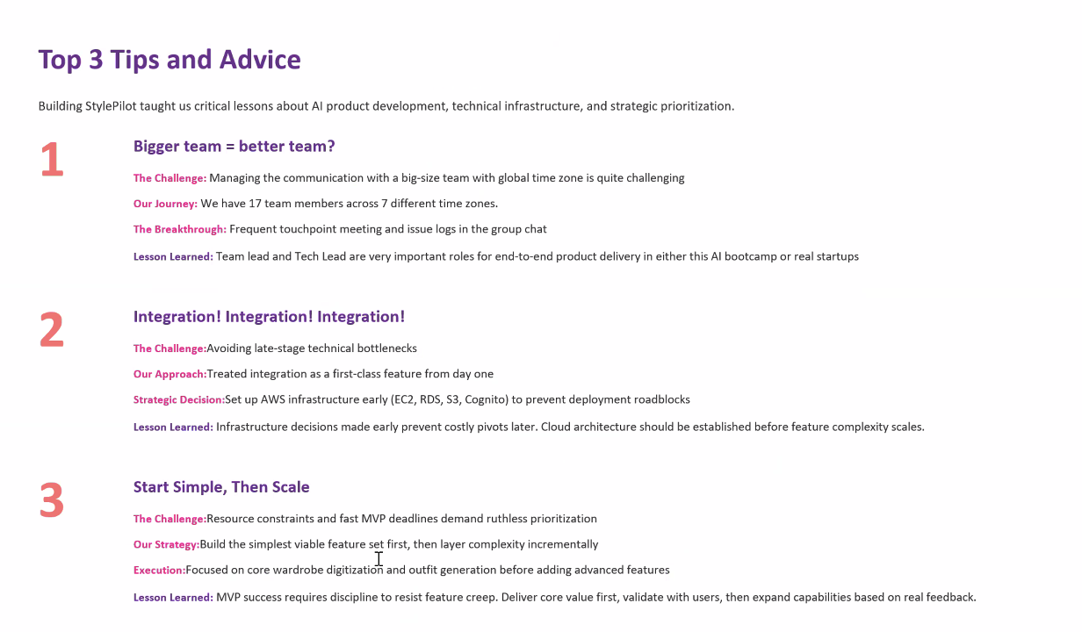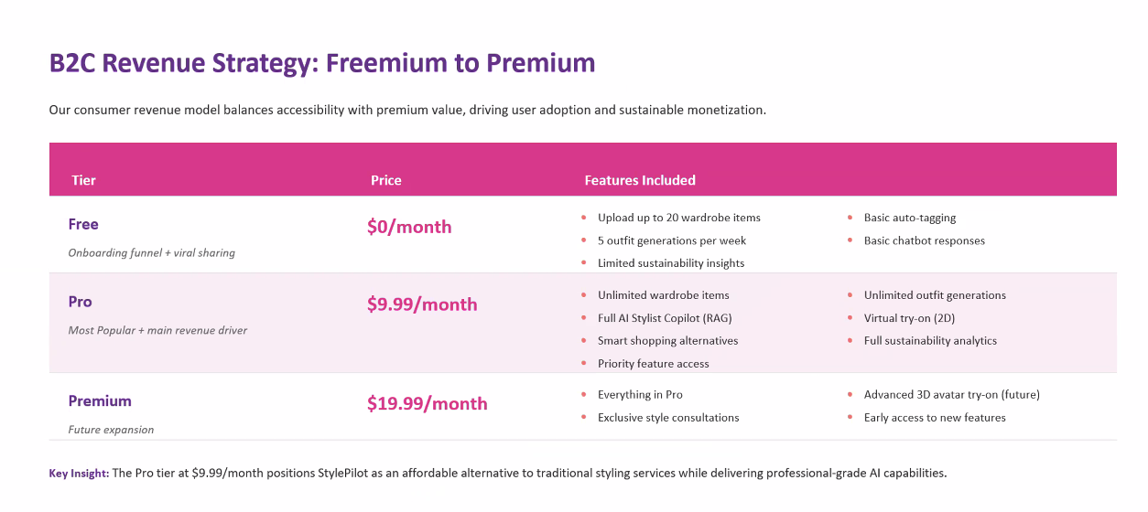

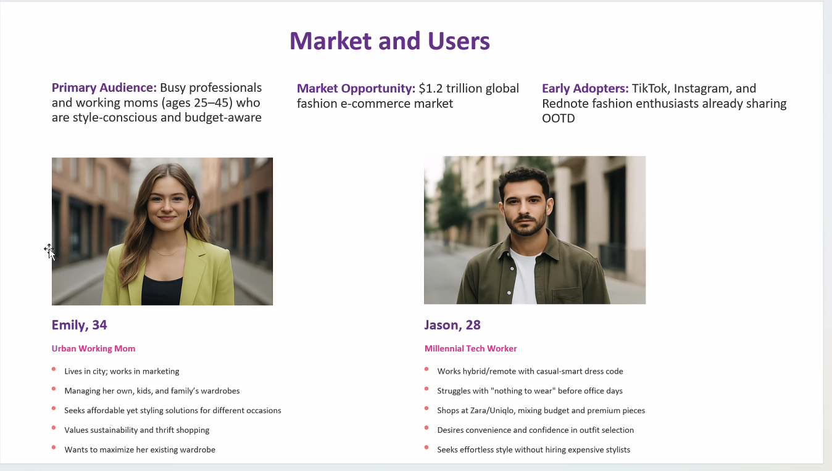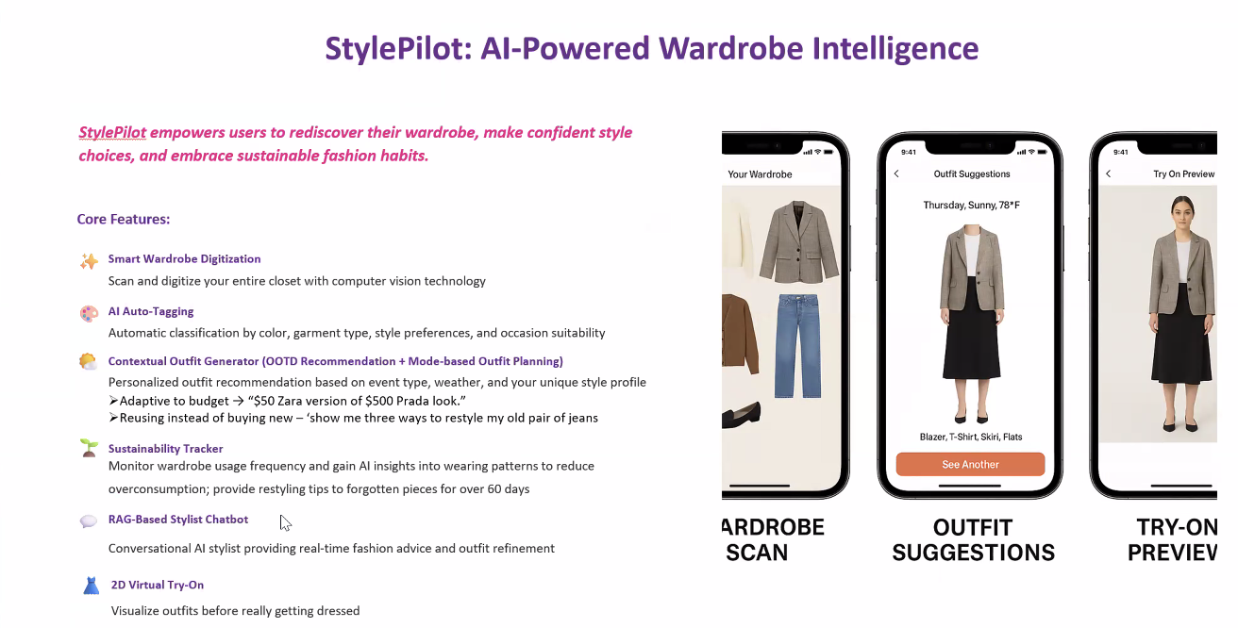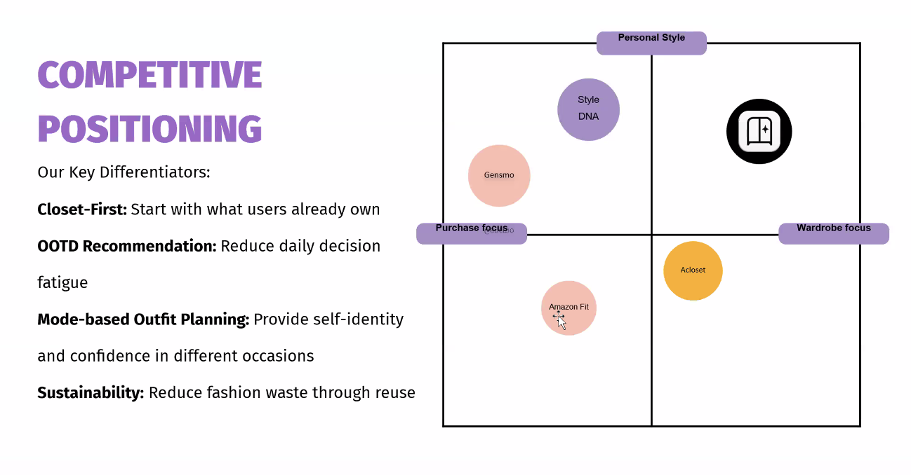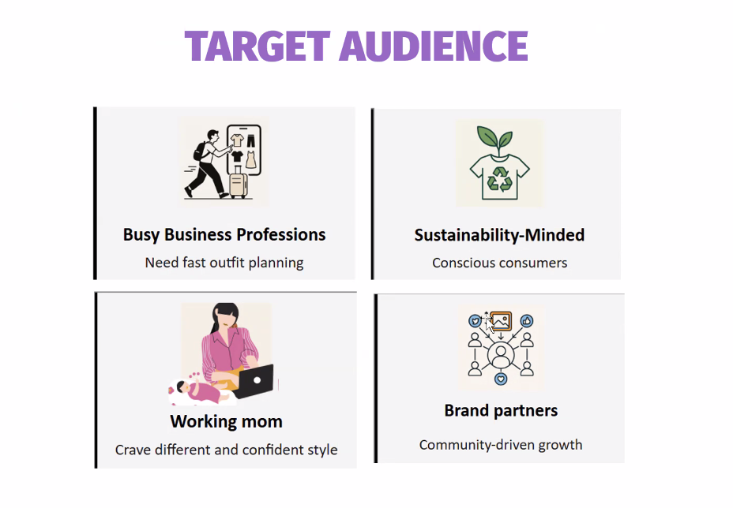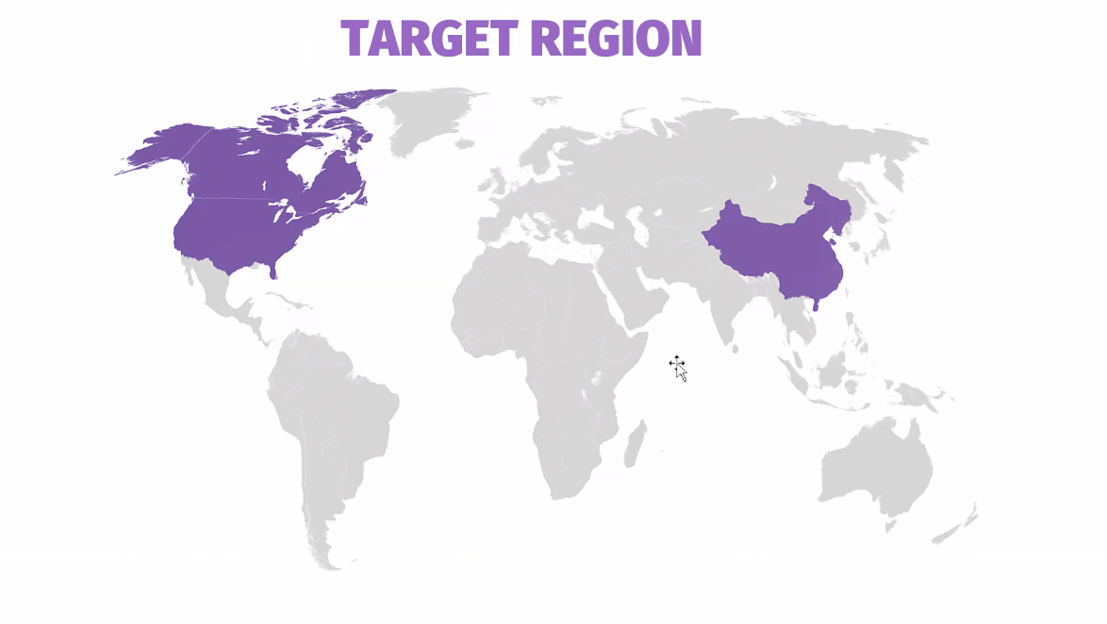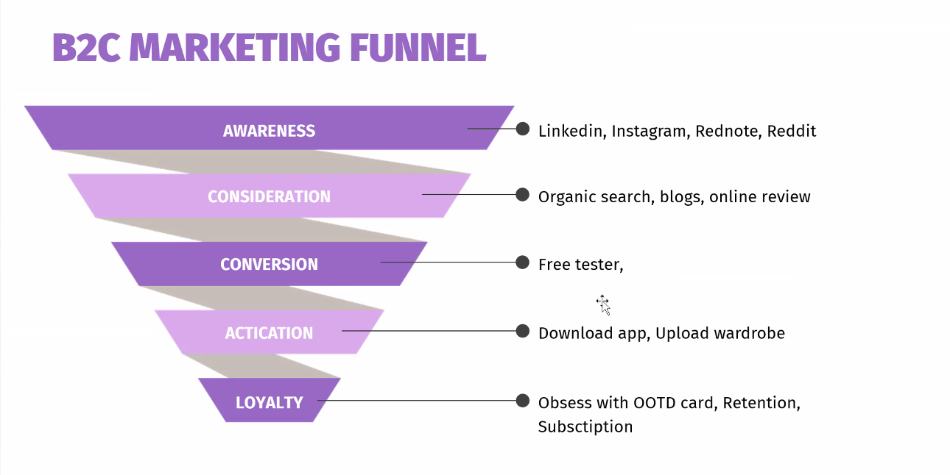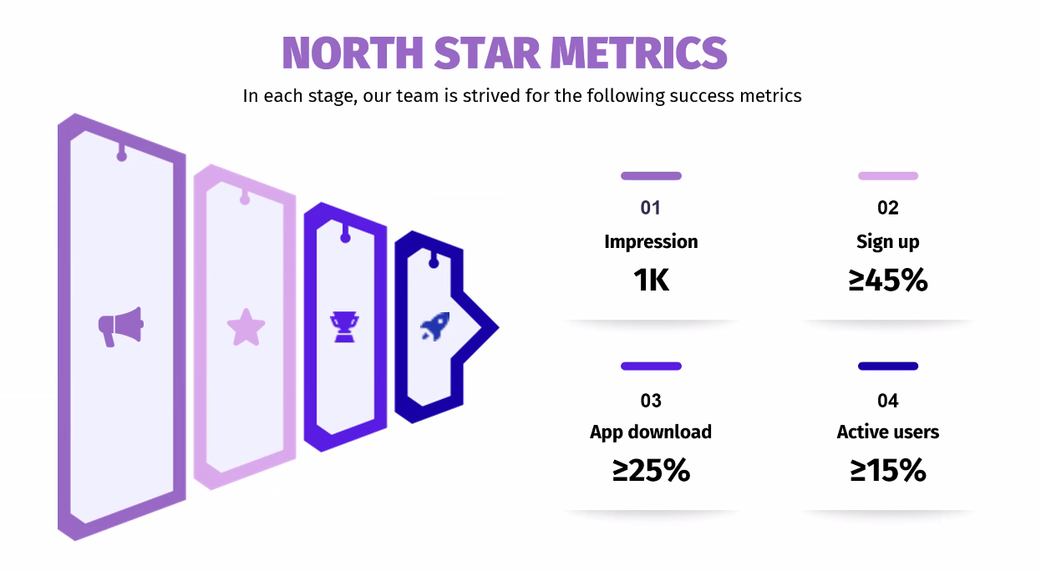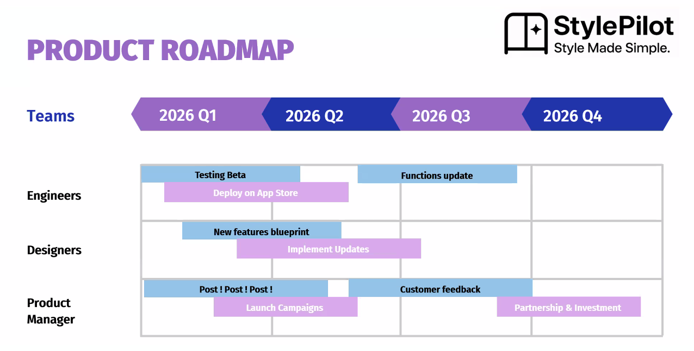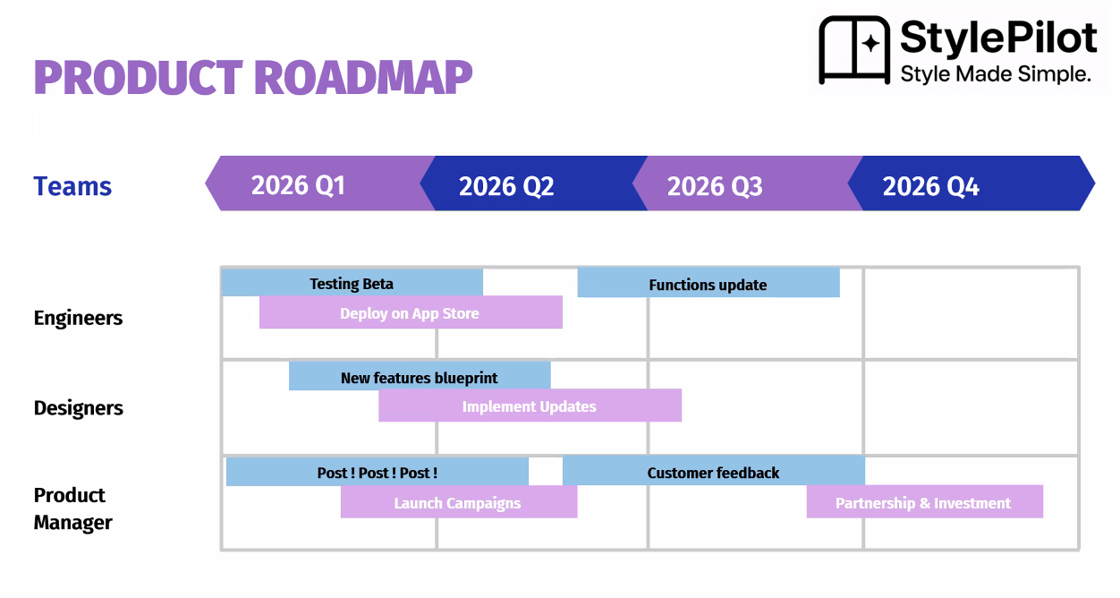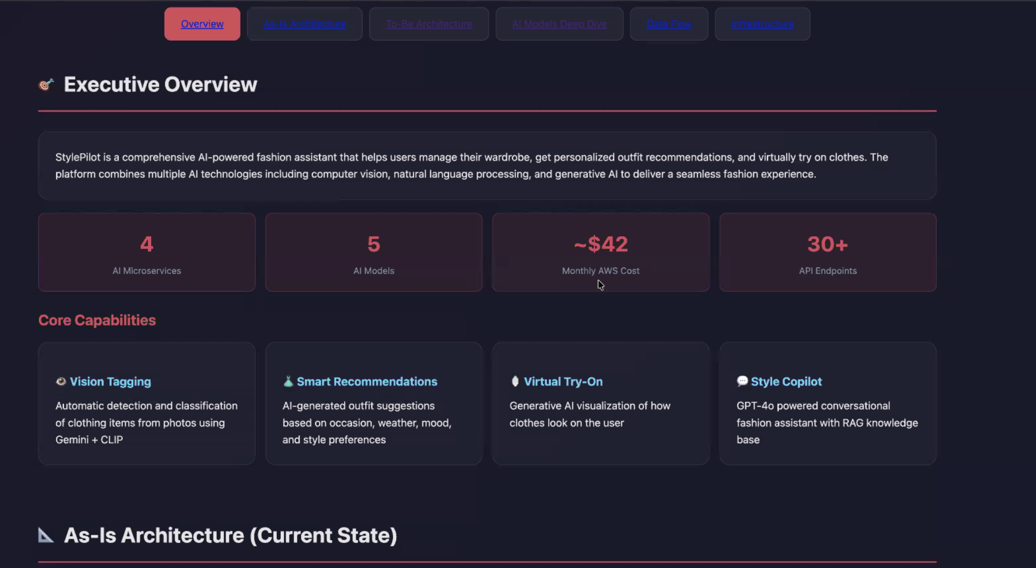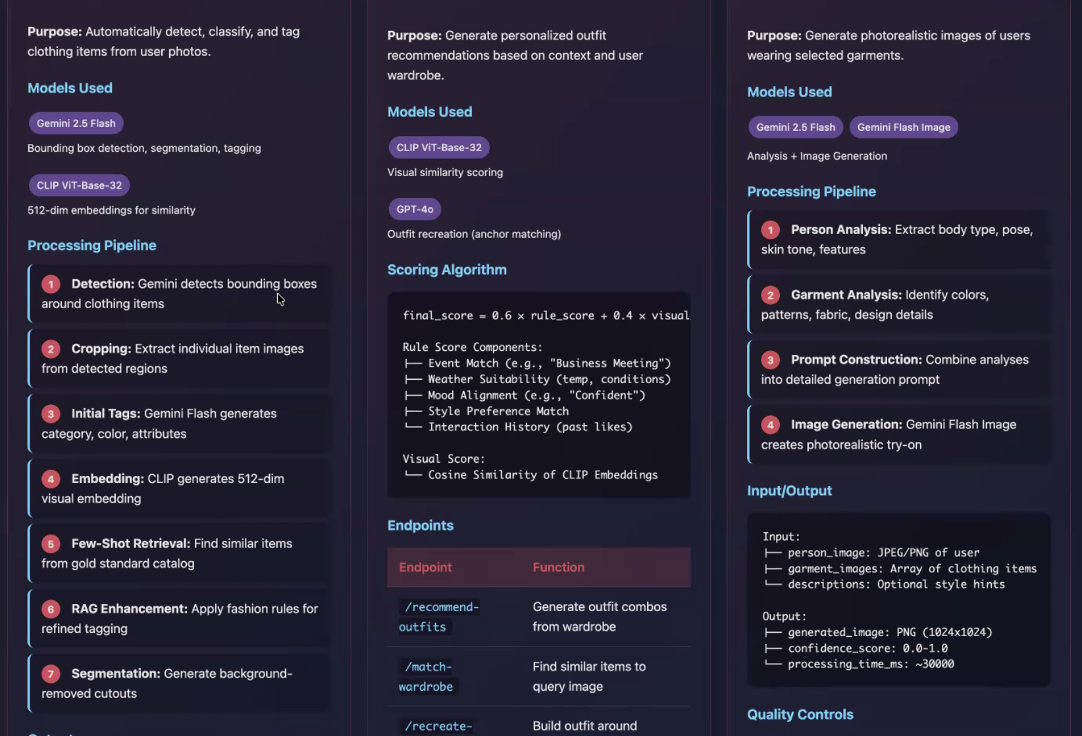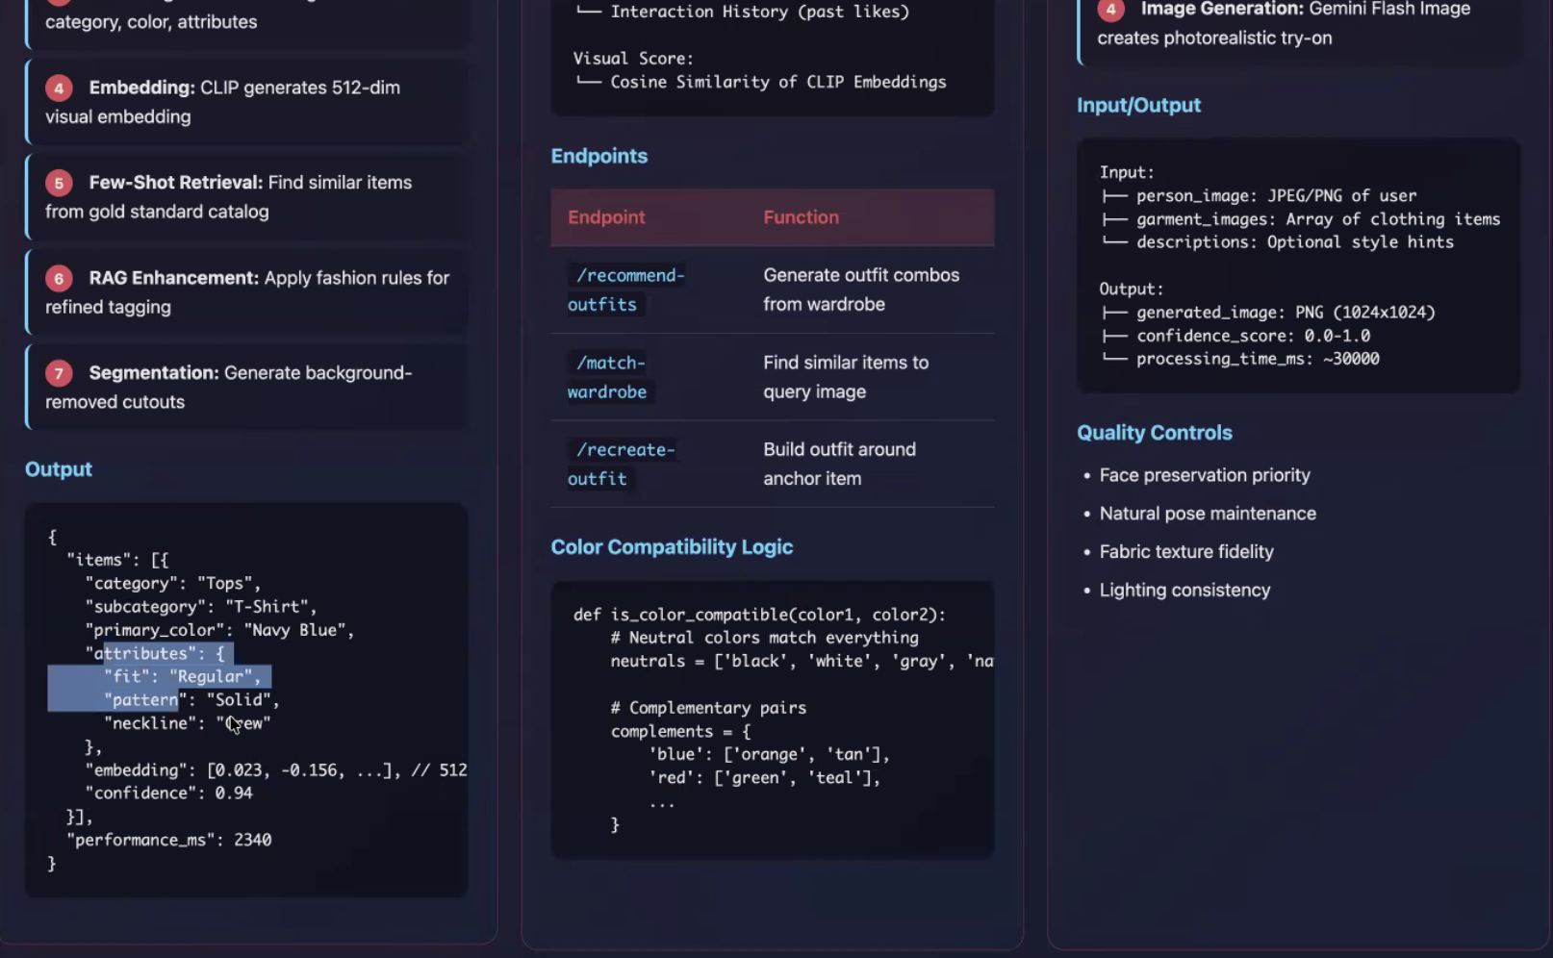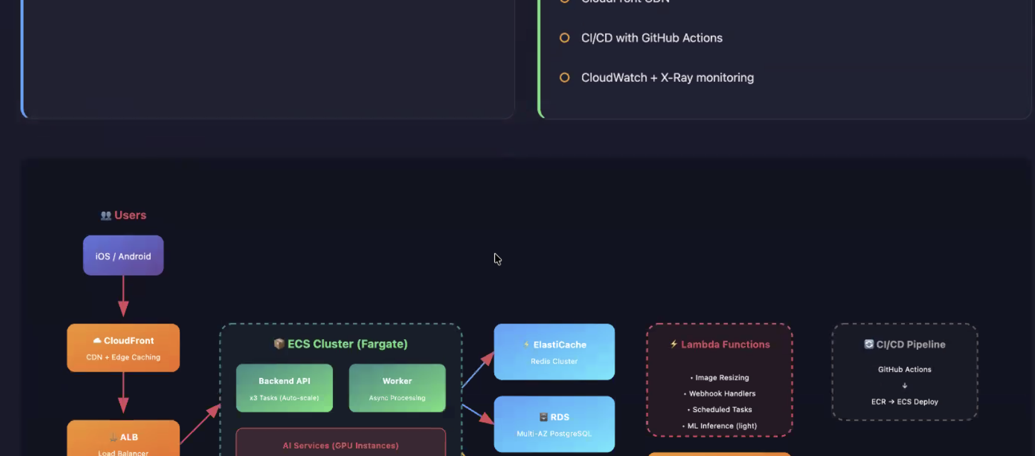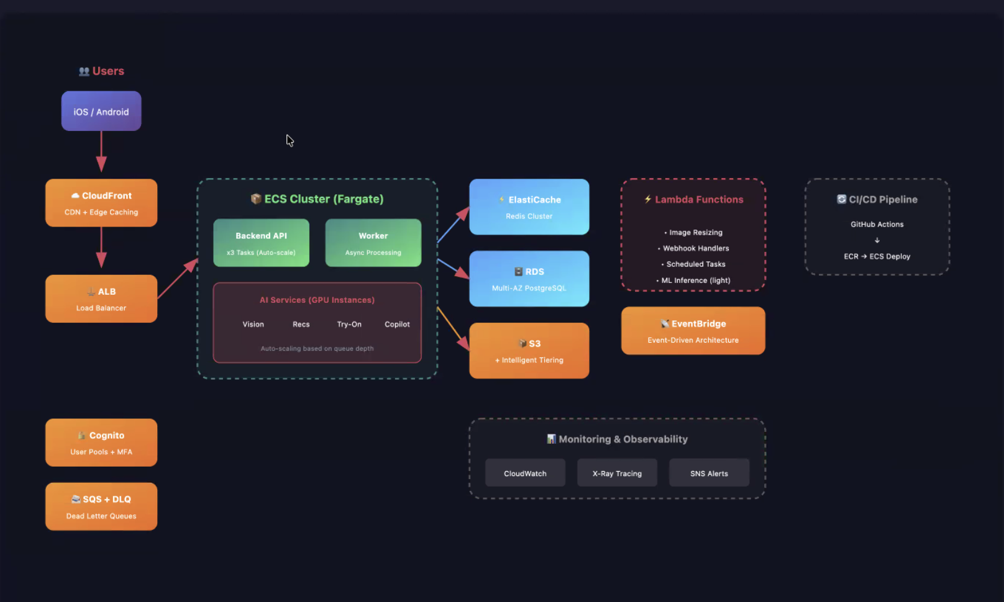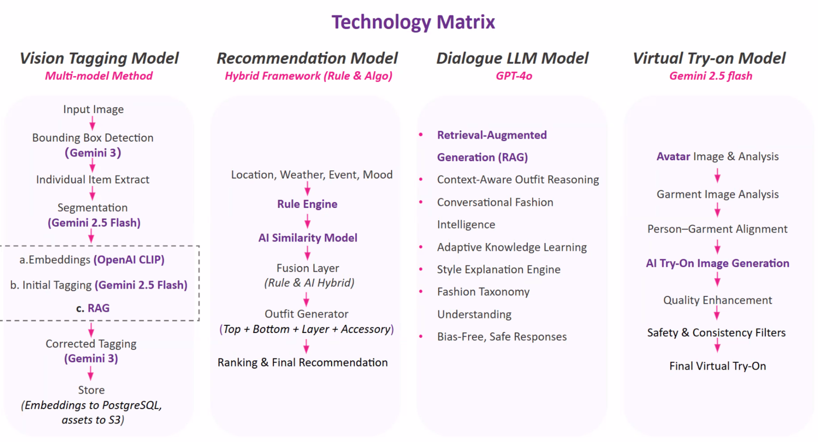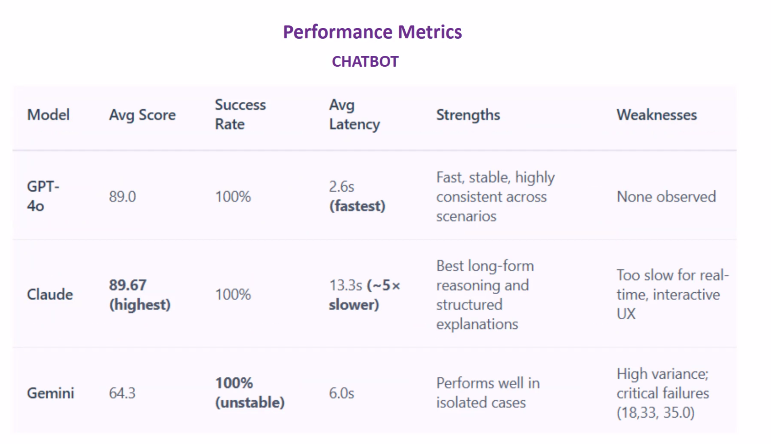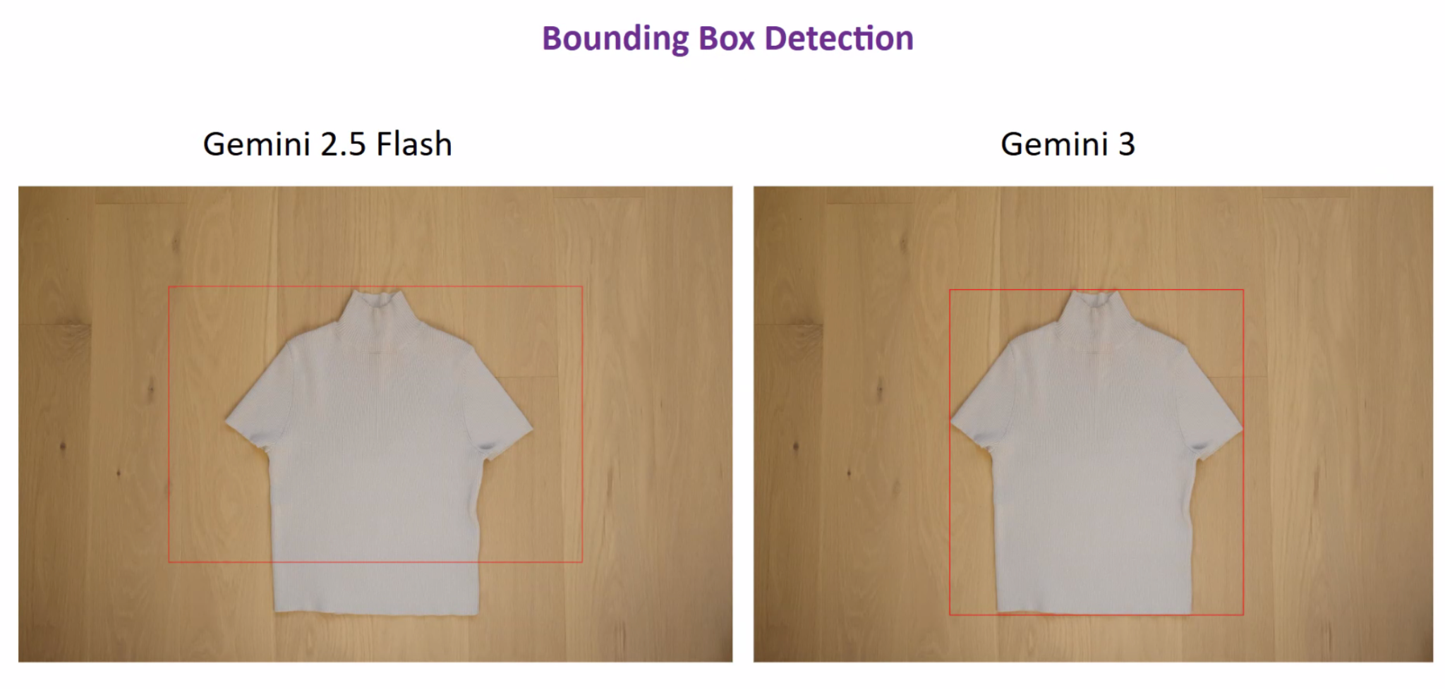

User Research

# Email - Finalised (Research Phase 2)

Hi {{first_name}},

I'm Eshma, UX Research Lead at RewardWise (working alongside Sabby, our Product Lead). Your survey responses gave us some sharp insights. Thank you!

We're now doing quick 1-on-1 chats to go deeper. It's 15 minutes, totally casual, and your perspective will directly shape what we build. There is no preparation needed and certainly no sales pitch. Just a brief conversation to ensure we’re building something that truly works for you.

In return, you'll get early access to RewardWise before anyone else.

I have slots open Saturday and Sunday- grab one here:<https://calendly.com/eshmaashettyy6/rewardwise-1-on-1>

If the available slots don't fit your schedule, simply reply and I'll do my best to accommodate.

Your input is genuinely shaping what we build. I appreciate your time.

Best regards,

Eshma

Draft samples  
  
 **~~Subject:~~** ~~Quick follow-up: Your thoughts on RewardWise~~

~~Hi {{first_name}},~~

~~I'm Eshma, UX Research lead at RewardWise. I’m working alongside Sabby, our Product Lead, and we’ve been reviewing the survey feedback you shared with us. Thank you again, your responses were incredibly insightful and gave us a lot to think about!~~

~~One of our biggest takeaways was that many people feel they’re leaving value on the table because points systems are just too complex to navigate. We’re building RewardWise to fix exactly that.~~

~~I’m hosting a few 1-on-1 conversations this weekend to dig a bit deeper. I’d love to invite you to a casual, 15-minute chat to hear more about your honest perspective, how you currently manage your rewards, what frustrates you most, and what your "dream tool" would look like.~~

~~There is no preparation needed and certainly no sales pitch. Just a brief conversation to ensure we’re building something that truly works for you.~~

~~As a thank you for your time, you’ll get:~~

* ~~Early Insider Access: Be among the first to test the product.~~
* ~~Direct Influence: Your feedback will directly shape our roadmap before we launch.~~

~~We’re wrapping up this phase of research by Sunday. If you’re open to a quick chat, you can pick a time that works for you here:~~ [~~https://calendly.com/eshmaashettyy6/rewardwise-1-on-1~~](https://calendly.com/eshmaashettyy6/rewardwise-1-on-1)**~~Note:~~** ~~If none of the times on the link work for you, please simply reply to this email and I will do my absolute best to adjust to your schedule.~~

~~Really appreciating your input, it is literally shaping what we build next.~~

~~Best regards,~~

**~~Eshma~~**   
  
  
**Subject:** 5 minutes for your thoughts on travel rewards?  
  
Hi [Name],

I am currently working on **RewardWise**, a project designed to help users maximize their credit card rewards and travel points. As part of my research, I am looking to better understand how people manage their points and the challenges they face along the way.

Would you be willing to share your thoughts in a brief user survey?

* **Time:** Approximately 5–7 minutes.
* **Privacy:** This survey is for research purposes only. Your individual responses will remain strictly confidential and will not be shared or published anywhere.
* **Note:** There are no right or wrong answers, we are simply looking for your honest experiences.

**[Link: Start the RewardWise Survey]**

Your feedback is incredibly valuable and will directly influence the design and features of this project. Thank you so much for your time and support!

Best regards,

**Option 2 - Insider Access hook**

Hi {{first_name}},

My name is {{researcher_name}} and I'm the UX researcher on the RewardWise team, working closely with Sabby (our product lead) to make sure we're building something people actually want.

A few weeks ago you took our survey on how you use credit card points and travel rewards — thank you! Your responses were incredibly valuable and honestly a bit eye-opening.

Here's what we learned: most people leave thousands of dollars on the table every year simply because the points system is too complex to navigate. You told us that, and we're building something to fix it.

I'd love to grab 15 minutes of your time for a quick 1-on-1 chat this weekend (Sat or Sun). No sales pitch — just a few follow-up questions so we can make sure we're solving the right problems for people like you.

What's in it for you:

* Early insider access to what we're building
* A direct line to shape a product before it launches
* A $15 coffee gift card as a thank you ☕

We're wrapping up this phase of research this weekend, so if you're open to it, pick a time that works: [Calendly link]

Really appreciate your time — your input is literally shaping what we build next.

Best,

{{researcher_name}}

UX Researcher, RewardWise

**Option 3 - Curiosity + urgency hook**

Hi {{first_name}},

I'm {{researcher_name}}, UX researcher at RewardWise. I work alongside Sabby, our product lead, and together we're using your survey feedback to shape the product roadmap.

Thank you again for taking our travel rewards survey! We got some fascinating responses and yours stood out. We're now in the final phase of our research and I'm having short 1-on-1 conversations with a small group of respondents this weekend to dig deeper. Think of it as a casual 15-minute chat — I'll ask a few questions about how you currently manage your points, what frustrates you, and what your dream tool would look like.

No prep needed. No pitch. Just your honest perspective.

As a thank you, everyone who chats with us gets early access to our product before public launch — plus a small gift card for your time.

I have slots open Saturday and Sunday — grab one here before they fill up: [Calendly link]

I would love to hear from you!

Best,

{{researcher_name}}

UX Researcher, RewardWise

**Option 4 - Direct + Warm**

Hi {{first_name}},

I'm {{researcher_name}}, UX researcher at RewardWise. I'm working with Sabby, our product lead, to turn your feedback into features — and your survey responses have already made a real impact on our direction.

I'm reaching out to a handful of respondents for a short follow-up conversation this weekend. It's 15 minutes, totally casual, and your answers will directly influence the product we're building.

Here's the deal:

• 15 min video or phone call — Sat or Sun, whatever's easier

• I'll ask about your real experiences with points and travel booking

• You'll get a first look at what we're creating + a coffee gift card ☕

We're closing out this research sprint by Sunday, so if you're up for it, book a slot here: [Calendly link]

No worries at all if the timing doesn't work — I'm grateful either way for the survey responses.

Talk soon,

{{researcher_name}}

UX Researcher, RewardWise

Interview cheat Sheet

# **RewardWise Validation Interview Guide(Redone)**

# **Objective: Confirm if "The Verdict" (AI recommendation) is trusted enough to trigger a booking.**

### **PHASE 1: WARM-UP + CONTEXT (3 min)** *"Thanks for joining! I'm [name], UX researcher working with Sabby on RewardWise. This is informal — no wrong answers. I'll ask a few quick questions, show you something we're building, and get your honest reaction."*

# **Icebreaker: "Walk me through the last time you had to decide: use points or pay cash?"**

# ***Justification:* Sets the stage by putting the user back in the "moment of indecision."**

### **PHASE 2: THE CONFIDENCE BASELINE (4 min)**

# **"When you made that decision, how many browser tabs did you have open?"**

# **"On a scale of 1-10, how confident were you that you got the best deal?"**

# **"What would have made you feel like a 10?"**

### **PHASE 3: PROTOTYPE REACTION (8 min) ⭐**

# ***Show "The Verdict" Mockup* 4. "In your own words, what is this screen telling you to do?" * 5. "If this said 'Use Points—Save $847' with 92% confidence, would you book it right now?" * 6. "Do you need to see the math behind that '$847' to trust it, or is the 92% score enough?" * 7. "How does this compare to your usual process of checking multiple sites?" \***

### **PHASE 4: STRESS TESTING THE VALUE (5 min) ⭐**

# **"If this gave you a 'Good' deal in 5 seconds, vs. a 'Perfect' deal that took 5 minutes of searching, which would you book?"**

# **"What's the #1 thing missing that would stop you from acting on this recommendation?"**

# **"What would make you pay for this vs. continuing to do it yourself for free?"**

# 

### **PHASE 5: CLOSE (2 min)**

# **"On a scale of 1-10, how likely are you to use this for your next trip?"**

# **"If <9: What is the one change that gets you to a 10?"**

# **13. How would you feel about the AI securely sync-ing with your [loyalty accounts/search habits] if it meant the 'Verdict' was 100% personalized to the points you actually have?**

# **RewardWise User Interview Guide**

| **Duration:** 15-25 minutes  **Objective:** Validate direction, not discover. Confirm our solution resonates.  **Key Question:** Would you trust this recommendation enough to act on it? |
| --- |

## **PHASE 1: WARM-UP + CONTEXT (2-3 min)**

| ***Script:*** *"Thanks for joining! I'm [name], UX researcher working with Sabby on RewardWise. This is informal — no wrong answers. I'll ask a few quick questions, show you something we're building, and get your honest reaction."* |
| --- |

**Icebreaker (pick one based on their survey):**

• "You mentioned [finding availability / doing the math / transferring points] was frustrating — can you tell me about the last time that happened?"

• "Walk me through the last time you had to decide: use points or pay cash?"

**Goal:** Get them talking, confirm their survey pain point is real.

## **PHASE 2: PROBLEM VALIDATION (3-4 min)**

**Confirm the confidence gap:**

1. "When you made that decision, how confident were you that you got the best deal?" *(1-10 scale)*

2. "What would have made you more confident?"

3. "Have you ever regretted a points decision after the fact?"

**Listen for:** Uncertainty language ("I think," "probably," "not sure"), mention of checking multiple sources, fear of wasting points.

## **PHASE 3: PROTOTYPE REACTION (6-8 min) ⭐**

| ***Script:*** *"Let me show you what we're building. This is early — nothing is final."*  **[Show prototype / mockup of The Verdict]** |
| --- |

**Immediate reaction:**

4. "What's your first impression?" *(Let them talk, don't guide)*

5. "What do you think this is telling you?"

**Trust question (CRITICAL):**

6. **"If this said 'Use Points — Save $847' with 92% confidence, would you trust it enough to act on it?"**

• If YES: "What makes you trust it?"

• If NO: "What's missing that would make you trust it?"

7. "What would you want to click on or explore further?"

**Competitive anchor:**

8. "How does this compare to what you do today — Googling, checking multiple sites, etc.?"

## **PHASE 4: GAP IDENTIFICATION (3-4 min) ⭐**

**Direct questions:**

9. **"What's the #1 thing missing that would stop you from using this?"**

10. "If this existed today, what would make you NOT use it?"

11. "What would make you pay for this vs. use a free alternative?"

**Feature validation (based on their survey):**

12. "Your survey said [finding availability / transfer partners] was frustrating — does this address that for you?"

## **PHASE 5: CLOSE + NEXT STEPS (2 min)**

13. "On a scale of 1-10, how likely would you be to use this for your next trip?"

• If <7: "What would get it to a 9?"

14. "Any final thoughts on what we're building?"

15. "Would you be open to testing an early version when it's ready?"

| ***Script:*** *"Thanks so much — this was incredibly helpful. We'll send you early access as a thank you!"* |
| --- |

# **Interviewer Cheat Sheet**

## **Validation Table — What to Listen For**

| **Survey Said** | **Validate This** | **Red Flag If They Say** |
| --- | --- | --- |
| 64% "Not knowing if worth it" | Does the verdict solve uncertainty? | "I'd still check other sites" |
| 49% double-check multiple sources | Do they trust ONE answer? | "I need to see the math myself" |
| 69% want "absolute best value" | Is 92% confidence enough? | "92% isn't good enough" |
| 44% would book immediately | Will they act on verdict? | "I'd use it for research only" |
| Top pain: Finding availability | Does real-time Seats.aero matter? | "Availability is my real problem, not the decision" |

## **Questions to AVOID (Discovery Mode — Save for Later)**

• ❌ "What features would you want?"

• ❌ "How much would you pay?"

• ❌ "What other tools do you use?" (unless brief)

• ❌ Open-ended "tell me about your travel habits"

## **Post-Interview Quick Score (Fill Out Immediately)**

| **Question** | **Score (1-10)** |
| --- | --- |
| Problem resonance (do they feel the pain?) | ___ |
| Solution fit (does verdict solve it?) | ___ |
| Trust level (would they act on it?) | ___ |
| Likelihood to use | ___ |
| **Blocker identified:** |  |

**Participant Name:** ________________________ **Date:** ____________

User Interview P2

**Notes on user Interview P2**  
**Product Development & Prototyping**

* **Build Clickable Prototype:** Use a "Cloud Code" and React-based workflow to build a front-end prototype. Focus on a design-first approach that is installable and clickable to test the UX without building a full back-end/database yet.
* **Refine Decision Logic:** Develop the "Cash vs. Points" calculation engine to provide clear, actionable "best value" recommendations to users.
* **Evaluate Integration vs. Deep-Linking:** Conduct a trade-off analysis to decide whether the app should facilitate bookings internally or deep-link users to airline portals.
* **Test "Sticky" Features:** Integrate and test high-utility notifications, specifically for expiring points and "hot deals," to drive user retention.

### **Technical Strategy**

* **AI Assistant Research:** Explore the integration of advanced models (like Opus/4.5) to handle complex tasks like voice-command bookings and cross-carrier transfers.
* **P2P Security & Trust:** Research documentation and encryption protocols needed to build trust in a peer-to-peer points trading environment.
* **Tooling Audit:** Review the suggested front-end design plugins and Google Labs tools to accelerate the rapid prototyping cycle.

### **Business & Networking**

* **Refine the Business Model:** Schedule a brainstorm session to finalize the revenue model (e.g., transaction fees on trades vs. subscription for the optimization tool).
* **Go-to-Market (GTM) Planning:** Identify the initial "niche" audience (e.g., high-value family travelers or "points enthusiasts") to target for the beta launch.
* **Follow-up Meeting:** Arrange a coffee chat/Friday meeting with the interviewee/collaborator to discuss the prototype feedback and seek further mentorship on the "Opus" integration.

Appendix

**B2B business model *(future scope)***

Pricing Structure:

• Enterprise License: $10,000-$50,000 annually (based on company size and travel spend)

• Per-Employee-Traveler: $50-$150/year per frequent traveler

• Concierge Bookings: $99-$299 per complex booking

• ROI Guarantee: Money-back if savings don't exceed subscription cost